Key Management –
Key management is a crucial aspect of cryptographic systems, and generating strong and secure keys is essential to maintain the security of encrypted data. Here are some considerations for generating keys: 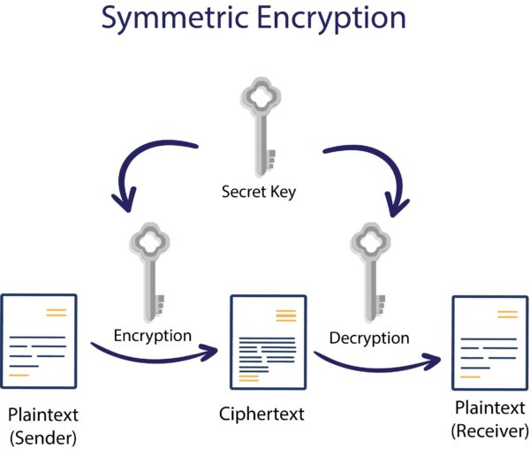
- Cryptographically Strong Randomness: Keys should be generated using cryptographically strong random number generation techniques. This ensures that the keys are truly random and unpredictable, making them resistant to cryptographic attacks. Cryptographically secure random number generators (CSPRNGs) are commonly used to generate random keys.
- Sufficient Key Length: The key length should be appropriate for the encryption algorithm being used. Longer key lengths generally provide higher security against brute-force and cryptographic attacks. It's important to follow recommended key lengths for specific algorithms (e.g., AES-256 for AES encryption).
- Key Generation Algorithms: Key generation algorithms should be carefully selected and implemented. Commonly used key generation algorithms include the key derivation function (KDF) and key exchange protocols like Diffie-Hellman. These algorithms ensure the generation of secure keys with proper randomness.
- Secure Seed or Initialization: Keys generated by pseudorandom number generators (PRNGs) or CSPRNGs rely on an initial value called a seed or initialization vector (IV). The seed or IV should be generated using a secure random source, such as a hardware random number generator (HRNG) or high-entropy input sources like system events or user interactions.
- Secure Storage: Generated keys should be securely stored to prevent unauthorized access or exposure. It is crucial to follow secure key storage practices, such as using hardware security modules (HSMs), key management systems, or secure key storage protocols like Key Management Interoperability Protocol (KMIP). Proper access controls and encryption of stored keys should also be implemented.
- Periodic Key Rotation: Keys should be periodically rotated or replaced to maintain security. Regular key rotation reduces the exposure time in case of a key compromise. The frequency of key rotation depends on the specific security requirements and the sensitivity of the data being protected.
- Key Backup and Recovery: Adequate backup and recovery mechanisms should be in place to ensure that keys are not lost or permanently unavailable. Regularly backing up keys and securely storing backup copies are important to prevent data loss or disruptions in case of key loss or system failures.
- Key Management Policies and Procedures: Establishing key management policies and procedures helps ensure consistent and secure key generation practices. This includes defining key generation processes, roles and responsibilities, key lifetime management, key archival, and key destruction procedures.
By following these key generation practices, organizations can generate strong and secure keys to protect their encrypted data effectively. Key management is an ongoing process, and regular review and updates to key generation practices should be conducted to align with industry standards and emerging cryptographic technologies.
Generating Keys-
When generating keys for cryptographic systems, it is important to follow best practices to ensure they are strong, secure, and resistant to attacks. Here are some key considerations and steps for generating keys: 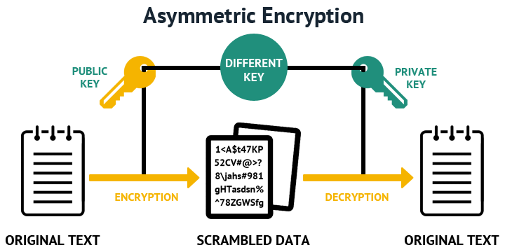
- Key Length: Determine the appropriate key length based on the cryptographic algorithm you are using. Longer key lengths generally provide higher security. Follow recommended key lengths for specific algorithms (e.g., 256 bits for AES).
- Cryptographically Strong Randomness: Use cryptographically secure random number generation techniques to generate keys. Cryptographic libraries or APIs often provide functions for generating random numbers. Ensure the random number generator used is suitable for cryptographic purposes and provides sufficient entropy.
- Seed or Initialization Vector (IV): If using a pseudorandom number generator (PRNG) or a cryptographically secure pseudorandom number generator (CSPRNG), provide a strong seed or IV as input. The seed or IV should be generated using a secure random source, such as a hardware random number generator (HRNG) or high-entropy input sources like system events or user interactions.
- Key Generation Algorithms: Select and use appropriate key generation algorithms. Common methods include the key derivation function (KDF), key exchange protocols like Diffie-Hellman, or cryptographic key generation algorithms provided by cryptographic libraries. These algorithms ensure the generation of secure keys with proper randomness.
- Secure Environment: Generate keys in a secure and trusted environment to prevent unauthorized access or leakage. Use trusted hardware or software components, such as hardware security modules (HSMs) or secure key generation systems, to enhance the security of the key generation process.
- Key Generation Policy: Establish a key generation policy that defines the process, roles, and responsibilities for key generation. This policy should align with industry best practices and organizational security requirements.
- Testing and Validation: Test and validate the generated keys before deployment to ensure their correctness and compatibility with the cryptographic system or protocol being used. Perform appropriate cryptographic tests, quality checks, and functional validation to ensure the generated keys meet the desired security criteria.
- Key Lifecycle Management: Implement a key lifecycle management process that covers key generation, distribution, rotation, backup, recovery, and destruction. Properly manage keys throughout their lifecycle to ensure their security, availability, and integrity.
- Secure Storage: Securely store the generated keys to prevent unauthorized access or exposure. Follow secure key storage practices, such as using secure file systems, protected databases, hardware security modules (HSMs), or secure key storage protocols like Key Management Interoperability Protocol (KMIP).
- Key Backup and Recovery: Establish key backup and recovery mechanisms to prevent key loss or unavailability. Regularly back up keys and securely store backup copies in separate, secure locations. Define procedures for key recovery in case of key loss or system failures.
Remember to adhere to industry standards, regulatory requirements, and cryptographic best practices when generating keys. Regularly review and update key generation processes to align with emerging cryptographic technologies and address any vulnerabilities that may arise over time.

