Lifetime of Keys:
The lifetime of cryptographic keys refers to the duration during which a key is considered secure and suitable for use in cryptographic operations. The key lifetime is influenced by various factors, including the cryptographic algorithm used, the sensitivity of the data being protected, and evolving security threats. Here are some considerations for determining the lifetime of keys:
- Cryptographic Algorithm: The choice of cryptographic algorithm affects the key lifetime. Different algorithms have different levels of security and recommended key lifetimes. It is important to follow the guidelines and recommendations provided by the algorithm's specification or relevant standards organizations.
- Security Requirements: Consider the security requirements of the system and the sensitivity of the data being protected. High-security environments or systems dealing with highly sensitive data may require shorter key lifetimes to minimize the risk of compromise. Assess the potential consequences of key compromise or unauthorized access to determine an appropriate key lifetime.
- Key Strength: The strength of the key, determined by its length or complexity, influences its resistance to cryptographic attacks. Longer keys generally provide higher security, but they may also impact performance and operational considerations. Consider the balance between key strength and practical considerations when determining the key lifetime.
- Cryptographic Advances: Advances in computing power and cryptographic attacks can weaken the security of cryptographic algorithms over time. Regularly monitor advancements in cryptanalysis and vulnerability research to assess the ongoing security of the chosen algorithm and adjust key lifetimes accordingly.
- Key Rotation: Key rotation, the process of regularly replacing keys with new ones, is a common practice to enhance security. The key rotation interval depends on the security requirements and the rate of cryptographic attacks on the algorithm. Shorter key lifetimes often necessitate more frequent key rotation.
- Compliance and Regulatory Requirements: Certain industries or regulatory frameworks may prescribe specific key lifetime requirements. Ensure that key lifetimes align with applicable compliance standards or legal requirements that govern the use of cryptographic systems.
- Operational Considerations: Consider operational factors, such as system performance, compatibility, and key management overhead, when determining the key lifetime. Striking a balance between security and operational efficiency is essential to maintain the effectiveness of cryptographic operations.
- Periodic Key Evaluation: Regularly evaluate the security of keys and the cryptographic systems in use. Conduct key assessments, vulnerability scans, or security audits to identify any weaknesses or vulnerabilities that may require adjusting key lifetimes.
It is important to note that determining the appropriate key lifetime is not a one-size-fits-all approach. It requires careful consideration of multiple factors, including the specific context, security requirements, and evolving threats. Regular review and updates to key management policies and practices ensure that key lifetimes remain aligned with current security best practices and address emerging risks.
Destroying Keys:
Destroying keys is a crucial step in maintaining the security and confidentiality of sensitive data, especially when the keys are no longer needed or have reached the end of their lifecycle. Proper key destruction ensures that the keys cannot be recovered or used by unauthorized individuals. Here are some considerations and best practices for securely destroying keys:
- Cryptographic Key Destruction: Use cryptographic techniques to securely destroy the keys. This involves applying secure key erasure or key wiping algorithms that make it computationally infeasible to recover the original key. Cryptographic key destruction ensures that even if the storage media or backup copies are compromised, the keys remain securely irrecoverable.
- Physical Destruction: Physical destruction of storage media or devices that contain the keys provides an additional layer of security. This can include physically shredding hard drives, destroying smart cards or tokens, or securely disposing of any physical medium that stores or contains the keys. Follow appropriate disposal and recycling practices in compliance with local regulations.
- Secure Erasure: If cryptographic key destruction is not feasible or applicable, ensure secure erasure of the keys from storage media. Use secure erasure software or tools that overwrite the key data with random or zero values, making it extremely difficult to recover the original key. Multiple passes of erasure may be necessary to ensure complete destruction.
- Documentation and Recordkeeping: Maintain proper documentation and records of the key destruction process. This includes details such as the date, method, and individuals responsible for the key destruction. Proper documentation helps demonstrate compliance with security policies, legal requirements, and audit trails.
- Key Destruction Verification: After key destruction, verify the effectiveness of the process to ensure that the keys have been completely destroyed and cannot be recovered. This can involve technical validation, physical inspection, or third-party verification to provide assurance that the keys are no longer usable.
- Backup Key Destruction: If backup copies of keys exist, ensure that they are also securely destroyed following the same key destruction practices. Backup keys are as sensitive as the original keys and should be treated with the same level of security and destruction measures.
- Key Destruction Policies and Procedures: Establish key destruction policies and procedures as part of the overall key management practices. Clearly define the key destruction process, including roles, responsibilities, and required approvals. Regularly review and update the policies to align with changing security requirements and industry best practices.
- Regulatory and Compliance Considerations: Consider any specific regulatory or compliance requirements that govern the destruction of keys. Some industries or jurisdictions may have specific guidelines or standards for key destruction that need to be followed to maintain compliance.
By following these best practices for key destruction, organizations can ensure that sensitive data remains protected even after the keys are no longer needed. Key destruction is a critical component of a comprehensive key management lifecycle and should be given careful consideration to mitigate risks associated with unauthorized key use or exposure.
Public key infrastructure: -
Public Key Infrastructure (PKI) is a system of technologies, policies, and procedures that enable secure communication and digital transactions by using public key cryptography. PKI provides the framework for managing public and private keys, digital certificates, and other cryptographic components. Here are some key aspects and components of PKI:
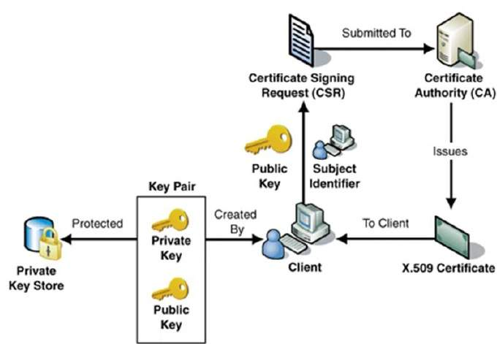
- Public/Private Key Pairs: PKI relies on asymmetric key cryptography, where each entity possesses a pair of mathematically related keys - a public key and a private key. The public key is freely distributed and used for encryption and verification, while the private key is kept secret and used for decryption and signing.
- Certificate Authorities (CAs): CAs are trusted third-party entities that issue digital certificates. These certificates bind the identity of an entity (such as an individual, organization, or device) to its public key. CAs establish trust by verifying the identity of the certificate holder and digitally signing the certificate.
- Digital Certificates: Digital certificates are electronic documents that contain the public key of an entity along with other information, such as the identity of the entity and the CA that issued the certificate. Certificates are digitally signed by the CA to ensure integrity and authenticity.
- Certificate Revocation: In case of key compromise or other security incidents, digital certificates can be revoked to indicate that they are no longer valid. CAs maintain Certificate Revocation Lists (CRLs) or use Online Certificate Status Protocol (OCSP) to disseminate information about revoked certificates.
- Certificate Validation and Chain of Trust: To establish trust in a digital certificate, it is necessary to validate the certificate and verify its integrity. This involves verifying the digital signature of the CA that issued the certificate and checking its status against CRLs or OCSP. The process also includes building a chain of trust, where the certificates of intermediate CAs are validated and trusted, ultimately leading to a trusted root CA.
- Secure Communication: PKI enables secure communication through various protocols, such as Transport Layer Security (TLS) or Secure Sockets Layer (SSL). These protocols use public key cryptography to establish secure connections, authenticate parties, and encrypt data during transmission.
- Key Management: PKI involves key management processes, including key generation, distribution, storage, and retirement. It encompasses practices to securely store private keys, protect key material, and establish appropriate key lifecycle management procedures.
- Applications of PKI: PKI is used in various applications, including secure email (S/MIME), secure web browsing (HTTPS), digital signatures, secure document exchange, secure remote access (VPN), and electronic commerce (e-commerce). PKI ensures the confidentiality, integrity, and authenticity of data and transactions in these applications.
- Standards and Frameworks: PKI is governed by standards and frameworks, such as the X.509 standard for digital certificates, the PKIX (Public Key Infrastructure X.509) framework, and the Certificate Policy (CP) and Certification Practice Statement (CPS) documents that define the policies and practices of CAs.
PKI plays a crucial role in establishing trust, enabling secure communication, and facilitating the use of digital certificates for various applications. It provides a foundation for secure and reliable cryptographic operations in both public and private environments.

