Nonlinear Key spaces –
Nonlinear key spaces refer to the use of keys that are not selected in a linear or predictable manner but instead exhibit a non-linear relationship. The concept of nonlinear key spaces enhances the security of cryptographic systems by increasing the complexity of the key search space, making it more difficult for attackers to guess or deduce the keys. Here are a few examples and considerations related to nonlinear key spaces:
- Key Derivation Functions (KDFs): KDFs are used to derive keys from a master secret or password. Nonlinear key spaces can be achieved by employing strong and computationally intensive KDFs, such as PBKDF2 (Password-Based Key Derivation Function 2) or bcrypt. These KDFs introduce additional iterations and randomization to generate derived keys, making it harder to deduce the original keys. 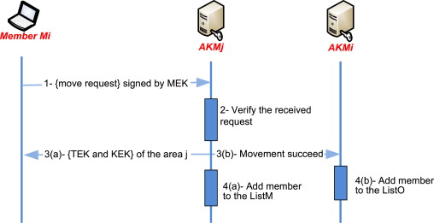
- Key Expansion: Nonlinear key spaces can be achieved through key expansion techniques. Instead of using a fixed-length key directly, a key expansion algorithm can generate a larger key space from a smaller initial key. This increases the complexity of the key space, making it more resistant to brute-force attacks. 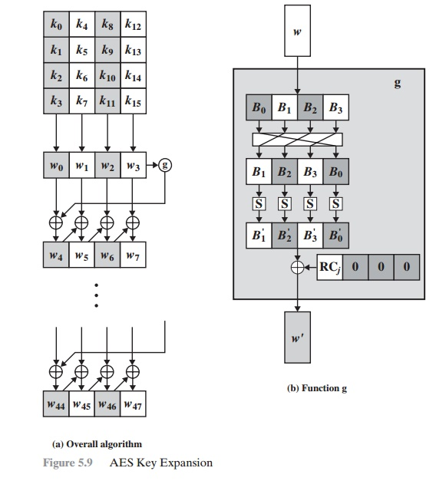
- Nonlinear Key Mixing: Nonlinear key mixing techniques involve combining key bits in a nonlinear manner, such as through bitwise logical operations (XOR, AND, OR) or substitution boxes (S-boxes). Nonlinear mixing of key bits helps introduce confusion and make it more challenging to analyze the key structure or exploit patterns.
- Key Generation from Multiple Sources: Nonlinear key spaces can be obtained by combining keys generated from multiple independent and unrelated sources. This approach, called key diversification or key merging, ensures that the resulting key space is nonlinear and unpredictable. It enhances security by mitigating the risks associated with a single compromised key source.
- Key Splitting and Secret Sharing: Nonlinear key spaces can be achieved by splitting a single key into multiple shares using secret sharing schemes like Shamir's Secret Sharing. Each share contributes to the final key space, and a threshold of shares is required to reconstruct the original key. This introduces a nonlinear relationship between the shares and provides additional security against attacks targeting a single key component.
- Nonlinear Cryptographic Algorithms: Nonlinear key spaces can be inherently present in cryptographic algorithms that exhibit strong nonlinear properties, such as substitution-permutation networks (SPNs) or Feistel networks. These algorithms operate on the principles of nonlinear transformations and ensure that even small changes in the key result in significant changes in the cipher behavior.
The use of nonlinear key spaces enhances the security of cryptographic systems by increasing the complexity and unpredictability of the key space. By incorporating nonlinear key generation, derivation, mixing, and expansion techniques, the security of the system is strengthened against various cryptographic attacks, including brute-force, key search, and key deduction attacks.
Transferring keys-
Transferring key securely is crucial to maintain the confidentiality and integrity of sensitive data. When transferring keys between parties, whether it's for encryption, authentication, or secure communication, it's important to follow best practices to protect the keys from unauthorized access or interception. Here are some considerations for securely transferring keys: 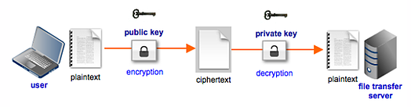
- Key Exchange Protocols: Utilize secure key exchange protocols that provide confidentiality and integrity during the transfer of keys. Examples of such protocols include Diffie-Hellman (DH), Elliptic Curve Diffie-Hellman (ECDH), or key exchange protocols based on the secure sockets layer/transport layer security (SSL/TLS) protocols. 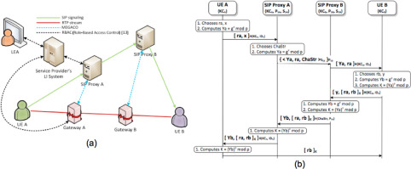
- Asymmetric Encryption for Key Transfer: Use asymmetric encryption (public-key cryptography) to securely transfer symmetric keys or other sensitive data. The sender encrypts the key using the recipient's public key, and the recipient decrypts it using their private key. This ensures confidentiality during the transfer. 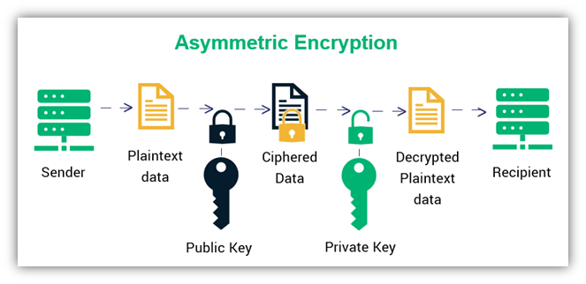
- Digital Signatures: Apply digital signatures to verify the authenticity and integrity of the transferred keys. The sender signs the key or key exchange parameters using their private key, and the recipient verifies the signature using the sender's public key. This protects against tampering and ensures that the key is from the intended sender.
- Key Wrapping: Wrap or encrypt the key using an additional layer of encryption before transfer. This adds an extra level of protection to the key, ensuring that only authorized parties with the decryption capability can access it. 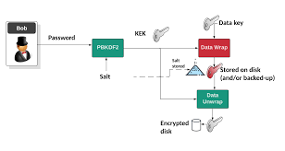
- Secure Channels: Use secure communication channels for transferring keys. Examples include secure file transfer protocols (SFTP), secure email protocols (PGP/S-MIME), or secure messaging platforms. These channels employ encryption and authentication mechanisms to protect the confidentiality and integrity of the transferred keys.
- Key Splitting and Secret Sharing: Split the key into multiple shares and transfer them separately through different channels or mediums. This approach, known as secret sharing or threshold cryptography, ensures that no single party has access to the complete key during transfer, adding an extra layer of security.
- Physical Transfer: In certain cases, physical transfer of keys may be necessary, such as through secure courier services or in-person key exchanges. These methods provide a high level of assurance against unauthorized access, interception, or tampering.
- Key Management Practices: Implement secure key management practices, including key lifecycle management, proper documentation, and access controls. This ensures that only authorized individuals or systems have access to the keys during transfer and storage.
- Key Validation: After the key transfer, validate the key's correctness and integrity to ensure it was transferred without errors or modifications. Use appropriate cryptographic techniques to verify the key's integrity, such as hashing or digital signatures.
By following these practices, keys can be securely transferred between parties, maintaining the confidentiality, integrity, and authenticity of the sensitive data being protected. It's important to choose appropriate protocols, encryption methods, and secure communication channels based on the specific security requirements and the sensitivity of the data being transferred.

