Pager Codes:
Pager codes, also known as numeric or alphanumeric codes, are a system of abbreviated messages used to communicate information via pagers or similar communication devices. These codes allow for concise and efficient communication, especially when character limits or transmission constraints are present. While pager codes can vary among individuals or groups, here are some common examples:
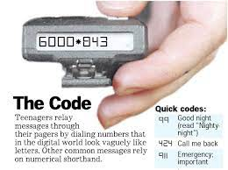
- Numeric Codes: Numeric codes use numbers to represent words, phrases, or specific messages. For example:
- 10: Message received/acknowledged.
- 911: Emergency situation.
- 143: "I love you" (using the number of letters in each word).
- Alphanumeric Codes: Alphanumeric codes use a combination of letters and numbers to convey information. These codes often involve assigning each letter or word a corresponding numerical value. For example:
- 2B: To be
- 4U: For you
- CUL8R: See you later
- Acronyms and Abbreviations: Pager codes often rely on acronyms and abbreviations to convey commonly used phrases or messages. For example:
- LOL: Laughing out loud
- BRB: Be right back
- ETA: Estimated time of arrival
- Predefined Codes: Some pager systems have predefined codes for specific messages or situations. These codes are typically programmed into the pager device and can be selected from a menu. Examples include:
- Urgent: Indicates a high-priority message.
- Callback: Request for the recipient to call back.
- Meeting: Notification of a scheduled meeting or appointment.
It's important to note that pager codes are informal and may vary depending on the context, region, or personal preference. Additionally, with the decline of pagers and the prevalence of smartphones and instant messaging, the use of pager codes has diminished. However, these codes may still be encountered in certain industries or among specific groups that continue to use pager-based communication systems.

Steganography
It is the practice of concealing secret or sensitive information within non-secret data or cover media, such as images, audio files, videos, or text documents. Unlike cryptography, which focuses on encrypting messages to make them unintelligible, steganography aims to hide the existence of the message itself. The goal is to make the embedded information undetectable to unauthorized observers.
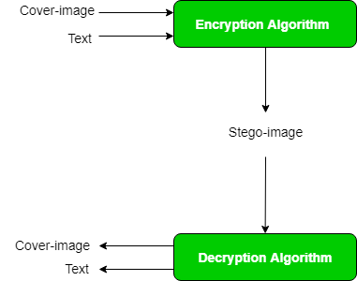
Here's an overview of how steganography works:
- Cover Media Selection: Steganography starts by choosing an appropriate cover media, which can be any digital file that appears innocuous and attracts minimal suspicion. Common choices include images (JPEG, PNG, etc.), audio files (MP3, WAV, etc.), or videos (MP4, AVI, etc.).
- Message Embedding: A secret message or data is then embedded within the cover media. This is typically achieved by modifying certain bits or elements of the cover media in a way that the changes are imperceptible to the human eye or ear. The specific technique used depends on the chosen steganography method.
- Steganography Techniques: There are various steganography techniques available, each with its own way of embedding data. Some common methods include:
  - Least Significant Bit (LSB): Modifying the least significant bits of the cover media to represent the hidden message.
  - Spread Spectrum: Spreading the hidden data across the entire frequency spectrum of the cover media, making it imperceptible.
  - Transform Domain Techniques: Embedding data within specific frequency bands or transformation domains (e.g., discrete cosine transform, wavelet transform) of the cover media.
  - Text Steganography: Concealing information within the structure or formatting of text documents, such as using invisible ink techniques or manipulating whitespace characters.
- Extraction and Decoding: To retrieve the hidden message, the recipient applies the reverse process, extracting the embedded data from the cover media using the appropriate steganography technique. This typically involves knowledge of the specific steganography method used and the corresponding extraction algorithm.
Steganography can be used for various purposes, ranging from covert communication and espionage to digital watermarking and copyright protection. It is important to note that the effectiveness of steganography relies on factors such as the complexity of the steganography technique, the size of the cover media, and the ability to evade detection by steganalysis techniques (methods used to detect the presence of hidden data).
As with any technology, steganography can be misused for illegal activities. Laws and regulations related to the use of steganography vary across jurisdictions, and it is important to understand and comply with the legal and ethical considerations when employing steganography techniques.

