Permutation Methods-
Permutation methods in operating system security involve changing the order or arrangement of elements within data using permutation rules. These methods are commonly used in cryptography and access control mechanisms to enhance data confidentiality, integrity, and overall system security. Here are a few examples of permutation methods used in operating system security:
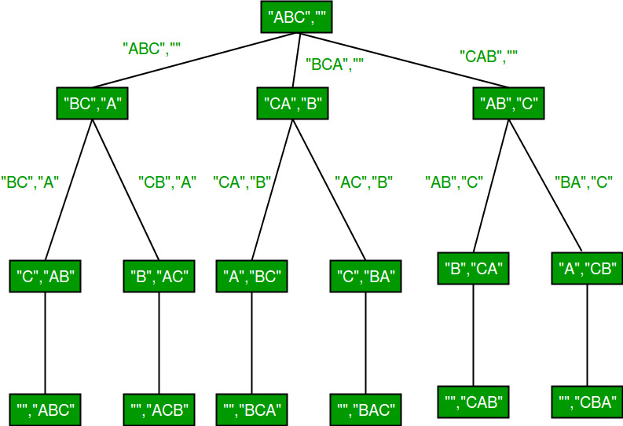

- Permutation Ciphers: Permutation ciphers, also known as transposition ciphers, rearrange the order of elements, such as characters or bits, within the ciphertext. The elements themselves are not altered, but their positions are changed based on a specific permutation rule. Permutation ciphers provide an additional layer of security when combined with other encryption techniques.
- Permutation Networks: Permutation networks are used in symmetric-key encryption algorithms and cryptographic protocols to shuffle or permute data elements systematically. They involve rearranging the bits or blocks of data based on a specific permutation rule. Permutation networks can provide confusion and diffusion properties, enhancing the overall security of cryptographic algorithms.
- Data Scrambling: Data scrambling techniques involve permuting or rearranging the order of data elements to obfuscate sensitive information. This can be used to protect data during transmission or to ensure that sensitive information cannot be easily deduced by unauthorized entities.
- Password Hashing: In the context of access control and password management, permutation methods are used to create password hashes. Password hashing algorithms, such as bcrypt or PBKDF2, employ permutation techniques to rearrange the characters or bits of the password, making it difficult to reverse-engineer the original password from the hash.
- Random Permutations: Random permutations are used in cryptographic protocols and algorithms to generate unique and unpredictable sequences. They are often employed for generating cryptographic keys, initialization vectors, or nonces, ensuring randomness and uniqueness in cryptographic operations.
Permutation methods can provide additional security layers, but they should be used in conjunction with other security measures, such as encryption algorithms, strong key management practices, secure configurations, and access control mechanisms. It's important to select and implement well-established permutation techniques to ensure their effectiveness and resistance against cryptographic attacks.

