Placement of Encryption
Encryption can be implemented at various levels and within different components of an operating system to ensure data confidentiality and enhance overall security. Here are some common placements of encryption:
- Disk Encryption: Disk encryption involves encrypting the entire disk or specific partitions/volumes where the operating system and data are stored. It protects the data when the system is powered off or the disks are physically accessed. Disk encryption can be achieved through technologies like Full Disk Encryption (FDE) or Self-Encrypting Drives.

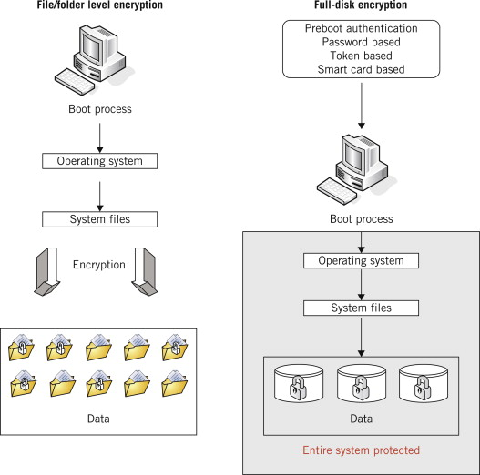

- File and Folder Encryption: Encryption can be applied to individual files or directories containing sensitive data. File and folder encryption allows for selective encryption of specific files or folders, ensuring that only authorized users with the encryption keys can access the encrypted data. 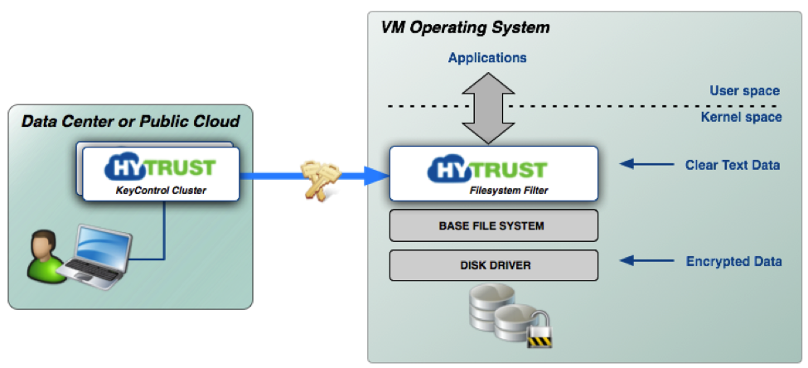
- Network Encryption: Network encryption secures data during transmission over networks. It can be implemented at different network layers, such as the Transport Layer (e.g., TLS/SSL) or the application layer (e.g., encrypted protocols like SSH or HTTPS). Network encryption safeguards data from eavesdropping and interception attacks. 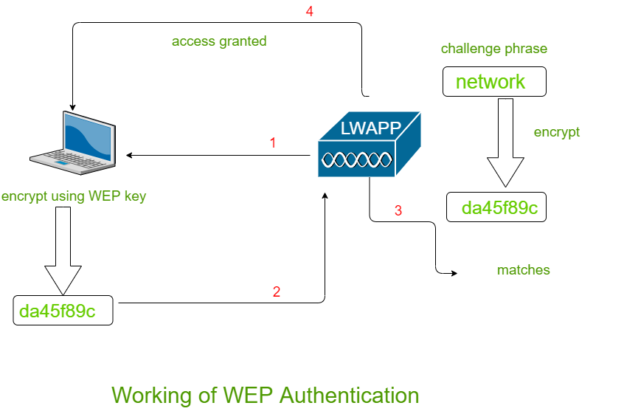

- Application-Level Encryption: Encryption can be implemented within specific applications to protect sensitive data. This includes encrypting databases, application data files, or user-specific data. Application-level encryption ensures that data remains protected within the application's context, even if the underlying storage or network layers are compromised.

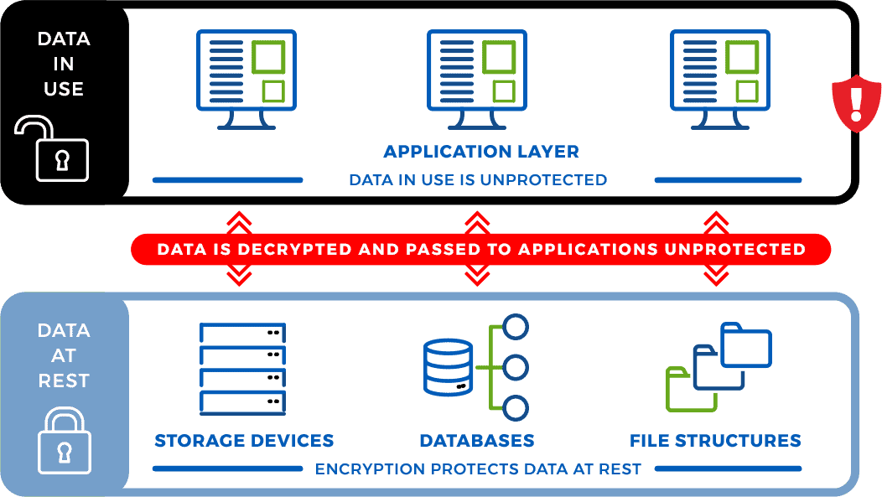

- Virtual Private Networks (VPNs): VPNs create encrypted tunnels over public networks to secure communication between remote systems. VPNs encrypt network traffic, ensuring the confidentiality and integrity of data transmitted over the network. 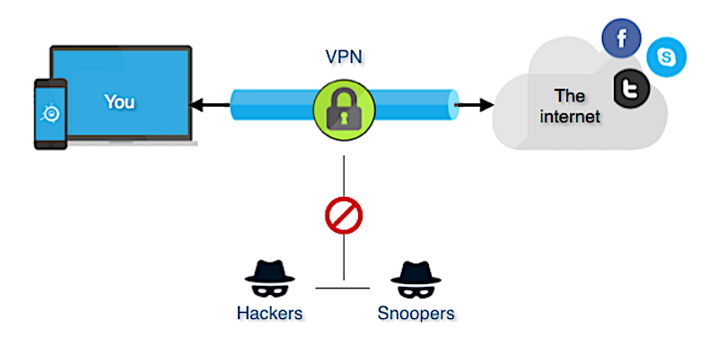

- Email and Messaging Encryption: Encryption can be applied to emails and instant messaging platforms to protect the content of communications. Technologies like Pretty Good Privacy (PGP) or Secure/Multipurpose Internet Mail Extensions (S/MIME) provide end-to-end encryption for email communication. 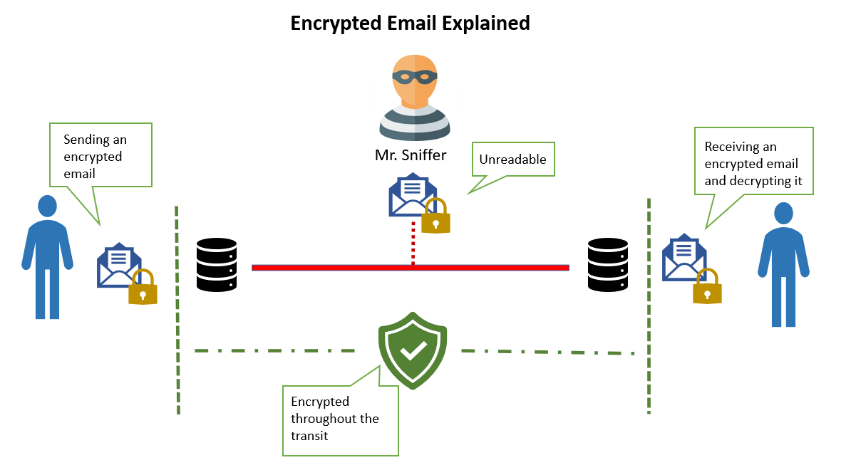
- Database Encryption: Encryption can be employed to protect sensitive data stored within databases. Database encryption can be applied at different levels, such as encrypting the entire database, specific tables, or individual columns. It protects data from unauthorized access, even if the database is compromised. 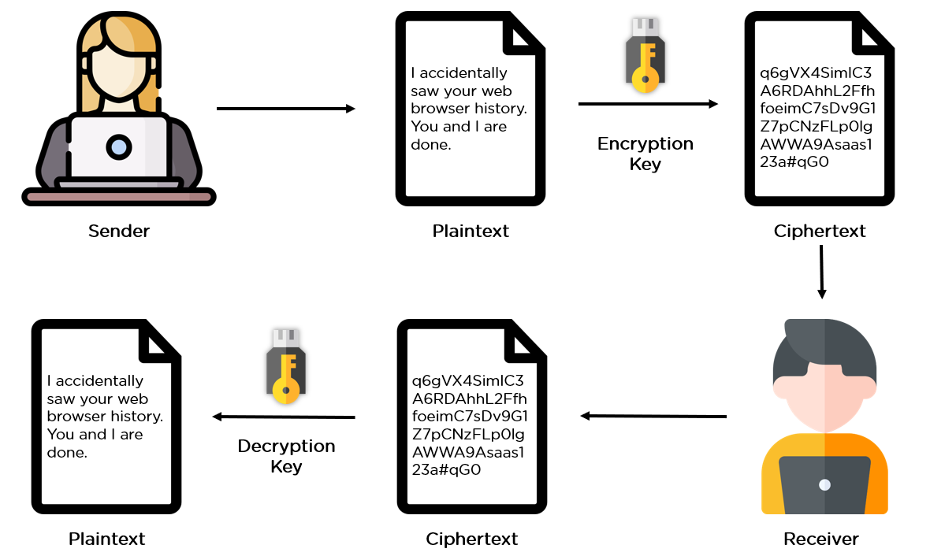
The placement of encryption depends on the specific security requirements, the nature of the data, and the overall security architecture. Employing encryption at multiple levels, such as disk, file, network, and application, helps establish a layered defense approach, providing comprehensive protection for data at rest, in transit, and in use within the operating system environment.

