Random Number Generation-
Random number generation (RNG) is a critical component of cryptography, security protocols, simulations, and various other applications where unpredictability and randomness are required. Let's explore the topic of random number generation:
- Pseudorandom Numbers: Pseudorandom number generators (PRNGs) produce a sequence of numbers that appear random but are generated using a deterministic algorithm. PRNGs rely on an initial value called a seed to start the sequence. They are typically used in situations where cryptographic-level randomness is not required, such as simulations or non-security critical applications. 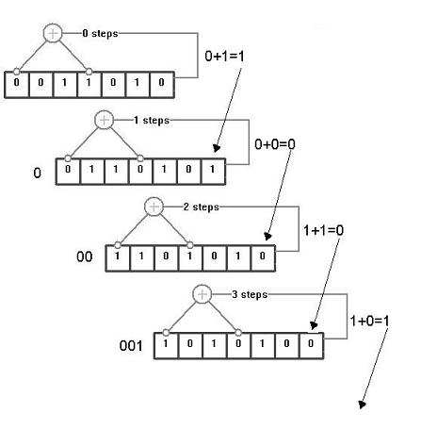
- True Random Numbers: True random number generators (TRNGs) generate random numbers based on inherently unpredictable physical processes or phenomena. They gather random data from sources like atmospheric noise, radioactive decay, or electronic noise. TRNGs provide high-quality random numbers and are suitable for cryptographic applications. 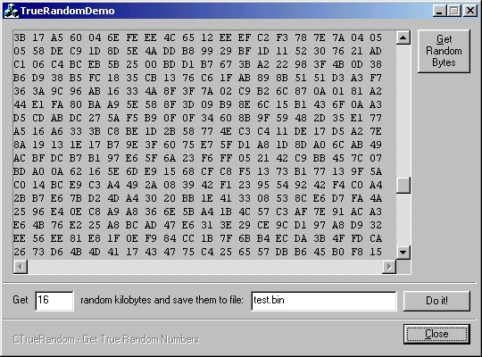
- Cryptographically Secure Random Number Generators (CSPRNGs): CSPRNGs are algorithms designed to generate random numbers suitable for cryptographic applications. They combine the properties of PRNGs with additional entropy sources and cryptographic techniques to produce highly unpredictable and statistically random sequences. CSPRNGs are required for generating encryption keys, initialization vectors, or nonces. 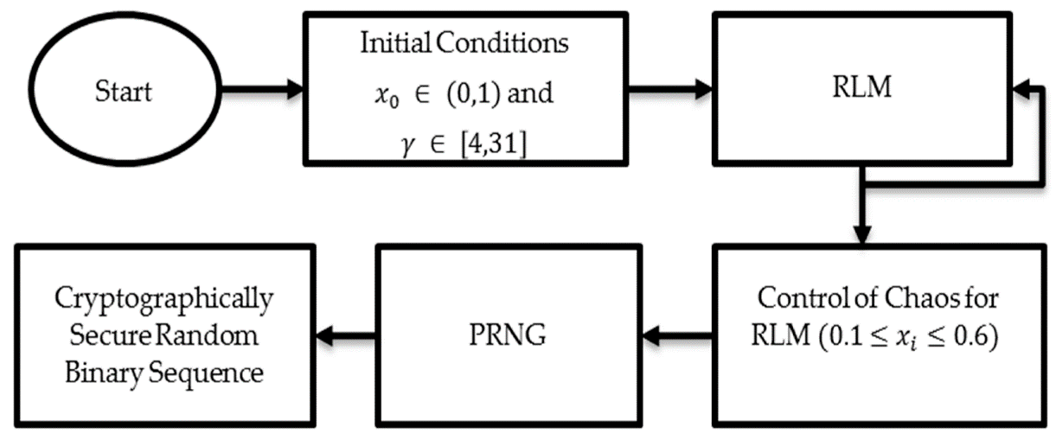
- Entropy: Entropy is a measure of the randomness or unpredictability of a source. In random number generation, entropy refers to the amount of "randomness" available to generate random numbers. Entropy sources can include hardware-based sources (e.g., mouse movements, keyboard timings) or software-based sources (e.g., system events, disk activity). Entropy is used to seed PRNGs or provide additional randomness to CSPRNGs.
- Seed Management: The seed is the initial value used to start a random number generator. In cryptographic applications, the seed must be unpredictable and kept secret. Proper seed management is crucial to ensure the security of random number generation. Seeds can be generated from high-entropy sources, such as TRNGs, or obtained from trusted external sources.
- NIST SP 800-90A: NIST Special Publication 800-90A provides guidance and recommendations for random number generation in cryptographic applications. It describes approved algorithms and security requirements for random number generators, including PRNGs and CSPRNGs.
When implementing random number generation, it is important to use well-vetted algorithms, follow best practices for entropy collection, seed management, and periodic reseeding. Additionally, regular testing, auditing, and adherence to recognized standards help ensure the quality and security of random number generation in applications requiring randomness and unpredictability.

