Substitution techniques
in operating system security refer to cryptographic methods that involve replacing elements of data, such as characters or bit patterns, with different elements based on a predefined substitution rule. While classical substitution techniques may not provide strong security on their own, they can still be used in combination with other cryptographic methods or as part of a larger security framework. Here are a few examples of substitution techniques in operating system security:
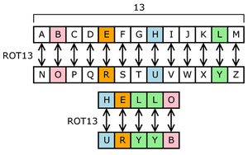

- Substitution Ciphers: Substitution ciphers replace plaintext elements (e.g., letters or bits) with different elements to create ciphertext. Classical substitution ciphers, such as the Caesar cipher, Vigenère cipher, or Playfair cipher, fall into this category. While these ciphers are relatively weak against modern cryptographic attacks, they can still provide basic confidentiality in certain scenarios or as building blocks in more complex encryption schemes.
- Substitution Boxes (S-Boxes): Substitution boxes are used in symmetric-key cryptographic algorithms, such as the Data Encryption Standard (DES) or Advanced Encryption Standard (AES). An S-box replaces input bit patterns with corresponding output bit patterns based on a predefined lookup table. The substitution process adds confusion and non-linearity to the encryption algorithm, increasing its resistance against various attacks.
- Hash Function Substitution: Cryptographic hash functions, such as SHA-256 or MD5, employ substitution techniques as part of their internal operations. Hash functions map input data to fixed-size output values (hashes) through a series of substitution and transformation steps. This ensures that even a small change in the input results in a significantly different output, providing data integrity verification and password storage capabilities.
- Substitution in Access Control: In the context of operating system security, substitution techniques can also be used for access control purposes. For example, role-based access control (RBAC) assigns users to specific roles and associates permissions with those roles. This substitution allows users to be granted access rights based on their assigned roles, simplifying the management of permissions and ensuring proper access controls.
It is important to note that while substitution techniques can provide some level of security, they should be used in conjunction with other security measures, such as strong encryption algorithms, secure key management, and secure configurations. Modern cryptographic algorithms and practices, such as symmetric and asymmetric encryption, digital signatures, and secure key exchange protocols, offer significantly stronger security and are recommended for robust operating system security.
Transposition Techniques-
Transposition techniques in operating system security involve rearranging or permuting elements of data, such as characters, bits, or blocks, without altering the actual content. These techniques are often used in conjunction with other cryptographic methods to enhance data confidentiality, integrity, and overall security. Here are a few examples of transposition techniques used in operating system security: 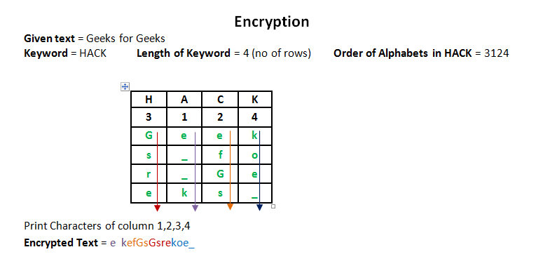
- Block Transposition: Block transposition involves rearranging blocks of data according to a specific permutation rule. This technique can be used in symmetric-key encryption algorithms, such as block ciphers. By changing the order of data blocks, block transposition provides additional confusion and diffusion, making it harder for attackers to analyze the encrypted data.
- Transposition Ciphers: Transposition ciphers do not change the individual elements (e.g., letters or bits) but rearrange them within the ciphertext. One well-known example is the Rail Fence cipher, where the plaintext is written in a zigzag pattern along a set number of rails, and the ciphertext is read off row by row. Transposition ciphers can be used in combination with substitution ciphers for enhanced security.
- Columnar Transposition: Columnar transposition involves rearranging the columns of a matrix or table based on a specific key or permutation rule. The plaintext is filled into the matrix row by row, and the ciphertext is obtained by reading the columns in a predetermined order. Columnar transposition can provide an additional layer of security when combined with other encryption techniques.
- Data Shuffling: Data shuffling techniques rearrange the order of data elements, such as characters or bits, within a given data stream. This technique can be used to obfuscate sensitive data or to randomize the order of data transmission, making it harder for attackers to extract meaningful information.
- Shuffle-Exchange Networks: Shuffle-exchange networks are used in cryptographic protocols to securely exchange or permute data between multiple parties. These networks shuffle or exchange data elements across multiple stages, ensuring secure and efficient data transmission in distributed systems.
Transposition techniques can be employed to enhance security in various areas, such as encryption algorithms, secure key exchange protocols, or data transmission protocols. It's important to note that transposition techniques alone may not provide sufficient security, and they should be used in conjunction with other security measures, such as encryption algorithms, access control mechanisms, and secure configurations.

