Transferring Keys
Transferring keys securely is crucial to maintain the confidentiality and integrity of sensitive data. When transferring keys between parties, whether it's for encryption, authentication, or secure communication, it's important to follow best practices to protect the keys from unauthorized access or interception. Here are some considerations for securely transferring keys: 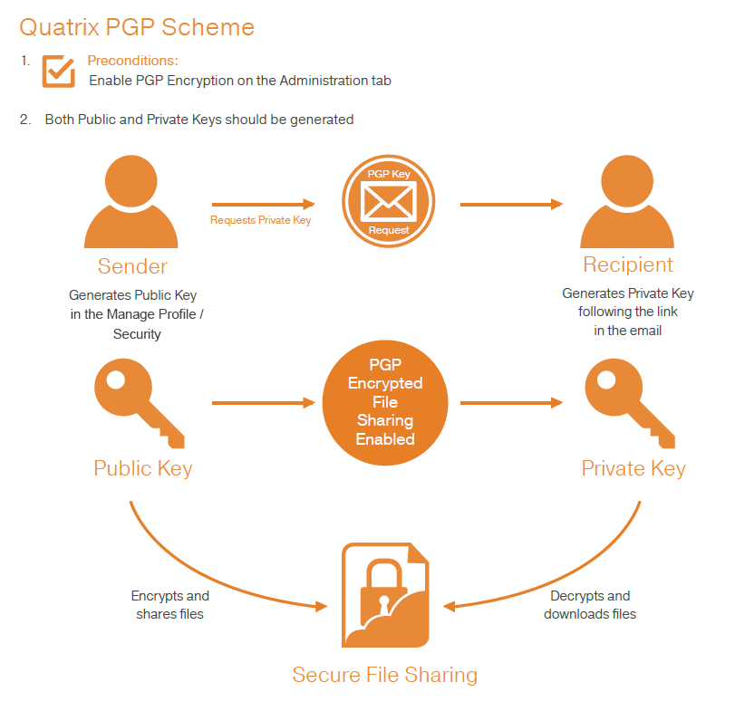
- Key Exchange Protocols: Utilize secure key exchange protocols that provide confidentiality and integrity during the transfer of keys. Examples of such protocols include Diffie-Hellman (DH), Elliptic Curve Diffie-Hellman (ECDH), or key exchange protocols based on the secure sockets layer/transport layer security (SSL/TLS) protocols.
- Asymmetric Encryption for Key Transfer: Use asymmetric encryption (public-key cryptography) to securely transfer symmetric keys or other sensitive data. The sender encrypts the key using the recipient's public key, and the recipient decrypts it using their private key. This ensures confidentiality during the transfer.
- Digital Signatures: Apply digital signatures to verify the authenticity and integrity of the transferred keys. The sender signs the key or key exchange parameters using their private key, and the recipient verifies the signature using the sender's public key. This protects against tampering and ensures that the key is from the intended sender.
- Key Wrapping: Wrap or encrypt the key using an additional layer of encryption before transfer. This adds an extra level of protection to the key, ensuring that only authorized parties with the decryption capability can access it.
- Secure Channels: Use secure communication channels for transferring keys. Examples include secure file transfer protocols (SFTP), secure email protocols (PGP/S-MIME), or secure messaging platforms. These channels employ encryption and authentication mechanisms to protect the confidentiality and integrity of the transferred keys.
- Key Splitting and Secret Sharing: Split the key into multiple shares and transfer them separately through different channels or mediums. This approach, known as secret sharing or threshold cryptography, ensures that no single party has access to the complete key during transfer, adding an extra layer of security.
- Physical Transfer: In certain cases, physical transfer of keys may be necessary, such as through secure courier services or in-person key exchanges. These methods provide a high level of assurance against unauthorized access, interception, or tampering.
- Key Management Practices: Implement secure key management practices, including key lifecycle management, proper documentation, and access controls. This ensures that only authorized individuals or systems have access to the keys during transfer and storage.
- Key Validation: After the key transfer, validate the key's correctness and integrity to ensure it was transferred without errors or modifications. Use appropriate cryptographic techniques to verify the key's integrity, such as hashing or digital signatures.
By following these practices, keys can be securely transferred between parties, maintaining the confidentiality, integrity, and authenticity of the sensitive data being protected. It's important to choose appropriate protocols, encryption methods, and secure communication channels based on the specific security requirements and the sensitivity of the data being transferred.
Verifying Keys

Verifying keys is an important step in ensuring the integrity and authenticity of the keys being used in cryptographic systems. Key verification helps detect any tampering, corruption, or unauthorized modifications to the keys. Here are some common techniques and considerations for verifying keys:
- Hash Verification: Calculate the cryptographic hash of the received key and compare it to a known and trusted hash value. If the calculated hash matches the trusted value, it indicates that the key has not been tampered with during transit. Popular hash algorithms like SHA-256 or SHA-3 can be used for this purpose.
- Digital Signatures: Keys can be signed using digital signatures to ensure their authenticity and integrity. The sender signs the key using their private key, and the recipient verifies the signature using the sender's public key. If the signature is valid, it confirms that the key was not modified during transmission and is from the intended sender.
- Certificate Authorities (CAs): For public key infrastructure (PKI) systems, keys can be verified through trusted certificate authorities. CAs issue digital certificates that bind public keys to the identity of the key owner. By validating the digital certificate and its chain of trust, the authenticity of the key can be verified.
- Key Fingerprints: Key fingerprints are compact representations of keys that can be used for verification. The sender provides the fingerprint of the key through a separate trusted channel, and the recipient compares it with the received key. If the fingerprints match, it ensures the integrity of the key.
- Key Verification Protocols: Secure key verification protocols, such as the ZRTP (Zimmermann Real-Time Transport Protocol), are designed specifically for verifying cryptographic keys during real-time communication sessions. These protocols incorporate mechanisms to detect tampering or man-in-the-middle attacks and provide assurance in key authenticity.
- Cross-Verification: In scenarios where multiple parties are involved, keys can be cross-verified by comparing them with keys obtained from different trusted sources. This helps ensure consistency and prevent unauthorized modifications.
- Visual Verification: For physical key transfers, visual verification can be employed by comparing key fingerprints or checksums printed on paper or other physical media. This method allows for direct comparison and verification of the keys.
- Key Trust and Chain of Trust: Consider the trustworthiness of the source providing the key. If the key is obtained from a trusted source or through a secure channel, it increases the confidence in the key's integrity. Establishing a chain of trust, where each party verifies and signs the keys of subsequent parties, can also enhance key verification.
It's important to note that key verification should be performed using trusted and secure mechanisms. Verifying keys helps ensure that the keys are genuine, unmodified, and from the expected sources, thereby strengthening the overall security and trustworthiness of the cryptographic system.

