common crypto standards and applications-
There are several common cryptographic standards and applications widely used in various domains to ensure secure communication, data protection, and authentication. Here are some of the most prevalent ones:
Cryptographic Standards:
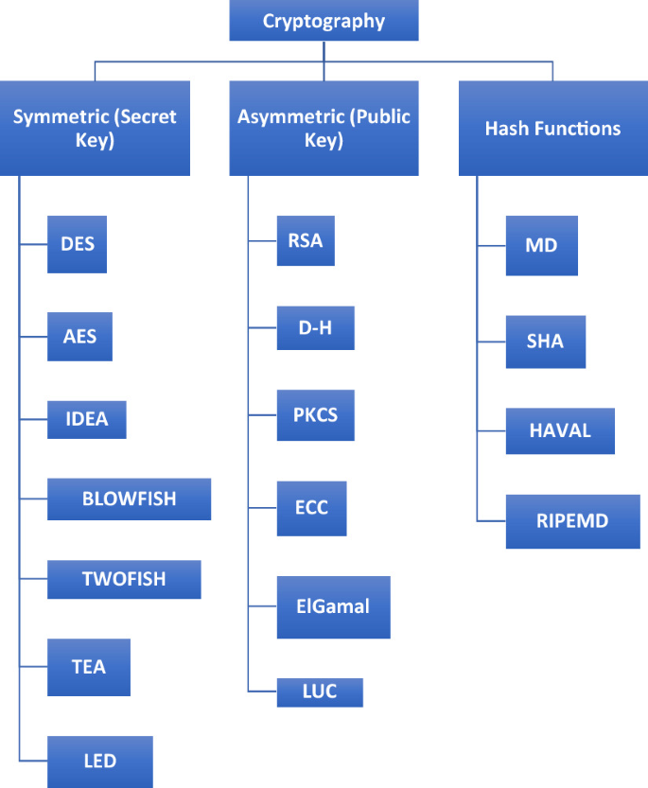
- Advanced Encryption Standard (AES): AES is a widely adopted symmetric encryption algorithm. It offers strong security and efficiency and is used for a variety of applications, including data encryption, disk encryption, and network communication encryption.
- RSA: RSA is an asymmetric encryption algorithm used for key exchange, digital signatures, and public-key encryption. It is widely employed in secure protocols, such as SSL/TLS, SSH, and secure email (PGP/S-MIME).
- Elliptic Curve Cryptography (ECC): ECC is an asymmetric encryption algorithm that provides strong security with relatively smaller key sizes compared to RSA. It is suitable for resource-constrained environments and is commonly used in secure communication, digital signatures, and key exchange protocols.
- Secure Hash Algorithm (SHA): The SHA family of cryptographic hash functions (such as SHA-256) provides data integrity verification, digital signatures, and password storage. They are widely used in secure protocols, digital certificates, and password-based authentication.
Cryptographic Applications:
- Secure Sockets Layer (SSL) and Transport Layer Security (TLS): SSL and its successor TLS are cryptographic protocols used to secure network communication, particularly web traffic. They provide encryption, authentication, and data integrity for secure web browsing (HTTPS).
- Pretty Good Privacy (PGP) and Secure/Multipurpose Internet Mail Extensions (S/MIME): PGP and S/MIME are encryption and signing standards used for securing email communication. They ensure confidentiality, authentication, and data integrity of email messages.
- Virtual Private Network (VPN): VPN technologies create secure and encrypted tunnels over public networks. They protect the confidentiality and integrity of data transmitted between remote systems, ensuring secure remote access, site-to-site communication, and anonymity.
- OpenPGP: OpenPGP is an open standard that combines encryption, digital signatures, and key management. It is widely used in email encryption, file encryption, and secure messaging.
- Public Key Infrastructure (PKI): PKI is a set of technologies, policies, and procedures for managing digital certificates and public-key encryption. PKI enables secure communication, digital signatures, and authentication in various applications, including secure email, SSL/TLS, and document signing.
These cryptographic standards and applications are widely recognized and implemented in different industries and domains, ensuring the security and privacy of sensitive data, secure communication, and trustworthy digital transactions.

