PETROLEUM PRODUCTS
Forensic chemistry in its world sense is the application of techniques and principles of science for the purpose of administration of criminal justice system chemistry is an integral part of forensic science forensic scientist must understand the principles concepts and techniques of chemistry to perform their duties in an effective manner. It involves complex procedures of chemical analysis that are used to identify elements and compounds. Identification procedures are highly reliable and are frequently based on the physical and chemical properties of the substance supported by the data obtained from analytical analysis. There are various analytical methods which may be used to find out the chemical changes that occurred during any incident, and in this way, it helps in the reconstruction of crime scene. Forensic chemistry meets the need of both the scientific and the legal communities by innovations in its research, practice, and presentation.
Scope of forensic science and Role of forensic scientist:
Forensic chemistry gives voice to the silent witness of physical evidence. It plays a critical role in the administration of justice, not only aids in the investigation and prosecution of crimes but also assist in meeting up the ends of justice.
The ability of the forensic professional is to establish a link between accused and crime by matching a physical evidence collected from the scene of crime and those with obtained from the victim or accused strengthen the case of prosecution communication forensic chemistry performs a different analysis to identify materials in order to determine the nature and composition of such evidences highly trained forensic chemist is capable of determining the composition and nature of materials and predicting the source as well as matching evidences collected from the crime scene with the controlled samples
Whenever the physical evidences are found at the crime scene those evidences are collected dropper packed and sealed in special container to order to mainly lives integrity and to prevent contamination a chain of custody should be maintained for each evidence which is sent to forensic laboratory for examination. Forensic chemist has a crucial role in forensic science laboratory and whenever it is required, they are often called onto the code to provide testimony as an expert witness.
Definition and importance of Petroleum products:
Petroleum is known to be a fossil fuel or crude oil. Incomplete decay of plants and animals buried inside thick rock layer over 600 million years and it is believed that petroleum is made up of remains of these organisms but the microscopic plankton organism remains in the petroleum and causes high organic carbon content of fine-grained sediments like the Chattanooga shale. Producers of petroleum are Saudi Arabia, Russia, United States, Iran, China, Mexico, Canada, the United Arab Emirates, Iraq, Kuwait, Venezuela, Nigeria, Norway, and Brazil. The largest known reserves are in the Middle East and Venezuela.
Physical and Chemical properties of different petroleum products:
Gasoline: Density, specific gravity and API gravity are the physical properties of petroleum products. According to the American Petroleum Institute, density, specific gravity and API gravity at 15°C. API gravity is an arbitrary scale and is related to specific gravity by the formulae,

API Gravity (Degrees) = $\frac{141.5}{Sp.Gr@15.6 C}-131.5$ = 0.68

The density at 15°C of a typical standard Petrol (Motor Gasoline) is 710-770 (Kg/m³). As per IS 2796/2000 a wide range is given for density (710 – 770 Kg/M³), which shows that petrol can be adulterated by significant amount of kerosene, naphtha and other middle boiling solvents in petrol. If petrol is adulterated with Naphtha, the density will not vary much and lies well within the limit. In case of simulation also, it is difficult to opine based on density. The same holds good for distillation criteria.
Kerosene:
Kerosene normally boils in the range of 150°C – 250°C (max: 300°C) and consists of C₁₁ – C₁₈ hydrocarbons.
Kerosene is a blend of Paraffins, Naphthene’s and Aromatics wherein Paraffins and Naphthene’s as major components and aromatics as minor components. Density at 15⁰ C of a Public Distribution Supplied kerosene is 0.78 – 0.82. The most important characteristics governed by IS 1459/1974 (reaffirmed 1996) are distillation, color, flash point, smoke point and burning quality.
API Gravity (Degrees) = $\frac{141.5}{Sp.Gr@15.6 C}-131.5$ = 0.78
Diesel:

Fractional distillation of petroleum products:
Fractional distillation is a process of refining of road oil into different forms of useful hydrocarbons which include short chain hydrocarbons and long chain hydrocarbons. Hydrocarbons with few carbon atoms are called short chain hydrocarbons were as hydrocarbons with a greater number of carbon atoms are called long chain hydrocarbons. Different sized hydrocarbons are having different boiling points fractional distillation separates hydrocarbons using their boiling points.
Fractional distillation of petroleum products involves three steps
- Evaporation
- Condensation
- Collection
Evaporation: crude oil is heated until it evaporates. Crude oil vapor is put into a fractionating column at the bottom and rises up.
Condensation: Temperature is highest at the bottom of the column. Long chain hydrocarbons are having high boiling points therefore they condense at the bottom and are collected as liquid. Short chain hydrocarbons are having lower boiling points and they pass up the column and condense at lower temperatures nearer the top.
Collection: The fractions are collected at different temperatures. They are then processed into different kinds of petroleum products such as petrol, diesel, kerosene, lubricants, aviation fuels, residues, etc,.
Petrol – It is having boiling point of 35 – 70⁰ C
Kerosene – It is having boiling point of 150 – 300⁰ C
Diesel – It is having boiling point of 165-357⁰ C
Analysis of petroleum products by using Thin Layer Chromatography:
Principle of TLC:
The separation of the components will be done on two mechanisms. Components will be separated based on the molecular charge and the affinity towards stationary phase. Molecular charge action – the heavier molecules travel slower through the column were as the lighter molecules travel faster through the column. Affinity towards stationary phase action – If the stationary phase is polar, then the molecules with nonpolar nature will travel slow as they attracted towards stationary phase and if the stationary phase is nonpolar, then the polar molecules will travel slow as they attracted towards stationary phase.
- The stationary phase used in the TLC is usually an inert material, such as Al₂O₃(Aluminum Oxides), MgO (Magnesium Oxides) or SiO₂(Silica Oxides)
- TLC is often named as Drop, Strip or spread layer surface chromatography
- TLC is used over all the other chromatographic techniques because of its wide selection range of mobile phase and requirement of simple equipments.
- TLC can able to separate all kinds of samples such as solid, liquid and semi solid samples.
- It is extremely sensitive over paper chromatography as 10 – 100 times more.
TLC system components consist of the following:
- TLC plates: It is made by mixing the Silica gel (60G) and distilled water in the ration of 2:1 and by coating it on to the microscopic glass slide as a thin film followed by allowing it to air dry. These are stable and chemically inert plates, where a thin layer of stationary phase is applied on its whole surface layer. The stationary phase on the plates is of uniform thickness and is in fine particle size.
- TLC chamber: This is used for the development of the TLC plate. The chamber maintains a stable environment inside for the proper development of spots. It also prevents the evaporation of solvents and keeps the process dust-free.
- Mobile phase: This comprises a solvent or solvent mixture. The mobile phase used should be particulate-free and of the highest purity for the proper development of TLC spots. The solvents recommended are chemically inert with the sample, a stationary phase. The solvents that are used for the separation of the petroleum products are Hexane: O-Toluene: Acetic acid (50:50:2)

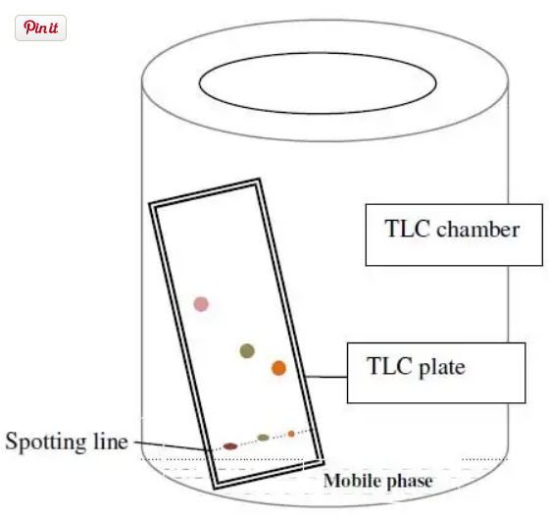
Procedure:
- Silica gel slurry is prepared by mixing silica gel (60G) and water in the ration of 2:1 ration
- The slurry is coated as a thin film on the microscopic glass slides and allowed it to air dry (These Process can be replaced by commercially used silica plates)
- Standard sample and test samples were spotted on the prepared TLC plates with the help of capillary tubes or micro pipettes
- The plates were developed in Hexane: Toluene: Acetic Acid [50: 50: 2] as solvent systems after the chambers are well saturated
- The plates were run up to solvent end. Remove the plate from the chamber and dry it.
- Spray the plate with dilute Sulphuric acid.
- Retardation factor (Rf values) were calculated by using
$$Rf=\frac{Distance travelled by the solute}{Distance travelled by the solvent}$$
Observation:
- Orange dye (Phenyl azo-2-naphthol) from Petrol (Standard) sample shows pink or Yellow to orange-colored spots. The standard Rf value for the petrol sample is 0.49 to 0.51.
- Blue dye (Di-alkyl amino anthraquinone) from kerosene sample shows blue colored spot, ranges around the Rf value of 0.40.

Analysis of petroleum products by using Gas chromatography:

Principle of Gas Chromatography:
Gas chromatography is a gas-liquid chromatography which works on a principle of particle separation. The separation of particles takes place in between gaseous mobile phase and liquid stationary phase that’s the reason it is also known as gas liquid chromatography.
Components and working procedure of GC:
Gas chromatography contains 3 main parts, first one injection port, where the introduction of sample will take place, the second column, where the actual separation of the sample takes place and the third one is detector, where the different components come out of the detector at different intervals and will be recorded by the recorder.
Gas chromatography chamber is an oven with controlled temperatures (usually 50⁰ C) with a fixed column of length 15mts to 30 mts and diameter of 0.25cm which is equal to the diameter of hair. The sample is injected into an injection port with the help of micro syringe. The sample reacts with the carrier gas and travels throughout the column reaches the detector. Here the carrier the carrier gases are inert gases such as helium, Krypton, argon will be used because they will not react with the sample molecule hence the separation will be fine. Inside the column it is packed with a finely divided solid particles into which a viscous liquid is quoted so the molecules which are coated in the column acts as a stationary phase whereas the carrier gas acts as a mobile phase. The sample can be in a liquid form or solid form or in a gaseous form, if the liquid is in a solid or gaseous form when it is injected into an injection port the temperature of gaseous chamber converts that liquid or solid sample into a gaseous phase and allows it to react with the carrier gas throughout the column. The sample which reaches first to the detector will be detected first and the sample which reaches the detector later will be detected in a sequence. The separation of the molecules in a sample will be done based on the affinity towards a stationary phase. The components which are having a lesser tendency to absorb to the stationary phase, they reach the detector first and the components which are having more affinity towards a stationary phase that compounds will hit the detector later and converts into electrical signals which will be recorded in the recorder. The graphs which are obtained from the recorder is now known as chromatogram and these chromatograms are compared with the known or reference chromatograms.
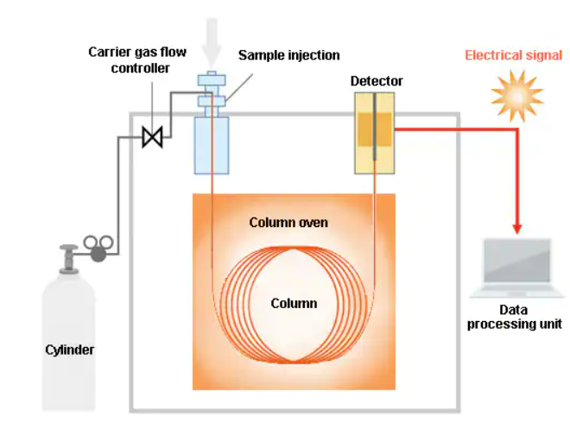
Observations:
- Adulteration of petrol and alcohols can be detected by using gas chromatography
- Forensic scientists use gas chromatography for the detection of accelerants from the samples like burnt clothes or bunch of burnt hair especially in the cases like arson or bright burning cases.
- Whether the sample might be liquid or solid but the samples which are having a lesser boiling point can be tested in gas chromatography.
- The liquid samples such as petrol, kerosene, diesel, alcohol, paints, vanishes, etc, can be tested under gas chromatography.
- Solid samples such as paint chips powders drugs also be tested under gas chromatography.
Analysis of petroleum products by using High Performance Liquid chromatography:
Principle:
High performance/pressure Liquid chromatography which works on a principle of particle separation under a pressure pump. The separation of particles takes place in between liquid mobile phase and stationary phase. The mobile phases will be pushed with a greater pressure with the help of pump into the column where the actual separation takes place.
Components and working procedure of HPLC:
HPLC contains 4 main parts, first one Solvent pump, where the solvent is pumped into the column along with the test sample. Secondly, injection port, where the introduction of sample will take place, thirdly column, where the actual separation of the sample takes place and the lastly is detector, where the different components come out of the detector at different intervals and will be recorded by the recorder.
The test sample will be injected into the sample port, Mobile phase reservoir is connected to the solvent delivery pump from where the mobile phase pumped into the column along with the test sample. In the column the test sample will the separated by reacting with the stationary phase and reaches to the detector. The detector is now connected to the recorder. All the amount of each component that hits the detector will be converted into an electrical signal and it will be recorded in the recorder. The major advantage with the HPLC is that the entire separation process will be takes place at room temperature. Therefore, the samples which are not suitable for GC will be separated in HPLC
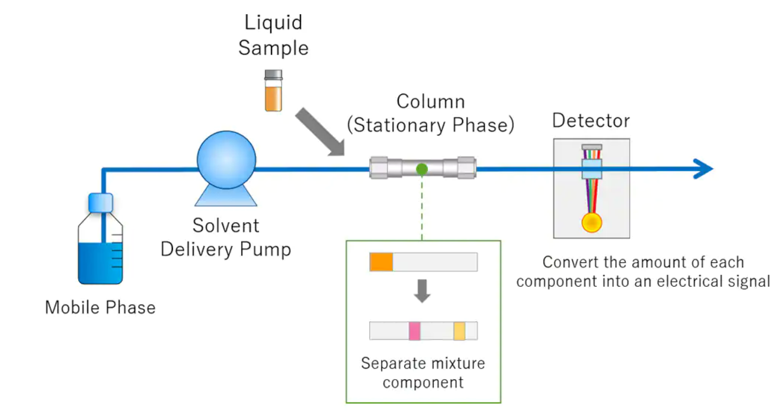
Observations:
- The components sensitive to high temperature may not survive under gas chromatography as it not carries out at high temperatures. In such situations HPLC is used as an alternative method for the analysis of sensitive components for the separation method.
- Organic explosives are generally heat sensitive and therefore more readily separated by HPLC
- Likewise, heat sensitive drugs such as LSD let themselves to analyze by HPLC

