Adult Hb
Hemoglobin comprises four subunits, each having one polypeptide chain and one heme group. All hemoglobins carry the same prosthetic heme group iron associated with a polypeptide chain of 141 (alpha) and 146 (beta) amino acid residues.
The polypeptide chains of adult hemoglobin themselves are of two kinds, known as alpha and beta chains, similar in length but differing in amino acid sequence. The alpha chain of all human hemoglobins, embryonic and adult, is the same. The non-alpha chains include the beta chain of normal adult hemoglobin (α₂β₂), the gamma chain of fetal hemoglobin (α₂^{β}₂), and the delta chain of HbA_{2.} Oxygen binds reversibly to the ferrous iron atom in each heme group.
In most vertebrates, Hb is a tetramer, consisting of two α-subunits (α₁ and α₂) and two β-subunits (β₁ and β₂) that are structurally similar and about the same size. Hydrogen bonds stabilize the helical sections inside this protein The α-subunits and β-subunits are formed of 7 and 8 helices. Each subunit has a binding pocket for heme, the heme group comprises an iron atom at the centre with a complex of 4 nitrogen atoms.
In humans, hemoglobin A (the main form of hemoglobin present in adults) is coded for by the genes, HBA1, HBA2, and HBB.^{[28]} The hemoglobin subunit alpha 1 and alpha 2 are coded by the genes HBA1 and HBA2, respectively, which are both on chromosome 16 and are close to each other. The hemoglobin subunit beta is coded by HBB gene which is on chromosome 11
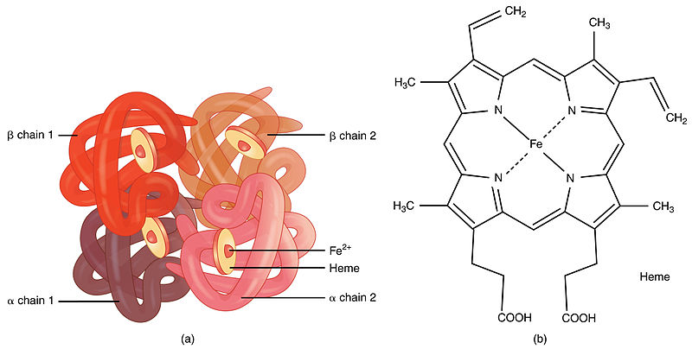

HbF
Hemoglobin F, like adult hemoglobin (hemoglobin A and hemoglobin A2), has four subunits or chains. Each subunit contains a heme group with an iron element which is key in allowing the binding and unbinding of oxygen. It is composed of two α (alpha) subunits and two γ (gamma) subunits. The production of hemoglobin F starts from week 6, but it's only from 3 months onwards that it becomes the main type found in fetal red blood cells.^{[4]} The switch to produce adult forms of hemoglobin (essentially hemoglobin A) starts at around 40 weeks of gestation, which is close to the expected time of birth.^{[1]} At birth, hemoglobin F accounts for 50-95% of the infant's hemoglobin and at around 6 months after birth, hemoglobin A becomes the predominant type. By the time the baby is one year old, the proportions of different types of hemoglobin are expected to approximate the adult levels, with hemoglobin F reduced to very low levels. These gamma subunits give fetal hemoglobin its increased affinity for oxygen.

