Principle and practices of water management

Course No. – AGRO 0504
CREDIT- 2 (2+1)
STUDY MATERIAL

CENTURION UNIVERSITY OF TECHNOLOGY & MANAGEMENT
Paralakhemundi, Odisha-761211,
INDIA

Lecture plan
Sl. No. | Lecture number | Topic to be cover | Page No.
1 | 1 | Irrigation: definition and objectives
2 | 2 | Water resources, irrigation projects in India, A.P and Odisha
3 | 3 | Soil plant water relationship
4 | 4 | Methods of soil moisture estimation
5 | 5 | Duty of water
6 | 6 | Conjunctive use of water
7 | 7 | Scheduling of irrigation
8 | 8 | Methods of irrigation- surface and sub-surface
9 | 9 | Sprinkler and drip irrigation
10 | 10 | Irrigation efficiency and water use efficiency
11 | 11 | Irrigation water quality criteria and its management
12 | 12 | Water logging
13 | 13 | Agricultural drainage

Theory
Irrigation: Definition and objectives; water resources, irrigation projects (major, medium and minor) in India and A.P. and Odisha; Soil Plant Water relationships; Methods of soil moisture estimation; Evapotranspiration and Crop water requirement; Duty of water; Conjunctive use of water; Scheduling of irrigation; Methods of irrigation-surface, subsurface, sprinkler and drip irrigation; Irrigation efficiency and Water use efficiency; Irrigation water quality criteria and its management; Water logging; Agricultural drainage.
Practical
Measurement of bulk density, study of soil moisture measuring devices, determination of field capacity and permanent wilting point, measurement of infiltration rate, irrigation water, scheduling of irrigation by IW/CPE ratio method, calculation on soil moisture, irrigation water needs, duty of water and irrigation efficiencies, layout of surface methods of irrigation, demonstration of drip and sprinkler irrigation, visit to micro irrigation systems in farmer’s fields, water management practices in different crops.

IRRIGATION – INTRODUCTION, IMPORTANCE, DEFINITION & OBJECTIVES

1.1 Introduction
Sustainable development and efficient management of water is an increasingly complex challenge in India. Increasing population, growing urbanization, and rapid industrialization combined with the need for raising agricultural production generates competing claims for water. There is a growing perception of a sense of an impending water crisis in the country. Some manifestations of this crisis are:

a) There is hardly any city which receives a 24-hour supply of drinking water. Besides in many rural habitations there are pockets where arsenic, nitrate, and fluoride concentration in drinking water are posing a serious health hazard.

b) Increasing costs of developing new water resource – Many major and medium irrigation projects seem to remain under execution forever as they slip from one plan to the other with escalating cost and time overruns.

c) Siltation of reservoirs and owing to lack of maintenance, the capacity of the older irrigation systems seems to be going down.

d) Declining groundwater table due to over-exploitation imposing an increasing financial burden on farmers who need to deepen their wells and replace their pump sets and on State Governments whose subsidy burden for electricity supplies rises.

e) Water pollution and degradation of water-related ecosystems - Water in most parts of rivers is not fit for bathing, let alone drinking. Untreated or partially treated sewage from towns and cities is being dumped into the rivers. Untreated or inadequately treated industrial effluents pollute water bodies and also contaminate groundwater,

f) Wasteful use of already developed water supplies, often encouraged by the subsidies and distorted incentives that influence water use.
g) Rise in water-logging and salinity resulting in degradation of soils in irrigated areas.

h) Increasing water conflicts about water rights between upper and lower riparian states in a river, conflicts about quality of water, people’s right for rainwater harvesting in a watershed against downstream users, industrial use of groundwater and its impact on water tables and conflicts between urban and rural users etc.

i) The gross irrigated area does not seem to be rising in a manner that it should be, given the investment in irrigation. The difference between potential created and area actually irrigated remains large. Unless we bridge the gap, significant increase in agricultural production will be difficult to realize.

j) Floods are a recurring problem in many parts of the country. Degradation of catchment areas and loss of flood plains to urban development and agriculture have accentuated the intensity of floods. India with 2.4% of the world’s total area has 17.7% of the world’s population; but has only 4% of the total available fresh water. This clearly indicates the need for water resource development, conservation, and optimum use.

1.2 Importance of irrigation water management

The importance of irrigation in the world is well stated by N.D. Gulhati of India:
“Irrigation in many countries including India is an age-old art – as old as civilization – but for the whole world it is a modern science – science of survival”.
The pressure of survival and the need for additional food supplies are necessitating a rapid expansion of irrigation throughout the world including India. Production and productivity of agricultural lands is primarily dependent upon the availability of irrigation water to crops. Expansion of irrigation has paid rich dividends in India. After independence, production registered nearly 5.75 times increase from around 50.8 million tons in 1950-51 to about 292 million tons in 2019-20. This has been mainly attributed to three factors viz., high yielding cereals, expansion of area under irrigation and fertilizer use. Irrigation may be considered as the major factor of modern intensive agriculture as it aids in efficient use of costly fertilizers and other inputs besides meeting crop water needs.
On the other hand, improper irrigation causes wastage of large amounts of water, leaches mineral nutrients from the root zone into the deeper layers contaminating groundwater, and impairs the productivity of soil, or yield losses may occur if insufficient water applied. Excessive application of water causes waterlogging and increase high water tables or seepage spots to develop which may be corrected only by the construction of expensive drainage systems. In addition, salts accumulate and an alkali soil may develop.
Water for irrigation and other uses is becoming more and more valuable due to increasing cost of irrigation projects and a limited supply of good quality water. Therefore, we must learn how to make optimal use of water to prevent an excessive wastage to preclude the degradation of the land and bring about its improvement for maximizing water productivity.

1.3 Irrigation – Definition
It is generally defined as “application of water to soil for the purpose of supplying
the moisture essential for normal plant growth and development”. In other words it is the human manipulation of hydrological cycle to improve crop production and quality and to decrease the economic effects of drought. However, a broader and more meaningful definition is that irrigation is the application of water to the soil for the following purposes:
¨ To add water to the soil for supplying moisture essential for normal plant growth
and development
¨ To provide crop insurance against short duration droughts
¨ To leach or dilute excessive salts in the crop root zone, thereby providing a
favourable environment in the soil profile for absorption of water and nutrients
¨ To soften tillage pans
¨ To cool the soil and atmosphere, thereby making more favourable
micro-environment for plant growth

1.4 Objectives of irrigation
The broad objectives of irrigation are as follows:
a) To increase crop production on sustainable basis where water is a limitation
• To increase national income/national cash-flow
• To increase labour employment
• To increase standard of living

b) Modification of soil & climatic environment
• For leaching of salts
• For reclamation of sodic soils
• For frost protection

c) To mitigate i.e., lessen the risk of catastrophes caused by drought
• To overcome food shortages
• To protect high value crops/trees

d) To increase population of arid and sparsely populated areas
• For national defence
• For population re-distribution
e) National security i.e., self sufficiency in food grain production
WATER RESOURCES AND IRRIGATION PROJECTS IN INDIA, ANDHRA PRADESH AND ODISHA
Water Resource in India:
India, with a population of over a billion is the world’s largest democracy, historically, civilization in India as around the world have largely evolved and developed around water bodies as most human activities, including agriculture and industry depend on water. The water situation in India seems to be going from bad to worse. Not only is there a growing scarcity of water in the country, the agriculturally important states like Punjab, Haryana, Tamilnadu and Rajasthan are facing a steady fall in their ground water levels. While the per capita availability of utilizable water in India in 1951 was 3,450 cubic meters; in 1999 it came down to 1250 cubic meters. According to the Ministry of Water Resource, per capita availability of utilizable water in India is expected to decrease to 662 cubic meters in 2050.

Although India occupies only 3.29 million km² geographical areas, which forms 2.4% of the world’s land area, it supports over 17.7% of the world’s population. The population of India as on 2nd May, 2021 stood at 139.1 crore. Thus, India supports about 1/6th of world population, 1/50th of world’s land and 1/25th of world’s water resources. India also has a livestock population of 500 million, which is about 20% of the world’s total livestock population. More than half of these are cattle, forming the backbone of Indian agriculture. The total utilizable water resources of the country are assessed as 1122 km³.

Surface water resources: In the past, several organizations and individuals have estimated water availability for the nation. Recently, the National Commission for Integrated Water Resources Development estimated the basin-wise average annual flow in Indian River systems as 1953 km³. Utilizable water resource is the quantum of withdraw able water from its place of natural occurrence. Within the limitations of physiographic conditions and socio-political environment, legal and constitutional constraints and the technology of development available at present, utilizable quantity of water from the surface flow has been assessed by various authorities differently. The utilizable annual surface water of the country is 690 km³. There is considerable scope for increasing the utilization of water in the Ganga–Brahmaputra basins by construction of storages at suitable locations in neighboring countries.

Groundwater resources: The annual potential natural groundwater recharge from rainfall in India is about 342.43 km³, which is 8.56% of total annual rainfall of the country. The annual potential groundwater recharge augmentation from canal irrigation system is about 89.46 km³. Thus, total replenishable groundwater resource of the country is assessed as 431.89 km³. After allotting 15% of this quantity for drinking, and 6 km³ for industrial purposes, the remaining can be utilized for irrigation purposes. Thus, the available groundwater resource for irrigation is 361 km³, of which utilizable quantity (90%) is 325 km³. This estimates by the Central Groundwater Board (CGWB) of total replenishable groundwater resource, provision for domestic, industrial and irrigation uses and utilizable groundwater resources for future use. The basin wise per capita water availability varies between 13393 m³ per annum for the Brahmaputra–Barak basin to about 300 m³ per annum for the Sabarmati basin.

Water Resources in Andhra Pradesh:
Surface water resources
The state is endowed with a variety of natural resources for irrigation and is popularly known as the “River State”. The mean annual rainfall of the state is 940 mm. Major portion (66.4%) of the rainfall is contributed by South-west monsoon from June to September followed by North-east monsoon (23.8%) from October to December. The rest 9.8% of the rainfall is received during the winter & summer months of January to May. Further, it has the advantage of having most of the East flowing rivers in the heart of the state bringing copious supplies from the Western and Eastern Ghats and Deccan Plateau up to Bay of Bengal. Of these, the most important major river systems are The Godavari, The Krishna and The Pennar besides 9 inter-state rivers and 28 intra state rivers total to about 40 river basins. The three major river systems viz., The Godavari, The Krishna and The Pennar together drain about 70% of the state’s land area (the Godavari basin accounting for 26%, the Krishna basin for 27% and the Pennar basin for 17%). The Godavari and Krishna river systems have major part of their catchment in other states (Maharashtra, Karnataka, Madhya Pradesh and Odisha), whereas; a small part of the catchment of Pennar river system is in Karnataka State. Since these are inter-state rivers, the availability of water to Andhra Pradesh State is dependent on established riparian rights. It is assessed that two major river systems flowing through the state viz., the Godavari and the Krishna contribute about 84% of the utilizable surface water of the state. Besides these, 9 other minor inter-state rivers flowing through the territories of Odisha, Tamilnadu, Karnataka and Andhra Pradesh contribute another 3.5% of the total surface flows. In addition to these 12 intra-state rivers, 28 other smaller river systems, which lie entirely within the state boundary, contribute the balance 9% of the surface flows. Thus, the total surface water wealth available from all the river basins of the state is therefore in the order of 77490 million m³ (equivalent to 0.078 TCM or 7.749 million ha meters). All the rivers in the state are highly seasonal and even in the case of perennial rivers, more than 90% of the total water flows occur during the monsoon period of June to September. In view of this, construction of expensive retention dams and reservoirs has been involved for irrigation development in this state.
Groundwater Resources:
Sizeable reserves of groundwater are available in this state. The utilizable ground water reserves for irrigation in this state are assessed to be 2.71 million ha meters. Out of which the present utilization is only 0.73 million ha meters of water for irrigation purposes mostly through dug wells & filter points. This leaves a balance of 1.98 million ha meters for further exploitation, which can bring about additional 1.3 million ha land under assured irrigation supplies. The maximum groundwater potential available is in Nellore district and lowest in Ranga Reddy district. With regard to net draft of water, the Nizamabad district ranks first with 44.4% followed by Karimnagar (42.9%) and Chittoor district (41.7%).
Irrigation Development in Andhra Pradesh
In Andhra Pradesh, around 40% of the state’s geographical area is under cultivation and around half of the cultivated area is under irrigation.
During successive 5 Years Plan, the state has put in planned efforts in the area of irrigation sector. As a result of this, several irrigation schemes were initiated and implemented. The total net and gross irrigated area in the state is 4.45 million ha and 6.07 million ha, respectively. However, the major source of irrigation is through canals accounting for about 36.7% of the gross irrigated area in the state. This is followed by tube wells (32.4%), open wells (14.3%), tanks (12.7%) and other sources (3.8%). The percentage of gross area irrigated to the total gross cropped area in the state is about 47.4%. The ultimate irrigation potential in the state is assessed at 9.2 million ha. In the state during 2006-07, rice crop alone accounted for 3.85 million ha of gross irrigated area (63.3%) followed by sugarcane (0.4 million ha), groundnut (0.28 million ha), maize (0.26 million ha), cotton (0.21 million ha) and sunflower (0.14 million ha). All other crops viz., jowar, bajra, chillies, turmeric, sesame etc., account for only 14.3% of the gross irrigated area in the state.
Water Resource in Odisha:
The state receives 231 BCM of rainfall annually. The average annual precipitation of Odisha is around 1500 mm and 80 per cent this occurs during June to September. Most of the rainfall in Odisha occurs due to south-west monsoon. The state experiences about 70 rainy days during monsoon.

Ground Water
The people of Odisha depend on three sources – rivers, surface storage and ground water – for water. But over the years, the dependence on the first two has progressively dwindled. Most of rivers in Odisha, once perennial, have lost their features significantly. They flow for 6 to 10 months of a year depending on the size and health of the catchments. Experienced people do unanimously inform that the rivers and their drainage lines are no more as dependable as they used to be. River flow statistics also substantiate such perception. The state of the surface water bodies is not good. Improper management of surface storages, the quality of water also gets reduced. The dwindling number of common as well as private ponds is due to the pressure on land, degradation of wetlands and water bodies etc. have seriously eroded the dependability of surface storages. Most of the surface water bodies do not even last till the summer months. Depletion and deterioration of the first two sources has inevitably led to over-dependence on ground water for drinking, domestic and irrigation purposes. Even industries have started using groundwater.

Technological advancements has helped in increasing preference for ground water as source for virtually every need, as they are less exposed to public, save time and cost and there is an absence of legislations and policies to regulate ground water. But the perception that Odisha has abundant ground water has led to promotion of ground water and as preferred source for all uses, including industry and agriculture.
Government organizations have estimated that Odisha as annually replenishable ground water of 2.10 Million Hectare Meter (mha m) or 21 BCM. The overall annual ground water draft, as per estimations made in 2004, was 3.85 BCM. Thus, the stage of groundwater was assessed at 14.8 per cent. The development of blueprint for the state is heavily dependent on ground water both for water supply to its citizens and irrigation to the drought-prone areas of Kalahandi-Bolangir-Koraput (KBK) region. This statistics may otherwise give an impression that, groundwater development in the state being so low, the potentials of it, is grossly untapped. But the grass-root facts revealed different picture, i.e., of dwindling water levels, ground water sources going dry and ground water quality getting affected. The English proverb ‘Lies, Damned Lies and Statistics’ may very nicely apply to Odisha’s groundwater scenario.
River Basin
The state has 11 major river basins. Almost all the Rivers are interstate Rivers. Major basins like: Mahanadi, Brahmani and Subarnarekha originate in other states but a significant portion of their catchments lie in Odisha and they drain out to the Bay of Bengal. Similarly there are other basins like Indravati, Vansadhara, Nagabali and Kolab which originate in Odisha but then meet their major parent basins in other states or drain out in other states. Most of the catchments of Budhabalanga and Baitarani basin lie in Odisha.

SOIL-PLANT-WATER RELATIONSHIPS
Introduction
To design a successful irrigation system, it is essential to know the plant rooting characteristics, effective root zone depth, moisture extraction pattern and moisture sensitive periods of crops.

Rooting characteristic of plants:

The purpose of irrigation is to provide adequate soil moisture in the immediate vicinity of the plant roots. All plants do not have the similar rooting pattern i.e., root penetration and proliferation. Some plants have relatively shallow root system (for example annual crops), while others develop several meters under favourable conditions (for example tree crops). It is obvious, therefore, that if one is to plan an efficient irrigation schedule for providing adequate soil moisture to plant roots, it is necessary to understand rooting habits of plants.

Soil properties influencing root development:

a) Hard pan: Root penetration is seriously affected by presence of a hard pan or compact layer in the soil profile. Thus roots cannot penetrate a hard layer except through cracks, if any. Thus, in shallow soils, crop roots may be confined to a thin layer of soil irrespective of their normal genetic rooting pattern in a soil having uniform structure and texture.
b) Soil moisture: Since roots cannot grow in soil that is depleted in moisture down to and below the permanent wilting point, a layer of dry soil below the surface in the profile can restrict root penetration.
c) Water table: A high water table limits root growth, and a rising water table may kill roots that have previously grown below the new water level.
d) Toxic substances: Presence of toxic substances in the sub-soil also limits root growth and development. Saline layers or patches in the soil profile therefore inhibit or prevent root penetration and proliferation.

Effective root zone depth:

The soil depth from which the crop extracts most (nearly 90%) of the water needed to meet its evapo-transpiration requirements is known as effective crop root zone depth. It is also referred to as design moisture extraction depth, the soil depth used taken into account to determine the irrigation water requirements for scheduling irrigation’s to crops. For best results, it is the depth in which optimum available soil moisture must be maintained for higher productivity of crops. It is not necessarily the maximum rooting depth for any given crop, especially for plants that have a long tap root system.
Since root development for any one crop varies in different agro-climatic zones because of soil and climatic differences, the design depth should be based on local moisture-extraction data for locally adapted crops. If two or more plant species with different rooting characteristics are to be grown together, the design depth should be that of the plant having the shallower root system.

Moisture extraction pattern:

The moisture extraction pattern refers to the amount of soil moisture expressed as percentage extracted from different layers in the soil profile. In most plants, the concentration of absorbing roots is greatest in the upper part of the root zone (usually in the top 45 cm) and near the base of the plant. Hence extraction of water from the topsoil layers is usually more as compared to lower layers. Since water also evaporates from upper few inches of soil, it is lost rapidly from the upper layers. As the amount of moisture in the upper part of root zone in the vicinity of roots is diminished, soil moisture tension increases and a moisture suction gradient is created between the upper layers and the far away lower layer from where moisture has not been extracted previously. This causes water to move towards the upper layers to attain equilibrium between two zones, thus, the plants get moisture from lower parts of the root zone. In uniform soils that are fully supplied with available soil moisture, plants use water rapidly from the upper part of the root zone and slowly from the extreme lower part. The basic moisture extraction curve indicates that for all crop plants growing in a uniform soil with adequate available water supply exhibits similar moisture-extraction pattern. The usual extraction pattern, about 40% of the soil moisture extracted is contributed from upper quarter of the root zone, 30% from the second quarter, 20% from the third quarter, and 10% from the bottom quarter. Values for individual crops may vary within the range of 10%.

Moisture sensitive periods:

The optimal moisture for plant growth varies with the stage of crop growth i.e., it is low in the initial stages (establishment & early development), increases with advancement of crop life and attains peak value during reproductive stage, thereafter it decreases towards ripening and maturity phases. Thus, not all the crop growth phases are equally sensitive, certain stages are more sensitive to soil moisture/stress when compared to other stages. These are known as moisture sensitive periods or critical growth stages for moisture.
“Critical growth period is the stage or stages of growth of the crop at which moisture stress has the greatest effect on quality & quantity of yield. Therefore, any stress during these stages will irrevocably reduce the yield and provision of adequate water and other management practices at other growth stages will not compensate the yield lost”.
In general moisture stress during germination and early seedling stage may have deleterious effect on field crop emergence and plant establishment because of soil crusting and small root system resulting in low plant population per unit area. Stress during vegetative stage has little effect on subsequent production unless it is so severe as to drastically reduce leaf area index and leaf area duration. Moisture stress during flowering causes flowers drop & pollen desiccation and affects fertilization; while that during grain development leads to production of shriveled grains and low mean test weight. Critical stages for various fields, vegetable and fruit crops are here.

Most Critical growth periods of crops for water supply:

Rice: Primordial development, Heading & Flowering
Sorghum: Booting, Blooming, Milky & Dough stages
Ragi: Primordial initiation & Flowering
Maize: Tasseling, Silking & Pollination
Bajra: Heading & Flowering
Wheat: Crown root initiation, tillering, booting & flowering
Groundnut: Flowering, Peg penetration & Pod development
Sesame: Flowering to Maturity
Sunflower: Star formation, Flowering & Seed development
Safflower: Rosette, flowering and Seed development
Soybean: Flowering & Seed formation
Cotton: Flowering & Boll development
Sugarcane: Formative & Stem elongation
Tobacco: Rapid growth & Topping stage
Chillies: Flowering & Fruit development
Potato: Tuber bulking to Tuber maturity
Onion: Bulb enlargement to Ripening
Tomato: Flowering & Fruiting
Citrus: Flowering, Fruit set & Fruit enlargement
Banana: Adequate soil moisture throughout growth period & fruit development
Mango: Flowering & fruit development

METHODS OF SOIL MOISTURE ESTIMATION
Introduction:
The measurement of soil moisture is needed to determine when to irrigate and the amount of water needed when irrigating, to evaluate evapotranspiration, and to monitor soil metric potential.

Direct methods

1. Gravimetric method/Oven drying:
The gravimetric method is a direct measurement of soil water content and is therefore the standard method by which all indirect methods are calibrated. The gravimetric water content, also called mass water content, is the ratio of the weight loss in drying to the dry weight of the soil sample. The mass water content can be expressed as mass water percentage by multiplying it with 100. This method involves collecting soil sample from the field using soil probe or auger from representative depths in the root zone and then determining its moist and dry weights. The moist weight is determined by weighing the soil sample as it is at the time of sampling, and the dry weight is obtained after drying the soil sample in an oven at 105°C for 24 hours or more to get a constant dry weight. The weight loss represents the soil water.

2. Volumetric method
The volumetric water content is defined as the volume of water present in a given volume (usually 1 m³) of dry soil. When it is multiplied by 100 it gives volume water percentage. This method involves collecting soil sample from the field using core sampler of known volume from representative depths in the root zone and then determining its moist and dry weights and calculating the volume wetness.
Volumetric water content (%) = {(Wt. of wet soil – Wt. of dry soil)/Wt. of dry soil} × 100 × B.D.

Merits:
• Ease of handling
• Low cost
• Minimum technical skill required
• Standard method of soil moisture determination with which other methods are compared

Demerits:
• Time consuming
• Accuracy is subjected to weighing and sampling errors
• Destructive soil sampling method
• Laborious
3. Spirit/Alcohol burning method:
Soil moisture from the sample is evaporated by adding alcohol and igniting. Provided the sample is not too large, the result can be obtained in less than 10 minutes. About 1.0 ml of spirit or alcohol per g of soil sample at field capacity (FC) and 0.5 ml of spirit or alcohol per g of soil sample at permanent wilting point (PWP) is adequate for evaporating the soil moisture. This method is not recommended for soils with high organic matter content.

4. Infrared moisture balance
It consists of a 250 watt infrared lamp, sensitive torsion balance and autotransformer. All housed in an aluminium cabinet. The radiation emitted by infrared lamp quickly vaporizes the soil moisture. The instrument is directly calibrated in per cent moisture. It gives fairly reliable moisture estimates in about 5 minutes.

Indirect methods

1. Electrical resistance blocks
Gypsum blocks or electrical resistance blocks, with two electrodes, is placed at a desired soil depth and allowed to equilibrate (Fig. 10.2). Electrical resistance of the block is measured by a meter based on the principal of Whetstone Bridge. Electrical resistance of the soil decreases with increase in water content. Soil water content is obtained with calibration curve, for the same block, of electrical resistance against known soil water content. Resistance blocks read low resistance (400 – 600 ohms) at field capacity and high resistance (50,000 to 75,000 ohms) at wilting point.

Merits
• Relatively inexpensive
• Easy to install
• Gives quick readings
• Suitable for irrigation scheduling to crops raised in fine textured soils

Demerits
• Not useful in coarse textured soils
• Resistance blocks readings are sensitive to soil salinity, which may affect readings
• Blocks may get damaged over time (2 – 3 years) and require replacement

2. Neutron scattering technique
First developed in the 1950s, the neutron scattering method has gained widespread acceptance as an efficient and reliable technique for monitoring soil moisture in the field.
The neutron moisture meter consists of two main components (Fig. 10.3) viz., a probe containing a source of fast neutrons (americium and beryllium) and boron trifluoride (BF₃) gas as a detector of slow neutrons, which is lowered into a hollow access tube pre-inserted into the soil; and a scaler or rate meter usually battery powered and portable to monitor the flux of the slow neutrons that are scattered and attenuated in the soil. The fast neutrons (having an energy range of 2 – 4 MeV and an average speed of about 1600 km/sec) are emitted radially into the soil, where they encounter and collide elastically with hydrogen nuclei (namely protons). Through repeated collusions, the neutrons are deflected and “scattered”, and they gradually lose some of their kinetic energy. As the speed of the initially fast neutrons diminishes, it approaches a speed of 2.7 km/sec, equivalent to a energy of about 0.03 eV. Neutrons slowed down to such a speed are said to be thermalized and are called slow neutrons. The slow neutrons thus produced scatter randomly in the soil, quickly forming a cloud of constant density around the probe. The density of sow neutrons formed around the probe is nearly proportional to the concentration of hydrogen in the medium surrounding the probe, and therefore approximately proportional to the volume fraction of water present in the soil. The slowed or thermalized neutrons are detected by slow neutron detector containing BF₃ gas, which is then transmitted through electric pulses to the scaler and is displayed as moisture content.

Merits
• Less laborious
• Rapid results
• Non-destructive method after initial installation
• Repeated measurements can be made at the same location and depth
• Independent of temperature and pressure

Demerits
• High initial cost of the equipment
• Probe must be calibrated for each soil & access tube
• Difficult to measure the soil moisture in the top 15 cm soil depth due to escape of neutrons into atmosphere
• Health hazards due to exposure to neutron & gamma radiation

3. Tensiometer
The tensiometer is an instrument designed to provide a continuous indication of the soil’s metric suction (also called soil-moisture tension) in situ. The essential parts of Tensiometer are shown in Fig. 10.4. The tensiometer consists of a porous ceramic cup, connected through a tube to a vacuum gauge (or manometer), all parts filled with water. When the cup is placed in the soil where the suction measurement is to be made, the water inside the cup comes into hydraulic contact and tends to equilibrate with soil water through the pores in the ceramic walls. When initially placed in the soil, the water contained in the tensiometer is generally at atmospheric pressure (essentially, 0 bars tension). Soil water, being generally at atmospheric pressure (or higher tension), exercises a suction, which draws out a certain amount of water from the rigid and air tight tensiometer. Consequently, the pressure inside the tensiometer falls below atmospheric pressure. The sub pressure is indicated by a vacuum gauge or manometer. A Tensiometer left in the soil for a period of time tends to track the changes in the soil’s metric suction. As soil moisture is depleted by drainage or plant uptake, or as it is replenished by rainfall or irrigation, corresponding readings on the Tensiometer gauge occur.
Suction measurements by tensiometry are generally limited to matric suction values below 1 bar or 100 kPa. However in practice, under field conditions the sensitivity of most tensiometers is a maximal tension of about 0.85 bars or 85 kPa.

Merits
• Repeated measurements at the same location
• Non destructive method
• Suitable for scheduling irrigations to crops raised in coarse textured soils where majority of ASM is between 0 – 0.8 bars or 0 to 80 kPa or centibars and requiring frequent irrigations

Demerits
• Measurements limited to 0.8 bars suction only
• Maximum depth of insertion is about 5 m only
• Water in the tensiometer must be maintained always at a constant height
• Requires few hours for equilibration after initial installation

4. Pressure plate & Pressure membrane apparatus
Laboratory measurements of soil water potential are usually made with pressure membrane and pressure plate apparatus. It consists of ceramic pressure plates or membranes of high air entry values contained in airtight metallic chambers strong enough to withstand high pressure of 15 bars or more. The apparatus enables development of soil moisture characteristic curves over a wide range of matric potential
The porous plates are first saturated and then soil samples are placed on these plates. Soil samples are saturated with water and transferred to the metallic chambers. The chamber is closed with special wrenches to tighten the nuts and bolts with required torque for sealing it. Pressure is applied from a compressor and maintained at a desired level. It should be ensured that there is no leakage from the chamber. Water starts to flow out from saturated soil samples through outlet and continues to trickle till equilibrium against the applied pressure is achieved. Soil samples are taken out and oven dried to constant weight for determining moisture content on weight basis. Moisture content is determined against pressure values varying from −0.1 to −15 bars. The values of moisture content so obtained at a given applied pressure are used to construct soil moisture characteristic curves.

EVAPOTRANSPIRATION

Evapotranspiration(ET= Evaporation+Transpiration)

Evaporationisadiffusiveprocessbywhichwaterfromnaturalsurfaces,suchasfree water surface,bare soil,fromliveordead vegetationfoliage(interceptedwater,dewfall, guttationetc) is lost in the form ofvapourto the atmosphere.It is one ofthe basic componentsofhydrologiccycle.
Likewise transpirationisaprocess bywhich water islost inthe form ofvapourthrough plantsurfaces,particularlyleaves.Inthisprocess water isessentially absorbedby theplantrootsduetowaterpotentialgradientsanditmovesupwardthrough thestemand isultimately lost into the atmospherethrough numerousminute stomatain the plant leaves.Itisbasicallyanevaporationprocess.However,unlikeevaporationfrom awater orsoilsurface,plant structureand stomatalbehaviouroperatinginconjunction withthephysicalprinciplesgoverningevaporation modifytranspiration.
Thus,evapotranspirationisacombined lossofwater fromthe soil(evaporation) andplant(transpiration)surfaces totheatmosphere through vaporizationof liquidwater, andisexpressed indepth perunittime(forexamplemm/day).Quantification ofevapotranspirationisrequiredinthecontextofmanyissues:
1.Management ofwaterresourcesinagriculture
2.Designingofirrigationprojectsonsoundeconomicbasis
3.Fixingcroppingpatternsandworkingouttheirrigationrequirementsofcrops
4.Schedulingofirritations
5.Classifyingregionsclimatologicallyforagriculture

Factorsinfluencingevapotranspiration:

Water losses tothe atmosphereare primarily determinedbyboth environmental andplant factors,besides toacertain extent bymanagementfactors.Theenvironmental effectonETiscalledatmosphericdemand orevaporativedemand oftheatmosphere.The followingfactorsinfluencetheatmosphericdemand andinturntheETofacrop.

Climaticorenvironmentalfactors
The meteorological factors,which have a significant bearing on the ET, are as follows:
a) Solarradiation:Solarorthermalenergyisnecessarytoevaporatethewaterfromboth soilandplantsurfaces.Thus,ofthetotalsolarradiationinterceptedbytheleaf,only1 to5%isusedforphotosynthesisand75to85%isusedforradiatingthecanopysurface i.e., leavesandfortranspiration.Hence,increasedsolarradiationincreasesatmospheric demand andinturnevapotranspiration.
b) Ambienttemperature:increasing thetemperatureincreasesthecapacityofairtohold water i.e.,vapourpressuredeficitishigh,whichmeans agreateratmospheric demand i.e.,greaterET.
c) Relativehumidity:The greaterthe water content ofair,the higher the air water
potentialwhich means that atmosphericdemand decreasesresulting inlowETwith increasing relativehumidity.

d) Wind: Transpirationoccurs whenwater diffuses through the stomata.Adiffusion gradientbarrierbuilds uparoundstomata(i.e.,leaf)when theairisstill.Thismeans that water diffusing from the wet leafinteriorsisalmost matched bywater buildup outside theleaf,whichreduces thediffusiongradientandthus reduces transpiration. When wind turbulenceremoves the water vapournext tothe leaf,the difference in water potentialinsideandimmediatelyoutside thestomatalopening isincreasedand netwaterdiffusionfromtheleafisincreased.
e) Soil moisture:Generally speaking the ETfrom a cropped field will increase with increase insoilwater content duetoenhancedsoilevaporation.However,theeffectof soilwater content onevapotranspirationvarieswithcropandisconditionedprimarily bytype ofsoiland itswater holding properties,crop rooting characteristicsand the meteorologicalconditionsdeterminingthelevelofevapotranspiration.

Plantfactors
Plant factors,aswellasatmosphericdemand; modifythe ETrate byaffectingthe resistancetowatermovementfromsoiltoair.
a) Stomatalclosureand opening:Mosttranspirationoccursthrough stomatabecause of therelative impermeabilityofthecuticle,andlittletranspirationoccurswhenstomata areclosed.Asstomataopenwider,more waterislostbutthelossincrease islessfor each unit increase instomatalwidth.Manyfactors influencestomatalopening and closing,themajor onesunder fieldconditionsbeinglightandmoisturelevel.Inmost cropplantslightcausesstomatatoopen.Alowmoisturelevelintheleaf(lowleafwater potential)causesguardcellstolooseturgor,resulting instomatalclosure

b) Stomatalnumberand size: Mostleaves ofproductivecrops have many stomataon both sides oftheir leaves. Stomatalnumberand size, which are affected by both genotype and environment, have much less effect on stomataltranspiration than stomatalopeningandclosing.
c) Leaf areaor canopycover:The higher the leaf surface area, the greater the transpirationowingtomore transpiringsurface.However,the increaseinwater loss foreachunitincrease intheleafareaindexisless.IthasbeenshownthatETcropwill notincrease withincrease intheleafareaindexoverthatrequiredintercepting85%of solarradiation.
d) Adaptivemechanisms:Manyplants havemechanismsinleaves that favourreduced
transpirationwhenwater becomeslimiting.Forexamplesomegrassspecies,likemaize
&sorghum reducetheirexposedleafareabyleafrolling.Whilecropswithbroadleaves haveother mechanismstoreduce water loss;forexample,soybean hasatendency to roll the leaves upside down sothe silvery pubescence(hair) on the exposed lower surfacecanreflectmorelighti.e.,albedoandreduceenergyload.
e) Rootingdepthand proliferation:Theavailability andextractionofsoilmoistureby
the cropis highly dependent on rooting depth and proliferation. Deeper rootingincreaseswateravailabilityandrootproliferation(rootsperunitsoilvolume)increases water extractionfromaunitvolumeof soilbeforepermanentwiltingoccurs.Therefore higher rootingdepth &proliferationensureshigher water extractionhence promotes transpiration.
f) Lengthofgrowingseason:Asthecropdurationincreasestheamount ofwaterneeded forcompletion ofitslifecycleincreases,hence,theETcropincreases.

Managementfactors
ThefollowingmanagementfactorsinfluencetheETcrop.
a) Methodofirrigation:Differentmethodsimplydifferent ratesofwater application due tolarge variationsinthe water balance components.Theadvantagesofone method overanotherarethereforedeterminedbydifferences intotalirrigationwater applied and the effectiveness with which crop requirements can be met. Irrigationwater requirementsaregenerally higherwithsurface irrigationmethodsviz.,furrow,border strip,checkbasin etcincomparisontoover headsprinkler,microsprinklerand drip methodsofirrigation.
b) Fertilizers:Theuseoffertilizers hasonlyalittleeffectonETcrop,unlesscropgrowth waspreviously adversely affectedbylowsoilnutritiondelayingfull cropcanopycover. Irrigationimposes agreaterdemand onfertilizer nutrients.Adequately fertilizedsoils produce muchhigheryieldsperunitofirrigationwaterthandopoorsoils,provided the fertilizer isatthelevelinthesoilprofilewhere soilwater isextractedbytheplant. The movementof solublenutrientsandtheiravailabilitytothecropishighlydependenton methodandfrequencyofirrigation

c) Wind breaks: Artificialandvegetative windbreaks Reducewindvelocitiesdownward from it. This may reduce ETcrop by about 5% to 30% under windy, warm, dry conditionsdepending on the horizontaldownward distance from the wind break. However,inmost cases shrubs and trees are used and,due to transpirationofthe vegetativebarrier,overallETcropmaybemore.
d) Anti-transpirants: The use of anti-transpirants, natural or artificially induced variationsinplantfoliagepropertiesandsoilconditionerstoreduce ETcroparefound tobeeffective,butcheapandpractically suitable materialsforfieldapplicationareyet beidentified.
e) Salinity:TheETcropcanbeaffectedbysoilsalinitysincethesoilwater uptakebythe
plant can be drastically reduceddue to higher osmotic potentialof saline water. Reducedwater uptakeunder salineconditionsisshown bysymptomssimilartothose caused bydrought,suchasearly wilting,leafburning,abluish-greencolourinsome plants,reducedgrowth andsmallleaves.Thesamelevelof soilsalinitycancausemore damage underhighthan under lowevaporativeconditions.Thenegative effectofsoil salinitycanbepartly offsetbymaintainingahighersoilwater regimeintherootzone tomaintaintheoptimalETcropvalues.

Consumptive use

The term consumptiveuse (Cu) is used to designatethe sum oflosses due to evaporation+transpirationfromthe cropped fieldaswellasthat water utilized bythe plantsinitsmetabolicactivitiesforbuildingupoftheplanttissues.Sincethewater usedin theactualmetabolic processesisinsignificant (about 1%of evapotranspirationlosses)the term consumptiveuseisgenerally taken equivalenttoevapotranspiration.Itisexpressed similartoETasdepthofwaterperunittimei.e.,mm/dayorcm/day.

a) Dailyconsumptiveuse: Itisthetotalamount of thewater usedinETpluswater used inmetabolicactivitiesbyacropduringasingledayor24-hoursperiodandisexpressed inmm/dayorcm/day.
b) Seasonalconsumptiveuse: Thetotal amountofwater used bythe crop inETand metabolic activitiesforbuildingupof planttissues duringitstotalgrowingseason.Itis expressedasdepth ofwater inmmorcmperseason.Seasonalconsumptive usevalues areneeded toevaluate anddetermine seasonal irrigationwater supplies andirrigated cropacreages.
c) Peak periodconsumptiveuse: Theaverage dailywater userates interms ofETplus thatconsumedinmetabolic process duringthehighestconsumptiveuseperiod (6–10 days)oftheseasoniscalledpeakperiodconsumptiveuserate.Thisisthedesignrateto beused inplanning anirrigationsystem.Thepeak-use consumptiveperiod generally occurswhenthecropisstartingtobuildupitsharvestableproduce,whereinthecanopy area is maximum and capable of intercepting maximum photosyntheticallyactive radiationandatmosphericdemand ishigh.

CROP-WATER REQUIREMENT

Water requirement:
It is defined as the quantity of water regardless of its source, required by a crop or diversified pattern of crops in a given period of time for its normal growth & development under field conditions at a given place. In other words it is the total quantity of water required to mature an adequately irrigated crop. It is expressed in depth per unit time.
Water requirement, if considered as a demand, it includes the quantity of water needed to meet the losses due to evapotranspiration (ET), plus the losses during the application of irrigation water (unavoidable losses) and the additional quantity of water required for special operations such as land preparation, transplanting, leaching of salts
below the crop root zone, frost control etc.
CONJUNCTIVE USE OF WATER

Groundwater is an important source of irrigation and caters to more than 45% of the total irrigation in India. The contribution of groundwater irrigation to achieve self-sufficiency in food grains production in past three decades is phenomenal. In the coming years, the groundwater utilization is likely to increase manifold for expansion of irrigated agriculture and to achieve national targets of food production. Although the groundwater is annual replenish-able resource, its availability is non-uniform with space and time. Hence, precise estimation and utilization in agriculture sector is a prerequisite for planning its development. In eastern states of India, the ground water development estimated is only 18 % in Orissa, 21 % in Jharkhand, 39 % in Bihar, 20 % in Chhattisgarh and 42 % in West Bengal as compared to the national average of 54%. In these states, rice is dominated and water exhaustive. However the productivity is quite low, though the amount of rainfall received is high as compared to other region of the country.
Groundwater being one of the most valuable resources of earth needs to be utilized properly for healthy and economic growth of any region. Present study on ground water and surface water use was carried out in Eastern part of India, where it is blessed with plenty of water resources but its utilization is very poor as compared to other part of India.

Present status of Odisha
Orissa State lies within latitude 170 48’ N - 220 34’N and longitude 840 24’E- 870 29’E. Out of total geographical area of 1,55,700sq km, 1,18,800 sq. km area is suitable for groundwater exploitation (Anon, 2003). It has an annual replenish able net groundwater resource of 21,00,928 ha-m, out of which 1,22,126 ha-m is committed for domestic and industrial requirements for coming 25 years. The present demand for irrigation use is estimated to be 300901 ha.m (Pati, 2007). The area covered by hard rock and alluviums is 86444 sq.km and 32356 sq km, respectively. Major portion (about 85%) of state covered by hard rock area are normally compact and rendered groundwater bearing only when fractured and weathered.
Orissa, being one of the resource rich States in India still struggles with low crop production and cropping intensity status. The groundwater development of the State is only 18.31 % out of total replenishable groundwater resources of 21,00,928 ha-m.. The groundwater earmarked for irrigation is 16,78,038 ha-.m.
So it is important to make utilization of excess rainwater of wet season effectively. This excess water can be recharged in to the ground by various recharged techniques wherever it is feasible. This recharged groundwater can be further exploited during dry season i.erabi and summer season and the cropping intensity and irrigated area can be increased as there is substantial deficit of water exists during rabi and summer season.
More numbers of the farmers have been benefited and they are now growing seasonal crops throughout the year without any depletion of ground water level as it remained at shallow depth (up to 2.73 m ) during dry season (March-May) and at surface level during wet season due to development of ground water structures. The economic return with two crops (paddy –brinjal) was maximum of Rs 90,031/ha in open well command and Rs 92,187/ ha in bore well command area. Amongst all vegetable crop, the maximum water productivity was recorded in brinjal.
With the help of this structure, farmers have recovered the expenditure incurred in development of open well and bore well in first year itself. The cost benefit ratio was also very high with two crops as compared to one crop as most of the farmers were following before development of these structures.
Rainfall pattern and distribution in Odisha
The distribution and pattern of rainfall status in this state, on an average of 50 years rainfall data (1901-1950), the total rainfall received is 1492.8 mm rainfall in 73 rainy days. Out of this, 1295.7 mm (86.8%) is received during June- October, 98.6 mm (6.6%) during November to March and rest amount of 98.5 mm (6.6%) during April and May.

Evaporative demands of the crops
However the annual crop evaporative demand is 1657.8 mm. This total annual crop evaporative demand (ETo ) is more by only 11% over the rain fall received, but water supply through rain is highly erratic during different seasons. So to fulfill crop water demand during off season, it is highly essential to exploit ground water and improve cropping intensity and water productivity.
In coastal area of Orissa, ground water balance model to estimate usable quantity of ground water gas been studied in area of 1066 sq. km (north latitude 21 0 27 ′ to 21 0 45′ 45′′ and south longitude 860 56 ′ 15′′ to 87 0 20′ 30′′). They considered assessing optimal crop planning with linear model under various soil types, non –saline and saline ground water, irrigated and rainfed situation to make best use of available ground and surface water.
The water balance model developed by them showed that additional water resources available is 400.84 M m³(after withdrawing 255.03 M m³) for further use, is more than present demand due to more recharge from rainfall and base flow from river. In coastal area, though ground water is exploited during off season, it is again recharged with rainwater and not depleted to that extent, as it occurs in other region of the country.
This type of conjunctive use study of multi-sources and multi-quality water is being practiced in India and elsewhere to use the bad quality saline / alkali water for crop production and improve water use efficiency.
Particularly in salt affected soils as well as the sodic water, the crop suffers due to excess salt, osmotic effect and specific ion effect in crop root zone.
So application of such water by blending, alternate use with permissible limit is essential. Such type of irrigation water is available in northern region of India and it is followed in Punjab, Haryana and Rajasthan. In eastern region, only saline water exists but it is not being used intensively as sufficient quantity of good quality water is available for crop production.

Importance of conjunctive use of surface and ground water
In water management practices conjunctive use is considered important as surface and groundwater are the related systems. Uncertainty in the parameters involved makes it difficult for the decision maker to derive the water use policy and estimate the returns from the system. Such uncertainties are efficiently tackled through fuzzy logic. Scientists have developed a mathematical model for achieving an optimal conjunctive use policy incorporating spatially and temporally distributed groundwater withdrawals and spatially distributed cropping patterns. The groundwater withdrawals were constrained to keep the water table elevations within an appropriate range. Murthy illustrated with a hypothetical example the case of conjunctive use of surface and groundwater to replace surface water. Scientists have developed a stochastic dynamic programming model to derive the optimal operating policy and also a lumped simulation model is used to evaluate the alternative policies for each alternative and a multiple criteria decision making is used to select the most satisfactory alternative plan. A farmers level programme model to derive optimal crop plans for an irrigation system for conjunctive use of surface and groundwater has also been formulated.

SCHEDULING OF IRRIGATION
Introduction
Scientific irrigation scheduling is a technique providing knowledge on correct time and optimum quantity of water application at each irrigation to optimize crop yields with maximum water use efficiency and at the same time ensuring minimum damage to the soil properties.

Criteria for scheduling irrigation
With the advancement of knowledge in the field of soil-plant-atmospheric system several criteria for scheduling irrigations are now available and are being used by investigators and farmers.

Advantages of Irrigation Scheduling
Irrigation scheduling offers several advantages:
a) It enables the farmer to schedule water rotation among the various fields to minimize crop water stress and maximize yields.
b) It reduces the farmer’s cost of water and labor through fewer irrigations, thereby making maximum use of soil moisture storage.

c) It lowers fertilizer costs by holding surface runoff and deep percolation (leaching) to a minimum.
d) It increases net returns by increasing crop yields and crop quality.
e) It minimizes water-logging problems by reducing the drainage requirements.
f) It assists in controlling root zone salinity problems through controlled leaching.
g) It results in additional returns by using the “saved” water to irrigate non-cash crops that otherwise would not be irrigated during water-short periods.

Soil water regime approach
In this approach the available soil water held between field capacity and permanent wilting point in the effective crop root zone depth described in several ways is taken as an index or guide for determining practical irrigation schedules. Alternatively soil moisture tension, the force with which the water is held around the soil particles is also sometimes used as a guide for timing irrigations. Different methods of scheduling irrigation following soil moisture regime approach are as follows:

1. Feel and appearance of soil
This is one of the oldest and simple methods of determining the soil moisture content. It is done by visual observation and feel of the soil by hand. The accuracy of judgement improves with experience.
Based on several years of experience guidelines have been developedwhich help the farmers to judge the soil moisture present in the soil samples drawn fromthe crop root zone depth and based on depletion of available soil moisture (DASM)irrigations are scheduled. Though it is a crude method it can be used satisfactorily for somepurpose if experience is backed by other local information. Further this method issubjective.
2. Depletion of the available soil moisture (DASM)
In this method the permissible depletion level of available soil moisture in the effective crop root zone depth is commonly taken as an index or guide for scheduling irrigations to field crops. In general, for many crops scheduling irrigation’s at 20 – 25%
DASM in the soil profile was found to be optimum at moisture sensitive stages. While at other stages irrigations scheduled at 50% DASM were found optimum.

3. Soil moisture tension
Soil moisture tension a physical property of film water in soil, as monitored by tensiometers (Fig. 18.2) at a specified depth in the crop root zone could also be used as an index for scheduling irrigations to field crops.Pertinent water storage properties of soil and water use rated as affected byclimatic conditions and plant vigour are intrinsically accounted for in such an irrigation schedule programme without measuring them. Tensiometers are installed in pairs, one in the maximum rooting depth and the other below this zone. Whenever critical soil moisture tension is reached say for example 0.4 or 0.6 or 0.75 bars etc in the upper tensiometer the irrigation is commenced. While the lower one (tensiometer) is used to terminate the irrigations based on the suction readings in the below soil profile zone. It is generally used for irrigating orchards and vegetables in coarse textured soils because most of the available soil moisture is held at lower tensions. Further the determination of critical soil moisture tension at which irrigation should be given has been the subject of much research

METHODS OF IRRIGATION
Each method of irrigation has some advantages and disadvantages and is adopted based on certain principles. Some methods may be adopted to a fairly wide range of conditions. In some lands, several methods can be profitably adopted. But choice of a method under a set of conditions should be made carefully as a wrong method may lead to a considerable loss of water by run-off and deep percolation. Further, it may cause soil erosion, rise of water table, development of salinity or alkalinity and ultimately loss of yields.
- Surface irrigation: Surface irrigation refers to irrigating lands by allowing water to flow over the soil surface from a supply channel at upper reach of the field. Principles involved in surface irrigation are:
- Field is divided into plots or strips to uniformly irrigate the soil to a desired depth.
- Water is discharged at the highest level of the field allowing water to flow down the gentle slope by gravity.
- Water loss by run-off or deep percolation is avoided
- Efficiency of irrigation is kept at a high
- Size of stream should be such as to have an adequate control of water.
Crops in India are irrigated mostly by surface irrigation
Advantages:
- Variable size of streams can be used.
- Large flow of water can be easily controlled.
- Skilled persons are not required.
- Cost of water application is low.
Disadvantages:
- Considerable land is wasted in construction of channels and bunds
- Initial construction cost is high.
- Causes soil erosion
1.1 Methods involving complete flooding
1.1a. Wild flooding: Wild flooding refers to irrigating fields that are relatively flat and level by allowing water from supply channels to flow over the land surface along the natural slope without much guidance by channels and bunds. This method is exclusive for low land rice cultivation. Water is allowed from the channel to the entire field.
Advantages:
- Land does not require precise land leveling and grading.
- Water application is quite cheap and easy.
- Skilled labour is not required.
Disadvantages:
- Flooding is uncontrolled.
- Uniform wetting of land cannot be achieved.
- Excessive water loss may occur.
- Water application efficiency is low.
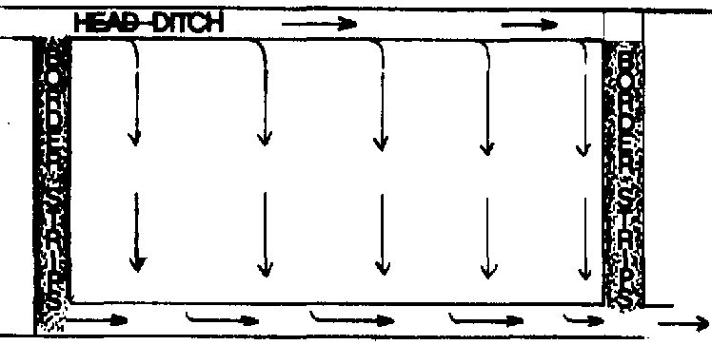
Diagram: Wild flooding
1.1b. Border strip irrigation: In this method, field is laid out into long, narrow strips, boundering with small bunds. Length of the strips ranges from 30 to 300 m and width from 3 to 15 m.
Water from the channel is allowed into each strip at a time. Method is suitable for close growing crops and medium to heavy textured soils, but not suitable for sandy soil.
Advantages:
- No land is wasted for making channels excepting the supply channel.
- Borders can be used for growing crops.
- Water application efficiency is high.
- Labour requirement is low.
Disadvantages:
- Initial construction cost is high.
- Precise levelling is essential.
- Enough skill is required in applying water.
Types of border:
Straight border: Borders are laid along the general slope of the field. Grading of the field is done by scraping away the surface soil from one part to other without affecting the soil productivity.
Contaur border: Borders are laid across the slope of the field. It is normally done when slope of the land is very steep with a shallow soil depth and levelling is not feasible.

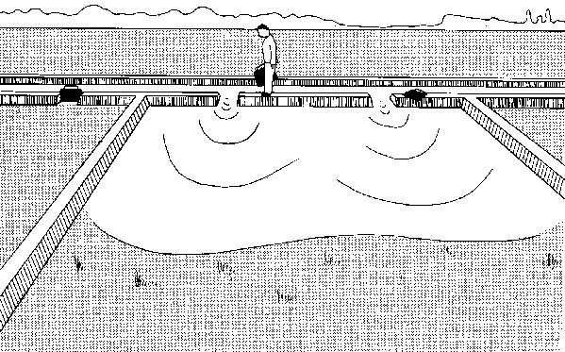
Diagram: Border strip method of irrigation
1.1c. Check basin irrigation: In this method, field is divided into small plots surrounded by bunds on all the four sides. Water from main channel is supplied to the field channels one after the other. Each field channel supplies water to two rows of check basins and water is applied to one basin after another. Size of check basins ranges from 4 m × 3 m to 6 m × 5 m depending on the stream size and soil texture. This method is the most common method among surface method of irrigation.
Advantages:
- Variable size of streams can be effectively used.
- It can be adopted for a wide range of soil.
- Water application efficiency is high.
- Water logging condition can be easily created for rice crop.
Disadvantages:
- Precise land levelling is essential.
- Considerable land is wasted by bunds and channels.
- Movement of implements and machinery are often restricted by bunds.
- Labour requirement is high.
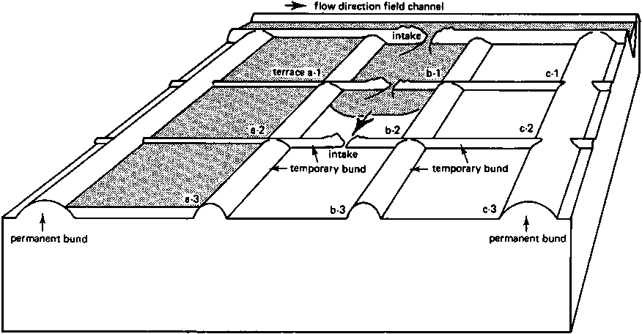
Diagram: Check basin method of irrigation
1.1d. Contour ditch irrigation: In topography with sloping and rolling where land leveling is not economical, the contour ditch or contour channel irrigation is adopted. Supply ditches are constructed along with the contours at certain intervals depending on the slope of land. Water is flooded down the slope from the upper ditch to irrigate the lower land between two adjacent ditches.
Advantages:
- It does not require precise land levelling.
- Cost of land preparation is low.
- Chances of soil erosion are low.
Disadvantages:
- Labour cost is high.
- Application efficiency is not high.
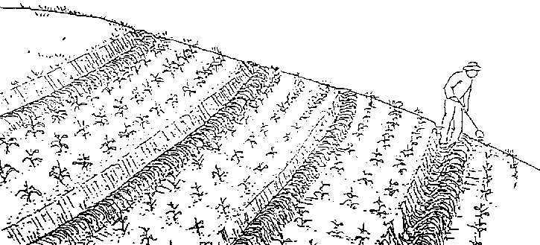
Diagram: Contour ditch method of irrigation
1.2 Methods involving partial flooding
1.2a Furrow method of irrigation: A method of surface irrigation in which water is delivered to the field through shallow ditches between ridges on which plants are grown. The size and slope of the furrow depends upon the crop grown, equipment’s used and spacing between two crops. Crops like maize, sorghum, potato, sugarcane, tobacco, sugarcane etc. are suitable for this method of irrigation.
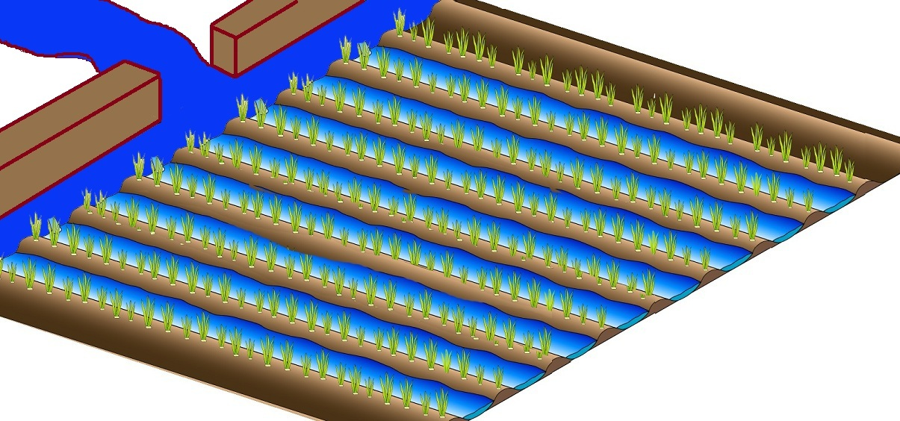
Diagram: Furrow method of irrigation
Types of furrow method of irrigation are:
- Alternate furrow: This method is adopted where water is limited and salt problem. Water is discharged in alternate furrows keeping the in between furrow dry. During the next irrigation, the left furrow is irrigated.
- Broad bed and furrow: This method is adopted for soil surface creeping vegetable crops. Fruits of those vegetables get damaged when comes in contact with the moist soil. A furrow runs between two rows of the adjacent ridges or beds.
- Skip furrow: This method is best suited in heavy soil like clay and loams. Alternate furrows are skipped and converted to ridges of wide bed. Method is recommended during the period of water scarcity for crops like cotton.
- Straight graded furrow: It is laid down to the prevailing land slope. They are best suited to sites where the land slope does not exceed 0.75%.
- Straight level furrow: It is suitable for soil having low infiltration rate and moderate to high water holding capacity.
- Contour furrow irrigation: It is adopted in an uneven and rolling topography. System may be used in most soil types except light sandy and cracking (black cotton) soil. All row crops are suitable for this method. The supply channel is either grassed or structured.
Advantages
- Uniform water application
- High water application efficiency
- Wide range of soil can be irrigated
- Variable sizes of stream can be used
- More saving of water as compared to flood method of irrigation
- No erosion hazard

Disadvantages
- Land requires precise grading to a uniform slope.
- Labour requirement is high for grading land and making furrow.
- Un suitable for light soil.
1.2b Corrugation: “Corrugation” means miniature furrows that are adopted for irrigating close growing crops. This method is suitable for fine to moderately coarse soil. Corrugation is ‘V’ shaped or ‘U’ shaped channels of about 10 cm depth, 40-75 cm apart. The slope should be just enough not to permit soil erosion. Corrugation is usually made after the crops shown but before germination of seed with simple implement called corrugator.
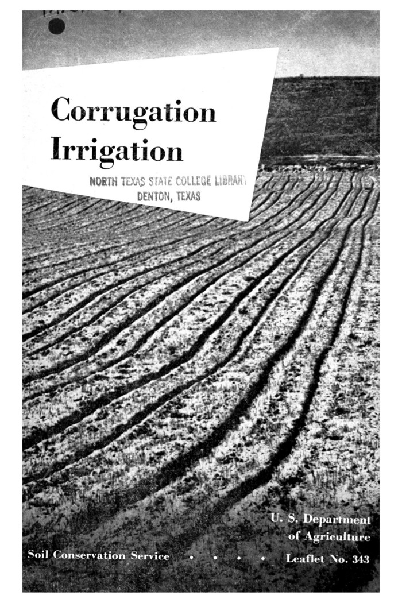
Advantages
- To save good amount of water
- Small sized streams can be used effectively to prevent crusting of soil.
- High water application efficiency
- No need of previous land leveling
Disadvantages
- Not suitable for high rainfall areas
- Not suitable where the land is leveled or slope is less than 1%
- Not suitable for sandy soil.

1.2c Basin and ring irrigation:
Basin irrigation: A basin is usually made for the tree sapling but it may include more than one sapling when they are not spaced very wide. Basin may be square, circular or rectangular. Water is supplied through laterals and each basin is connected to a lateral with a short and narrow furrow.
Ring irrigation: In this method, a ring is laid at the periphery of the tree canopy. The dimension of ring trenches is 30-50 cm. wide and 30 cm. deep. This method is adopted in orchards.
Advantages
- Save considerable amount of irrigation water.
- Reduce water losses through deep percolation and evaporation.
- Water application efficiency is very high.
- Control variable size of stream.
Disadvantages
- Adaptable only in orchard and plantation crop.
- Restrict the movements of animals and farm machinery.
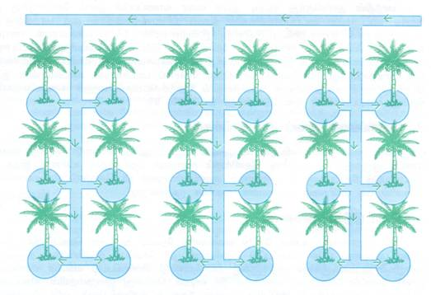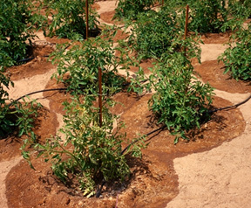
Diagram: Basin irrigation Diagram: Ring irrigation
- Sub surface irrigation: Sub surface irrigation or sub irrigation involves irrigation to crops by applying the water from beneath the soil surface either by constructing trenches or installing underground perforated pipe lines or tile lines. The principal crops that can be irrigated through this method are potato, sugar beet, vegetable, alfalfa coconut etc.
In India, this method is commonly used in Kashmir for vegetable crops and in Kerala for coconut crop.
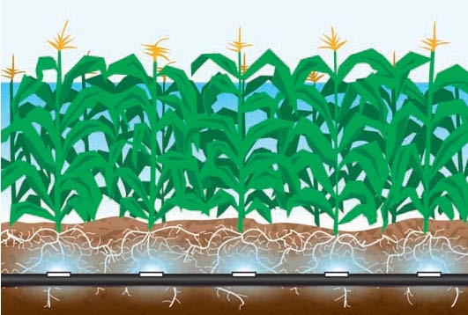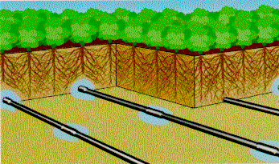
Diagram: Subsurface irrigation
The following condition should be satisfied for applications of sub surface irrigation method are:
- High water table or a hard impermeable pan should be located bellow the root zone.
- High permeable surface soil such as loam or sandy loam is required.
- Uniform topographic condition and moderate land slope is required.
- Water used for irrigation should not be saline.
Advantages
- Water is not lost through deep percolation.
- Minimum evaporation losses from the soil surface.
- Operation of farm machinery is possible at any time.
Disadvantages
- Good quality irrigation water is required.
- Chance of soil salinity and alkalinity due to upward movement of salts with the water.
- Sprinkler or Overhead irrigation: The method of aerial application of water through pipes fitted with sprinkling units. The spray is developed by the flow of water under pressure through small orifices and nozzles.
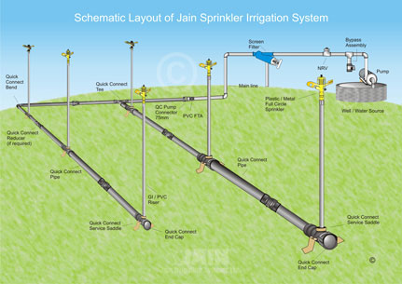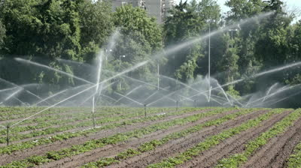
Diagram: Sprinkler irrigation
Adaptability
- For almost all crops except rice and jute.
- Sandy soil having high infiltration rate.
- Steep slopes or uneven topography.
- For growing high price crops.
- Where water is scarce and costly.
Advantages
- Water use is economized as losses by deep percolation can be totally avoided.
- Land leveling is not necessary.
- Water application efficiency is very high.
- Application of pesticides, herbicides and fertilizers can be easily made along with irrigation water.
- Uniform application of water can be made.
Disadvantages
- High capital investment is involved in its installation.
- Operating cost is high.
- Clean water is needed to avoid clogging of nozzle.
- Areas with hot winds are not suitable.
- Drip or Trickle irrigation: Drip irrigation is defined as the precise and slow application of water in the form of discrete or continuous or tiny streams or miniature sprays through mechanical devices called emitters at the specific point. In 1964, Symcha Blasé, an Israeli engineer first developed the irrigation system. USA has the largest area under drip irrigation. In India, Maharashtra has the largest area under drip irrigation.
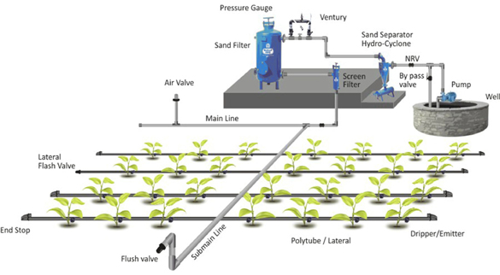
Diagram: Drip/ trickle irrigation
Adaptability: Arid regions
Areas under water scarcity and salt problems
For various types of crops like grape, apple, strawberry, corn, cotton, sugarcane, tomato, cauliflower, lettuce, cucumber, onion etc.
Advantages:
- Irrigation is possible with low available discharge.
- High water application efficiency.
- Labour requirement is low.
- Improves fertilizer use efficiency.
- Weed growth is minimum.
- Possibility of using saline water.
Disadvantages:
- Initial capital investment is high.
- High skill is required for design, installation and maintenance of the system.
- Clogging of emitters may create problem.
Efficiency of drip irrigation:
Ex.- Sugarcane under drip irrigation system yields about 1000 t/ha, 35% more than conventional irrigation.
Components of drip irrigation:
Pump, Head, Central distribution system (Fertilizer unit, Filtration system), Main line, Sub main line, Emitters or drippers.

Types of drip irrigation system:
Different drip irrigation systems are available. These are surface drip irrigation and Sub-surface drip irrigation.
Surface drip irrigation:
The most common system is the surface drip irrigation system where in the laterals and drips are on the soil surface. The advantage of surface drip irrigation is easy to install, inspection, changing and cleaning of emitters. In case of subsurface drip irrigation system, the laterals are buried below the soil surface. Spray irrigation systems apply water as a small spray, fog or mist to the soil surface. Pulse irrigation system supplies water in series of pulses or discharges with an interval of 5, 10 or 15 minutes.
Sub-surface drip irrigation:
In this system a small amount of water is applied to the soil through emitters placed below the soil surface. Porous pipe or PVC pipes with holes are used as laterals.
Continuous- flow Drip irrigation:
In this system water is applied continuously to the crop field throughout the 24 hours of a day with very small amount of water, and so maintains the crop root zone near field capacity all through the crop growing season. The continuous-flow rate of water is nine drops of water per minute (0.03l/ha) for tomato.
Fertigation:
Application of irrigation water along with fertilizer in amount and in location at a rate which matches the plant requirement is known as fertigation.
Micro irrigation:
Micro irrigation covers large number of irrigation practices whose common characteristics are relatively small cross sections of the supply and distribution lines, the low water emission rates per distributary, as well as localized delivery of water to a limited area. As a rule, micro irrigation systems are stationery, solid set installations which are capable of supplying optimum amount of water to the crops.
Indigenous drip method of irrigation:
This method is cheap, consists of mud pots of 20 liters capacity with pencil size hole made a little above the bottom. These pots are kept buried neck deep in the basins of fruit trees. The pots are filled with water and covered with lid. Water slowly trickles from the pot and replenishes the root zone. This method is suitable for young fruit trees and vegetable crops. By this method, considerable amount of water is saved.

WATER USE EFFICIENCY

It indicates how efficiently the supplied available water is being used based on different method. Irrigation efficiency is the ratio usually expressed as per cent of the volume of irrigation water transpired by the plant, plus the evaporated from the soil, plus that necessary to regulate the salt concentration in the soil solution and that used by the plant in building plant tissue to the total volume of water diverted, stored or pumped for irrigation.

Wt + Ws- Re
Ei = × 100
Wi
Where, Ei is irrigation efficiency (%); Wt is the volume of irrigation water per unit of land transpired by plants, evaporated from the soil during crop period (including field preparation and nursery); Ws is the volume of irrigation water per unit area of land to regulate the salt content of soil solution; Re is effective rainfall and Wi is the volume of water per unit area of land that is stored in a reservoir or diverted for irrigation.
Conveyance efficiency:
It indicates the efficiency with which water is conveyed from source of supply to the field. It estimated the conveyance losses and expressed as:
Wf
Ec = × 100
Ws
Where, Ec is water conveyance efficiency (%); Wf is water delivered at the field and Ws is water delivered from the source.
Water application efficiency:
The percentage ratio of the amount of water stored in the crop root zone during the irrigation to the amount of water delivered to the field. It is expressed as:
Ws
Ea = × 100
Wf
Where, Ws is the amount of water stored in the crop root zone.
Wf is the amount of water delivered to the field.

Water storage efficiency:
The percentage ratio of the amount of water stored in the effective crop root zone soil to the amount of water needed to make up the soil depleted in crop root zone prior to irrigation.
Ws
Es = × 100
We
Where, We is the amount of water needed to the crop root zone prior to irrigation.
Wsis the amount of water stored in the crop root zone of the soil.

Water distribution efficiency:
It gives a measure of the uniformity of the depth of irrigation all over the field and expressed as:
Y
Ed = 1 - × 100
D
Where, Y is average numerical deviation
D is average depth of water stored during irrigation.
Water use efficiency (WUE):
It refers to the amount of marketable end product obtained per unit of water used by the crop.
Total economic yield (kg ha⁻¹)
WUE (kg ha⁻¹ mm⁻¹) =
Total consumptive use (mm)
Factors affecting water use efficiency:
- Factors affecting crop yield
- Climatic condition (amount, distribution and intensity of rainfall)
- Occurrence of drought
- Soil characteristics
- Irrigation
- Drainage
- Fertilizer used
- Crop varieties
- Crop management practices
- Weed, insect and disease infestation
- Factors affecting consumptive use of water by the crop
- Climatic condition
- Soil characteristics
- Crop types and varieties
- Water supply and irrigation practices
- Tillage practices
- Weed control
- Fertilizer use
- Use of mulch
- Use of anti-transpirant
- Growth retardance.

Agronomic practices for improvingwater use efficiency:
- Improving rain water harvesting
- Improving rain water harvesting in situ by adopting following practices.
- Land shaping
- Contour bunding
- Graded bund
- Teraceing
- Vertical mulching
- Deep chiseling
- Improving rain water harvesting ex situ by adopting following practices.
- Smothering the land surface.
- Covering the soil surface with impervious material like plastic film.
- Selection of suitable crop and varieties:
- Selection of crop according to the environment
- Selection of input
- Application of water at proper depth and interval.
- Use of proper irrigation method.
- Reduce runoff and percolation losses due to over irrigation.
- Reduce evaporation by using mulches.
- Reduce transpiration by controlling weeds.
- Apply manures and green manures where possible.
- Practice soil conservation and sustainability.
- Irrigate at high frequency and in the exact amount to prevent water deficits.
- Proper use of residual soil moisture for crop cultivation.
- Control of micro climate induces better plant growth by adopting wind breaks and shelter belts.

IRRIGATION WATER QUALITY CRITERIA AND ITS MANAGEMENT

Water Quality Parameters
The parameters of water quality, namely pH, electrical conductivity, alkalinity, nitrate, phosphate, sodium, calcium, magnesium, TDS and TSS, have effect or adverse effect on irrigated agriculture. Impact assessment of adequate supply of usable quality water for the purpose of irrigation to influence the crop quality and marketability has a great deal with present art of agriculture. A number of water management technologies, for various crops have been developed over years to enhance agricultural production as well as profit. The area of crop(s) under irrigation was also increased substantially. The irrigation potential was created at the cost of huge amount of national exchequer.

Physical Properties
- Water temperature (⁰C)
- Electrical Conductivity (EC)
- Total Suspended Solids (TSS)
- Transparency or Turbidity (T)
- Total Dissolved Solids (TDS)
- (i) Odour (ii) Colour (iii) Taste of water

Chemical Properties
- pH
- Biochemical Oxygen Demand (BOD)
- Chemical Oxygen Demand (COD)
- Dissolved Oxygen (DO)
- Total Hardness (TH)
- Heavy Metals (i) Arsenic (ii) Fluoride (iii) Cadmium (iv) Chloride
- Ca, Mg, Fe, Zn, B, Al,

Biological Properties
- Bacteria
- Fungi
- Viruses

Radiological Properties
- X-ray
- Mutation (Gamma-ray)
- Radio activation

Water quality & its management
Water quality refers to the chemical, physical, biological, and radiological characteristics of water.It is a measure of the condition of water relative to the requirements of one or more biotic species and or to any human need or purpose. It is most frequently used by reference to a set of standards against which compliance can be assessed. The most common standards used to assess water quality relate to health of ecosystems, safety of human contact, and drinking water.
Allirrigationwatersarenotpure andmaycontain somesoluble salts.Inaridand semi-arid regions successful crop productionwithoutsupplemental irrigationisnotpossible.Irrigationwater isusually drawn fromsurface orground water sources,which typicallycontain salts intherange of200to2000 ppm(=200to2000 g/m3).Irrigation water contains10–100timesmoresaltthanrainwater.Thus,eachirrigationeventadds salts tothesoil.Cropremoves water fromthesoiltomeet itswater needs (ETc)leaving behind most ofthesalts toconcentrateintheshrinking volumeofsoilwater . This isacontinuousprocess.Application ofsaline watermayhinderthecropgrowthdirectly andmayalsocausesoildegradation.Beyonditseffectoncropandsoil,irrigation water of lowqualitycanalsoaffectenvironmentbyintroducingpotentiallyharmful substancesintosurfaceandground watersources.Therefore,asaltbalanceinthesoilhas to bemaintainedthroughproper watermanagement practicesforcontinuous andsuccessfulcultivationofcrops.

Adverse effect of salt contents on crops
- salt accumulation,
- increase in osmotic potential,
- decreasedwater availability to plants,
- poor germination,
- patchy crop stand,
- stuntedgrowth withsmaller,thicker anddarkgreenleaves,
- leafnecrosis &leafdrop,
- root death,wiltingofplants,
- nutrientdeficiencysymptomsand
- poorcropyields

WATER LOGGING

Definition:
When the conditions are so created that the crop root-zone gets deprived of proper aeration due to the presence of excessive moisture or water content, the tract is said to be waterlogged. To create such conditions it is not always necessary that under groundwater table should enter the crop root-zone. Sometimes even if water table is below the root-zone depth the capillary water zone may extend in the root-zone depth and makes the air circulation impossible by filling the pores in the soil.
The waterlogging may be defined as rendering the soil unproductive and infertile due to excessive moisture and creation of anaerobic conditions. The phenomenon of waterlogging can be best understood with the help of a hydrologic equation, which states that
Inflow = Outflow -I- Storage
Here inflow represents that amount of water which enters the subsoil in various processes. It includes seepage from the canals, infiltration of rainwater, percolation from irrigated fields and subsoil flow. Thus although it is loss or us, it represents the amount of water flowing into the soil.

Causes of Waterlogging:
After studying the phenomenon of waterlogging in the light of hydrologic equation main factors which help in raising the water-table may be recognised correctly.
They are:
i. Inadequate drainage of over-land run-off increases the rate of percolation and in turn helps in raising the water table.
ii. The water from rivers may infiltrate into the soil.
iii. Seepage of water from earthen canals also adds significant quantity of water to the underground reservoir continuously.
iv. Sometimes subsoil does not permit free flow of subsoil water which may accentuate the process of raising the water table.
v. Irrigation water is used to flood the fields. If it is used in excess it may help appreciably in raising the water table. Good drainage facility is very essential.

Effects of Waterlogging:
The waterlogging affects the land in various ways. The various after effects are the following:

1. Creation of Anaerobic Condition in the Crop Root-Zone:
When the aeration of the soil is satisfactory bacteriological activities produce the required nitrates from the nitrogenous compounds present in the soil. It helps the crop growth. Excessive moisture content creates anaerobic condition in the soil. The plant roots do not get the required nourishing food or nutrients. As a result crop growth is badly affected.

2. Growth of Water Loving Wild Plants:
When the soil is waterlogged water loving wild plant life grows abundantly. The growth of wild plants totally prevent the growth of useful crops.

3. Impossibility of Tillage Operations:
Waterlogged fields cannot be tilled properly. The reason is that the soil contains excessive moisture content and it does not give proper tilth.

4. Accumulation of Harmful Salts:
The upward water movement brings the toxic salts in the crop root-zone. Excess accumulation of these salts may turn the soil alkaline. It may hamper the crop growth.

5. Lowering of Soil Temperature:
The presence of excessive moisture content lowers the temperature of the soil. In low temperature the bacteriological activities are retarded which affects the crop growth badly.

6. Reduction in Time of Maturity:
Untimely maturity of the crops is the characteristic of waterlogged lands. Due to this shortening of crop period the crop yield is reduced considerably.

Detection of Waterlogging:
From the subject matter discussed above it is clear that the waterlogging is indicated when the ground water reservoir goes on building up continuously. When the storage starts building up in the initial stages the crop growth is actually increased because more water is made available for the crop growth. But after some time the waters table rises very high and the land gets waterlogged. Finally the land is rendered unproductive and infertile.
The problem of waterlogging develops in its full form slowly. Therefore its early detection is possible by keeping a close watch over the yields and also on the variations in the groundwater level. A comparative reduction in crop yields in spite of irrigation and fertilisation and early maturity of crops indicate the symptoms of waterlogging. Also when harmful salts start appearing on the fields as white incrustation or deposit it indicates that waterlogging is likely to follow. In worst cases the water-table rises so high and close to the ground surface that the fields turn into swamps and marshes.
The best way of keeping watch over the problem of waterlogging is by observing variations in the groundwater level. It can be done by measuring the depth of water levels at regular interval in the wells dug in the area. Continuous high water levels indicate that the groundwater storage is building up which may create waterlogging in the area.

Solution to the Problem of Waterlogging:
The problem of waterlogging may be attacked on two fronts. First is preventive measures, which keep the land free from waterlogging. Secondly curative measures may be adopted to reclaim the waterlogged area. But in principle both measures aim at reducing the inflow and augmenting the outflow from the underground reservoir.

Preventive Measures:
Preventive measures include the following:
(a) Controlling the loss of water due to seepage from the canals:
The seepage loss may be reduced by adopting various measures for example
i. By lowering the FSL of the canal:
Loss may be due to percolation or absorption but when FSL is lowered the loss is reduced to sufficient extent. It is course essential to see that while lowering the FSL command is not sacrificed.
ii. By lining the canal section:
When the canal section is made fairly watertight by providing lining the seepage loss is reduced to quite a good extent.
iii. By introducing intercepting drains:
They are generally constructed parallel to the canal. They give exceptionally good results for the reach where the canal runs in high embankments.
(b) Preventing the loss of water due to percolation from field channels and fields:
The percolation loss can be removed by using water more economically. It may also be affected by keeping intensity of irrigation low. Then only small portion of the irrigable tract is flooded and consequently the percolation loss takes place only on the limited area. It keeps the water-table sufficiently low.
(c) Augmentation of outflow and prevention of inflow:
It may be accomplished by introducing artificial open and underground drainage grid. It may also be achieved by improving the flow conditions of existing natural drainages.
(d) Quick disposal of rainwater:
Quick removal of rainwater by surface or open drains is a very effective method of preventing the rise in water table and consequent waterlogging of the tract. It is needless to state that the rainwater removed is net reduction in inflow.

Curative Measures:
Curative measures include the following:
(a) Installation of lift irrigation systems:
When a lift irrigation project in the form of a tube well irrigation system is introduced in the waterlogged area the water table gets lowered sufficiently. It is found to be very successful method of reclaiming waterlogged land. Thus a combination of a canal system and a supplementary tube well irrigation system may be considered to be most successful and efficient irrigation scheme.
Of course it is true that it will create some complications while assessing the charges for irrigation water. (The canal water being cheaper than tube well water). Implementation of drainage schemes: The waterlogged area may be reclaimed by introducing overland and underground drainage schemes.
(b) Implementation od Drainage Schemes:
The waterlogged area may be reclaimed by introducing overland and underground drainage schemes.

Extent or Waterlogged Area:
In our country water-logging is a problem of great concern. It is estimated that total area of waterlogged land is 86.92 lakh hectares. It includes area in irrigation commands as well as other area outside the command.
While the areas in the irrigation command get waterlogged due to rise in water table as a direct consequence of inadequate drainage, other areas get waterlogged due to inundation, as consequence of flooding for long durations. The States mainly affected and the extent of area rendered infertile and unproductive are given in Table 11.1.
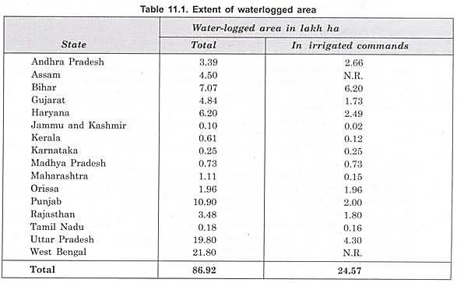

About 48 lakh ha are estimated to be affected by salinity and 25 lakh ha by alkalinity. Saline soils include 10 lakh ha in arid and semi-arid regions of Rajasthan and Gujarat and 14 lakh ha in black cotton soils. The alkali problem is mainly in Punjab, Haryana and Uttar Pradesh.
Steps are being taken to reclaim the waterlogged land in the country. The steps taken to reclaim such areas include implementation of drainage schemes, provision of deep drains, excavation of new channels and improvement of existing ones, construction of sluices with marginal embankment and installation of tube wells.
The spread of conjunctive use of groundwater with that of surface water especially in Punjab, Haryana and parts of Uttar Pradesh has substantially lowered the groundwater table and helped in containing water-logging/salinity.
Summarising the most effective and efficient anti-water-logging measures are:
i. Lining of channels (main canal, branches and field channels).
ii. Provision of surface drains for drainage of rainwater; and
iii. Implementation of tube well projects both extensive and local.
Other methods are of local importance and hence benefit derived from them is limited.

AGRICULTURAL DRAINAGE
Agricultural Drainage
Excess water in the crop root zone soil is injurious to plant growth. Artificial drainage is essential on poorly drained agricultural fields to provide optimum air and salt environments in the root zone. Crop yields are drastically reduced on poorly drained soils, and, in cases of prolonged waterlogging, plants eventually die due to a lack of oxygen in the root zone.Waterlogging in irrigated regions may result in excess soil salinity, i.e., the accumulation of salts in the plant root zone.

Sources of excess soil water that result in high water tables include: high precipitation in humid regions; surplus irrigation water and canal seepage in the irrigated lands; and artesian pressure.Agricultural drainage is the removal of excess water from the soil surface and/or soil profile of cropland, by either gravity or artificial means. In some soils, the natural drainage processes are sufficient for growth and production of agricultural crops, but in many other soils, artificial drainage is needed for efficient agricultural production.

Agricultural drainage improvement can help reduce the year-to-year variability in crop yield, which helps reduce the risks associated with the production of abundant, high quality, affordable food. Improved access of farm equipment to the field provides more time for field activities, can help extend the crop production season, and helps reduce crop damage at harvest.

Agricultural drainage conditions around the world can be grouped according to three agro-climatic zones: the temperate zone, the arid and semi-arid zone and the humid and sub-humid zone.

In the temperate agro-climatic zone the major role of drainage is to prevent waterlogging, i.e., excess water in the root zone of crops from surplus rainfall. It also serves the purpose of improving the traffic ability of the farms for farm machinery etc. The field drainage system is generally sub-surface.

In arid and semi-arid zone the function of drainage is to prevent irrigation induced waterlogging and salinization of soils. These zones suffer from population pressure and intensive agriculture through irrigation is resorted to which makes drainage provision essential to maintain the sustainability of agricultural lands.

In humid and semi-humid regions the role of drainage is a combination of waterlogging control, salinization prevention and flood protection. Generally open drainage systems are applied as the rainfall intensities are so high that the sub-surface drainage becomes insufficient or exorbitantly inexpensive.

Surface Drainage System

1. Random Drainage System

2. Parallel Field Drainage System

3. Parallel Open Ditch Drainage System

4. Bedding Drainage System

Sub Surface Drainage System

Tile Drainage System

Random Drainage System

Herringbone System

Gridiron System:

Double Main System

Intercepting System

Mole Drainage System

Drainage Coefficient

Defined as depth of water (cm) to be removed in 24 hours period from the entire drainage area (0.6 to 2.5 cm/day in extreme cases 10 cm/day)

Surface Drainage

Plant roots must have a favourable environment to be able to extract water soluble nutrients and water to meet the plant’s requirement. Excess water or excess concentrations of salts in the root zone or at the land surface do not allow the plant roots to function normally. As a result, the plant growth and yield are adversely affected. In the extreme cases of waterlogging and salinity, the seeds may not germinate and the plants may wilt permanently. The result is a loss of agricultural production. Land drainage is thus the removal of excess surface and subsurface water from the land to enhance crop growth, including the removal of soluble salts from the soil. It is an effective method to restore or maintain a sustainable agricultural system. Agricultural land drainage is both a preventive and a curative measure for the physically and chemically degraded agricultural lands to enhance their productive potential. Among the various activities in the agricultural production system, drainage is the most neglected in the country.

Waterlogging and salinity of agricultural lands are caused due to natural processes or man-made activities.

The natural causes consist of i) poor natural drainage of the sub soil under unfavourable geology like existence of hard pan below the soil surface,

ii) submergence under floods, and

iii) deep percolation from rainfall, iv) hydraulic pressure from saturated areas located at higher elevations.

Artificial or man-made causes of waterlogging include i) practice of high intensity of irrigated agriculture without any consideration of soil and subsoil conditions, ii) excessive enclosing of irrigated fields with embankments and choking up natural drainage, and iv) poor maintenance of natural drainage or blocking of natural drainage by roads and railways. Waterlogging in any area may also be caused when the inflow into the groundwater reservoir exceeds the outflow from it resulting in rise of water table. In irrigated areas chemical degradation of land is a subsequent development on account of long duration waterlogging caused due to canal seepage and adoption of faulty irrigation practices. Irrigation development in the arid and semi-arid regions is associated with more risk of chemical degradation of land. Some of the major causative factors precipitating drainage and related are discussed below.

Potential Causes of Drainage Problem

Poor natural drainage:

Uneven rainfall distribution: very heavy rain in a short duration causing accumulation of runoff.

Tidal intrusion:

Spilling of rivers /streams causing submergence of land

High depth of groundwater table

Seepage: from unlined canals, distributaries, minors and watercourses rendering the adjoining land wet for long duration.

Poor on-farm water management: field to field and over irrigation, uncertainty in the release of water in proper time and quantity, mostly un-gated and many unauthorized outlets, absence of roster in canal deliveries.

Unrealistic cropping pattern: tilted in favour of water-loving crops

Poor water quality: brackish ground and surface water are used in irrigation for want of adequate of fresh water

Higher water allowance

Development activities: unplanned construction of roads, bridges, canals, flood embankments, railways, buildings, many a times obstructing natural drainage.

Lack of catchment protection: deforestation, faulty cultivation practices, less in-situ moisture conservation, more runoff and soil loss, silting of downstream channels.

Lack of monitoring: lack of monitoring of the health of the land and the water resources. Problem becomes known when it is too late and the remedy is expensive.

People’s participation: absence of cooperative or community approaches to tackle the problem and too much dependence on government.

