Supply Chain Management

Introduction

The supply chain is a global network used to deliver products and services from raw materials to customers, through an engineered flow of information, physical distribution and cash. In other words, supply chain management includes the design, planning implementation, control and monitoring of supply activities with the objective of creating net value, building a competitive infrastructure, leveraging worldwide logistics, synchronizing supply with demand, and measuring performance worldwide. To stay competitive, enlightened companies have strived to achieve greater coordination and collaboration among supply chain partners in an approach called “supply chain integration”, in which Information Technology plays a key role in furthering their goals.SCM includes agility, flexibility, stability, reliability and sustainability.

A Supply chain acts as a connecting chain of materials from the suppliers to the manufacturer to the distributor to the retailer to the ultimate customers .In a supply chain the flow of demand information is in a direction opposite to the flow of materials .Thus, the information flow on demand is from the customer to the retailer to the distributor to the manufacturer to the supplier .It may be noted that the supply chain is not a linear chain but takes the form of a network. It consists of a network of facilities and distribution options that perform the functions of procurement of materials, transformation of these materials into intermediate and finished products, and the distribution of these finished products to customers in the right time and of the right quantity and quality

Need of SCM

Supply chain drivers are key to the performance of Supply chain constituents and role players across the network. The drivers are components of the supply chain structure that lead to effectiveness of the supply chain. These drivers may be viewed as operating tools for implementing S C strategies and carrying out operations. Drivers could be logistic drivers such as warehouse facilities, inventory and transportation or cross functional drivers such as pricing, sourcing and information. Apart from these drivers certain external factors such as regulatory systems, international agreements, tax systems, and infrastructure may impact the performance of SC indirectly through configuration of the drivers.

Both business strategy and specialized software are used in these endeavors to create a competitive advantage. Supply chain processes affect both the speed and efficient service delivery of a company. With the advent of emerging technologies such as cloud computing, big data and more, the need for a SCM system is becoming more prominent.

An effective SCM system helps accomplish the following:

Managing contractual obligations to assure a continuous supply and avoid a service company’s

delivery disruptions.

Strengthening supplier relations for systematic synergy with suppliers and different lines of business.

Enterprise spending management to assure procurement happens through the right suppliers

and reduces costs.

Managing risk and compliance to abide by organizational as well as industry specific

regulations and compliances.

Establishing a single comprehensive supplier view and deriving insightful procurement

analytics.

Changing customer attitudes

Today’s customer is not the same as that of 10 years ago. Whether we speak of end consumers like you and me, companies have to think very differently about how to deliver value to their customers. For example, online retailers like Amazon are giving a serious run for their money to brick-and-mortar retailers.

Customization (segment of one) and multi-dimensional competition:

Consumers today are used to customized solutions tailored just for them. What’s more, consumers will not settle for just low price, or just high quality, at the expense of the other. Consumers expect low prices, high quality, and high service, and many other attributes, all at the same time.

Short product life cycles

Not only do companies want to compete by offering a lot of products, uniquely customized for their customers, they do so by introducing new products at a dizzying pace. A newly purchased laptop is already outdated in about three months by a newer model that is faster, cheaper and better. This rapid pace at which new products are introduced places unprecedented burdens on how companies design, manage and coordinate their supply chains.

Globalization

Today, companies design products in one part of the world, source raw materials in another, manufacture or assemble finished products in yet another part, and sell to customers in an entirely different geography. And you may want to think again if you believe that companies can rest once such a network is designed. Indeed, this structure must constantly evolve as operating conditions evolve. This complex maze of facilities not only creates a serious management challenge, it also exposes companies to financial, political, and natural risks that are irrelevant in a fully domestic supply chain.

Elements in supply chain management: A supply chain is a sequence of processes that must be completed to produce and distribute a commodity. This commodity might be goods or it might be services, but either way, there needs to be a clear manufacturing path for the goods or services to be produced. Having a strong supply chain is crucial to that goal, and so is managing it effectively so the supply chain produces the best results -- because that's vital to business health.

Planning

This is one of the most important stages. Before the beginning of the entire supply chain, it is essential to finalize the strategies and put them into place. Checking the demand for the product or service, checking the viability, costing, profit, and manpower etc., are vital. Without a proper plan or strategy in place, it will be well-nigh impossible for the business to achieve effective and long term benefits. Therefore, enough time has to be devoted to this phase. Only after the finalization of the plans and consideration of all pros and cons, can one proceed further. Every business needs a plan or blueprint or a roadmap based on which the strategies are made. Planning helps to identify the demand and supply trends in the market and this, in turn, helps to create a successful supply chain management system.

Information

The world today is dominated by a continuous flow of information. In order to be successful, it is essential that a business stays abreast with all the latest information about the various aspects of its production. The market trends of supply and demand for a particular product can be best understood if the information is properly and timely disseminated through the many levels of the business. Information is crucial in a knowledge-based world economy, and ignorance about any aspect of business may actually spell doom for the prospects of the business.

Source

Suppliers play a very crucial role in supply chain management systems. Products and services sold to the end user are created with the help of different sets of raw materials. It is therefore necessary that suitable quality raw materials are procured at cost effective rates. If a supplier is unable to supply on time, and within the stipulated budget, the business is bound to suffer losses and gain a negative reputation. It is crucial that a company procures good quality resources so it can create good quality products and maintain its reputation in the market. This necessitates a strong role for suppliers in the supply chain management system.

Inventory

For a highly effective supply chain management system it is essential that an inventory is kept and thoroughly maintained. An inventory means the ready list of items, raw materials and other essentials required for the product or service. This list has to be regularly updated to demarcate available stock and required stock. Inventory management is critical to the function of supply chain management, because without proper inventory management the production, as well as sale of the product, is not possible. Businesses have now started to pay more attention to this component simply because of its impact on the supply chain.

Production

Production is one among the most important aspects of this system. It is only possible when all the other components of the supply chain are in tandem with each other. For the process of production to start it is essential that proper planning and supply of goods, as well as the

inventory, are well maintained. The production of goods is followed by testing, packaging and the final preparation for delivery of the finished product.

Location

Any business, that wants to survive as well as flourish, needs a location which is profitable for the business. Location refers to nodal organization in the supply chain where a product or service is being fabricated, assembled, produced, processed and stored.In agribusiness, the main purpose is to manage demand and supply gaps across time and regions. Furthermore, temrature controle is also another important factor specially in warehouse decisions.

Location/facilities
Production units/ Manufacturere,
assemble or process
Warehouse- Stocking point at background and
forward linkages(distribution centre)

Take for example, a carbonated drink factory is set up in an area where water supply is scarce. Water is a basic necessity of such business. The lack of water could hamper the production as well as affect the goodwill of the company. A business cannot survive if it has to share an already scarce raw material with the community. Hence, a suitable location, which is well connected, and very close to the source of essential resources for production is vital to a business’ prosperity. The requirement and availability of manpower must also be considered while setting up a business unit.

Transportation

Transportation is vital in terms of carrying raw materials to the manufacturing unit and delivering the final product to the market. At each stage, timely transportation of goods is mandatory to sustain a smooth business process. Any business which pays attention to this component, and takes good care of it, will benefit from the production and transportation of its goods on time.

Integration

This could be considered the brains and heart of the supply chain. Overseeing supply chain integration means coordinating communications between the rest of the supply chain to produce effective and timely results. Often, this means exploring new software or other technological means to foster communications among departments. Those in charge of integration are responsible for making sure that things are happening on time and on the budget, without sacrificing quality.

Operations

This link in the supply chain coordinates the specifics of day-to-day operations for the company. It plans the company’s output to make sure everything is running well and that advantages are maximized. Operations will keep an eye on company inventory. They use business forecasting to predict which supplies will be needed when and by whom and also to find ways to predict the effectiveness of products, marketing approaches, as well as end-user results. Overall, the company’s production is overseen by operations.

Purchasing

This department sources the materials, products, or other goods needed to generate the company’s products. Purchasing creates relationships with suppliers and also identifies the qualities and quantities of necessary items. It’s very important for those in purchasing to keep an eye on the budget for things to be cost-effective for the company, as well as adhering to high- quality standards.

Distribution

How do businesses commodities end up where they are supposed to? Distribution coordinates that. The logistics of communications among retailers, clients, or wholesalers is the responsibility of the distribution part in the supply chain of command. These groups must keep on eye on shipments, and to know not only what is needed in-house to produce products but also that the products get to the end-customer on time and in good shape.

Traditional vs Modern SCM

Earlier the traditional SCM was based on a push based strategy where the manufracturers produced the goods and pushed them through the supply chain without receiving any proper feedback and information regarding any requirements or specifications In the process, There was often some gap between the supply and demand which led to either shortage or waste of produc

ed end product.

Features of Traditional SCM: Traditional SCM always used the telephone, fax and regular mail to contact their upstream (supplier) and downstream (customers) connections, however, the use of face-to-face negotiation is not longer needed, as it involved lots of time and costs.

Improper planning leading non harmonization between channel partners Focused on individual performance without considering the intermediaries. Lack of long term growth plan and focus

Lack of vision and mission statements

Modern SCM: Internet technologies can reduce production times and costs by increasing the flow of information, as a way to integrate different supply chain activities. Through doing this, the supply chain can be made more efficient and the services delivered to customers more readily.

Strong network across the whole supply chain leads to cost saving and higher profitability Long term growth plan and strategies are aliened with the company’s vision and mission Strong connection between the supplier and procurement managers

Constantly monitored the existing practice at regular intervals to improve performance and efficiency

Reduction of inventory waste through SCM

All the individual systems are integrated with each other properly

Difference between E-business and e-commerce

E-business and e-commerce are fundamentally different. E-commerce uses electronic media to conduct transactions, such as buying, selling, or exchanging products, services and information via computer networks, whereas E-business is the transformation of key business processes through the use of Internet technologies. e-business is not confined to buying and selling of goods only, but it includes other activities that also form part of business like providing services to the customers, communicating with employees, client or business partners can contact the company in case if they want to have a word with the company, or they have any issue regarding the services, etc. All the basic business operations are done using electronic media. Example of e business are accounting , production, finance and human resource which are conducted electronically.

Demand in SCM

Demand-driven SCM will ensure that production schedules become stable, predictable and effective. In SC context the expression ‘agility(autonomously responsive) thru stability’ might appear to be something of an oxymoron.

Factors That Influence the Demand of Goods

The demand changes as a result of changes in price, other factors determining it being held constant. We shall explain below in detail how these other factors determine market demand for a commodity. These other factors determine the position or level of demand curve of a commodity. It may be noted that when there is a change in these non-price factors, the whole curve shifts rightward or leftward as the case may be. The following factors determine market demand for a commodity.

Tastes and Preferences of the Consumers:

An important factor which determines the demand for a good is the tastes and preferences of the consumers for it. A good for which consumers’ tastes and preferences are greater, its demand would be large and its demand curve will therefore lie at a higher level. People’s tastes and preferences for various goods often change and as a result there is change in demand for them. The changes in demand for various goods occur due to the changes in fashion and also due to the pressure of advertisements by the manufacturers and sellers of different products. On the contrary, when certain goods go out of fashion or people’s tastes and preferences no longer remain favourable to them, the demand for them decreases.

Income of the People:

The demand for goods also depends upon the incomes of the people. The greater the incomes of the people, the greater will be their demand for goods. In drawing the demand schedule or the demand curve for a good we take income of the people as given and constant. When as a result of the rise in the income of the people, the demand increases, the whole of the demand curve shifts upward and vice versa.The greater income means the greater purchasing power. Therefore, when incomes of the people increase, they can afford to buy more. It is because of this reason that increase in income has a positive effect on the demand for a good.When the incomes of the people fall, they would demand less of a good and as a result the demand curve will shift downward. For instance, as a result of economic growth in India the incomes of the people have greatly increased owing to the large investment expenditure on the development schemes by the Government and the private sector.

As a result of this increase in incomes, the demand for good grains and other consumer goods has greatly increased. Likewise, when because of drought in a year the agriculture production greatly falls, the incomes of the farmers decline. As a result of the decline in incomes of the farmers, they will demand less of the cotton cloth and other manufactured products.

Changes in Prices of the Related Goods:

The demand for a good is also affected by the prices of other goods, especially those which are related to it as substitutes or complements. When we draw the demand schedule or the demand curve for a good we take the prices of the related goods as remaining constant. Therefore, when the prices of the related goods, substitutes or complements, change, the whole demand curve would change its position; it will shift upward or downward as the case may be. When the price of a substitute for a good falls, the demand for that good will decline and when the price of the substitute rises, the demand for that good will increase.

For example, when price of tea and incomes of the people remain the same but the price of coffee falls, the consumers would demand less of tea than before. Tea and coffee are very close substitutes. Therefore, when coffee becomes cheaper, the consumers substitute coffee for tea and as a result the demand for tea declines. The goods which are complementary with each other, the fall in the price of any of them would favorably affect the demand for the other. For instance, if price of milk falls, the demand for sugar would also be favorably affected. When people would take more milk, the demand for sugar will also increase. Likewise, when the price of cars falls, the quantity demanded of them would increase which in turn will increase the demand for petrol.

Advertisement Expenditure:

Advertisement expenditure made by a firm to promote the sales of its product is an important factor determining demand for a product, especially of the product of the firm which gives advertisements. The purpose of advertisement is to influence the consumers in favour of a product. Advertisements are given in various media such as newspapers, radio, and television. Advertisements for goods are repeated several times so that consumers are convinced about their superior quality. When advertisements prove successful they cause an increase in the demand for the product.

The Number of Consumers in the Market:

The market demand for a good is obtained by adding up the individual demands of the present as well as prospective consumers of a good at various possible prices. The greater the number of consumers of a good, the greater the market demand for it. Now, the question arises on what factors the number of consumers for a good depends. If the consumers substitute one good for another, then the number of consumers for the good which has been substituted by the other will decline and for the good which has been used in place of the others, the number of consumers will increase. Besides, when the seller of a good succeeds in finding out new markets for his good and as a result the market for his good expands the number of consumers for that good will increase. Another important cause for the increase in the number of consumers is the growth in population. For instance, in India the demand for many essential goods, especially food grains, has increased because of the increase in the population of the country and the resultant increase in the number of consumers for them.

Consumers’ Expectations with Regard to Future Prices:

Another factor which influences the demand for goods is consumers’ expectations with regard to future prices of the goods. If due to some reason, consumers expect that in the near future prices of the goods would rise, then in the present they would demand greater quantities of the goods so that in the future they should not have to pay higher prices. Similarly, when the consumers expect that in the future the prices of goods will fall, then in the present they will postpone a part of the consumption of goods with the result that their present demand for goods will decrease.

Increase in Demand and Shifts in Demand Curve:

When demand changes due to the factors other than price, there is a shift in the whole demand curve. As mentioned above, apart from price, demand for a commodity is determined by incomes of the consumers, his tastes and preferences, prices of related goods. Thus, when there is any change in these factors, it will cause a shift in demand curve. For example, if incomes of the consumers increase, say due to the hike in their wages and salaries or due to the grant of dearness allowance, they will demand more of a good, say cloth, at each price. This will cause a shift in the demand curve to the right. Similarly, if preferences of the people for a commodity, say colour TV, become greater, their demand for colour TV will increase, that is, the demand curve will shift to the right and, therefore, at each price they will demand more colour TV. The other important factor which can cause an increase in demand for a commodity is the expectations about future prices. If people expect that price of a commodity is likely to go up in future, they

will try to purchase the commodity, especially a durable one, in the current period which will boost the current demand for the goods and cause a shift in the demand curve to the right. As seen above, the prices of related commodities such as substitutes and complements can also change the demand for a commodity. For example, if the price of coffee rises other factors remaining the constant, this will cause the demand for tea, a substitute for coffee, to increase and its demand curve to shift to the right.

Decrease in Demand and Shift in the Demand Curve:

If there are adverse changes in the factors influencing demand, it will lead to the decrease in demand causing a shift in the demand curve. For example, if due to inadequate rainfall agricultural production in a year declines this will cause a fall in the incomes of the farmers. This fall incomes of the farmers will cause a decrease in the demand for industrial products, say cloth, and will result in a shift in the demand curve to the left. Similarly, change in preferences for commodities can also affect the demand. For example, when colour TVs came to India people’s greater preference for them led to the increase in their demand. But this brought about decrease in demand for black and white TVs causing leftward shift in demand curve for these black and white TVs.

The decrease in demand does not occur due to the rise in price but due to the changes in other determinants of demand. Decrease in demand for a commodity may occur due to the fall in the prices of its substitutes, rise in the prices of complements of that commodity and if the people expect that price of a good will fall in future.

Kinds of Demand

Some of the important kinds of demand are: 1. Price demand, 2. Income demand, 3. Cross demand, 4. Direct demand, 5. Derived demand or Indirect demand, 6. Joint demand and 7. Composite demand:

Price demand:

Price demand refers to the different quantities of the commodity or service which consumers will purchase at a given time and at given prices, assuming other things remaining the same. It is the price demand with which people are mostly concerned and as such price demand is an important notion in economics. Price demand has inverse relation with the price. As the price of commodity increases its demand falls and as the price decreases, its demand rises.

Income demand:

Income demand refers to the different quantities of a commodity or service which consumers will buy at different levels of income, assuming other things remaining constant. Usually the demand for a commodity increases as the income of a person increases unless the commodity happens to be an inferior product. For example, coarse grain is a cheap or inferior commodity. The demand for such commodities decreases as the income of a person increases. Thus, the demand for inferior or cheap goods is inversely related with the income.

Cross demand:

When the demand for a commodity depends not on its price but on the price of other related commodities, it is called cross demand. Here we take closely connected or related goods which are substitutes for one another. For example, tea and coffee are substitutes for one another. If the price of coffee rises, the consumer will be induced to buy more of tea and, hence, the demand of tea will increase. Thus in case of substitutes, when the price of one related commodity rises, the demand of the other related commodity increases and vice-versa. But in case of complimentary or joint demand goods, e.g., pen and ink, horses and carriages etc. when the price of one commodity rises, the demand for it will fall and as a result of it the demand for the other joint commodity also falls (even though its price remains the same). For example, if the price of horses increases, their demand will fall and as a result of it the demand for carriages will also fall even though their price does not change.

Direct demand: Commodities or services which satisfy our wants directly are said to have direct demand. For example, all consumer goods satisfy our wants directly, so they are said to have direct demand.

Derived demand or Indirect demand:

Commodities or services demanded for producing goods which satisfy our wants directly are said to have derived demand. For example, demand for a factor of production (say labor) is a derived demand because labor is demanded to help in the construction of houses which will directly satisfy consumers’ demand. Thus, the demand for labor which helps us in making a house in a case of indirect or derived demand. The demand for labor is called derived demand because its demand is derived from the demand of a house.

Joint demand:

In finished products as in case of bread, there is need for so many things—the services of the flour mill, oven, fuel, etc. The demand for them is called joint demand. Similarly for the construction of a house we require land, labor, capital, organization and materials like cement, bricks, lime, etc. The demand for them is, thus, called a ‘joint demand.’

Composite demand:

A commodity is said to have a composite demand when its use is made in more than one purpose. For example the demand for coal is composite demand as coal has many uses—as fuel for a boiler of a factory, for domestic fuel, for oven for steam-making in railways engine, etc.

For LLL

Challenges in SCM

https://books.google.co.in/books?id=jjsyAwAAQBAJ&pg=PR3&source=gbs_selected_pages&c ad=3#v=onepage&q&f=false

Factors That Influence the Demand of Goods

Price Income Customer

Number of consumers Expectations

Taste and Habits religion

Demand analysis

The law of Demand

There is an inverse relationship between price and quantity demand for eg. when the price goes down for milk, the quantity consumers buy will increase

Substitution effect Income effect

Law of diminishing Marginal utility

Substitution effect: Changes in price motivate consumers to buy relatively cheaper substitutes product

Income effect: Changes in price affect the purchasing power of consumers’ income

Law of diminishing Marginal utility: As you continue to consume a given product, you will eventually get less addition utility (satisfaction) from each unit you consume.

Demand analysis

Desire, ability, willingness to pay

Type of demand (https://youtu.be/oVoJDxSt9ZY)

Individual demand

Agriculture refers to farming, animal husbandry, aqua –marine related activities. The term “Agribusiness” reaches beyond the farm and commodities or produce.. It includes everything required to bring food to the consumer, even the challenges of providing inputs to farms for producing food. For example if we consider the production of wheat and conversion into flour and / or processed food, till the end products reach the customers.

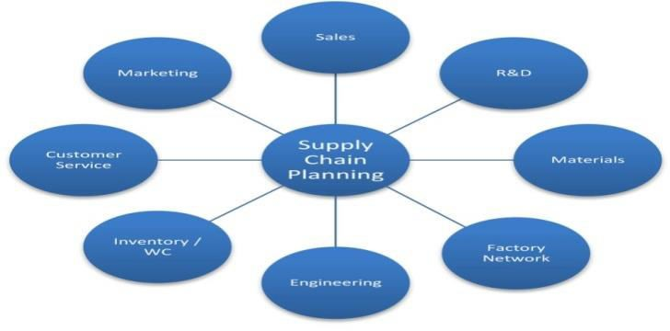

History of Supply Chain Management:

Everything related to materials handling and warehouse design and layout was manual in early years.

The 1980s marked the beginning of a sea-change in the history of supply chain management. The emergence of personal computers in the early 1980s provided tremendously better computer access to planners and a new graphical environment for planning.

The communication capabilities have fundamentally changed the way we think about communications and information sharing. Advances in communications technology, such as the Internet and mobile phones, are making it easier to track and discuss corporate activities.

The term “supply chain management" was in boom in mid of 1990s with the advent of globalization. Globalization brought tremendous change and development in warehousing and distribution, transportation, and manufacturing logistics.

Supply chain management (SCM) is the active management of supply chain activities to maximize customer value and achieve a sustainable competitive advantage. It represents a conscious effort by the supply chain firms to develop and run supply chains in the most effective & efficient ways possible. Supply chain activities cover everything from product development, sourcing, production, and logistics, as well as the information systems needed to coordinate these activities.

The concept of Supply Chain Management (SCM) is based on two core ideas:

The first is that practically every product that reaches an end user represents the cumulative effort of multiple organizations. These organizations are referred to collectively as the supply chain.

The second idea is that while supply chains have existed for a long time, most organizations have only paid attention to what was happening within their “four walls.” Few businesses understood, much less managed, the entire chain of activities that ultimately delivered products to the final customer. The result was disjointed and often ineffective supply chains.

The organizations that make up the supply chain are “linked” together through physical flows

and information flows.

Physical Flows

Physical flows involve the transformation, movement, and storage of goods and materials. They are the most visible piece of the supply chain. But just as important are information flows.

Information Flows

Information flows allow the various supply chain partners to coordinate their long-term plans, and to control the day-to-day flow of goods and materials up and down the supply chain.

Case study

Pantaloons is among India's largest chains of fashion stores, These stores have presence with stores not just in Metros but also in smaller towns. All stores have wide range of categories like casual wear, ethnic wear, party wear and sports wear for men, women and kids.

Strength:

Pantaloon Retail operates in over twenty diverse store formats, with a spectrum of offerings ranging from food and grocery to carpentry service.

Pantaloon develops long term relationship with the suppliers in a manner that ensures sustainability and grwoth of every supply partner.

Pantaloon helps customers save more, and providing guarantee up to date, provides wide choice of products ranges for all segments and purchasing power.

aware in providing relevant products i for every community help protect and celebrate local customs, festivals and art forms .

Pantaloon providing benefits and training to all employees to improve their knowledge and skill base for professional growth.

Weakness:

The number of Pantaloon Outlets available across the country is very limited.

Products available on e-retailing are also very limited.

Inability to develop customer loyalty.

Cannibalization of sales by ‘Big bazaar’ another chain of stores under PRIL.

Opportunities:

Opening of new malls not only in the metro’s but also in smaller cities and towns.

Concept of rural malls becoming more famous across the country.

With more middle class families having more disposable income and also the population of the youth expected to increase almost by 50% , we can expect a growth in retailing sector.

Customers becoming more brand conscious.

Threats:

Governments changing policy with Foreign Direct Investment, entry of foreign retailers could be a major threat.

Increasing cost of raw materials could be a big concern as price is a big concern for most Indian consumers.

Competitors opening more number of stores around the location of Pantaloons.

Although more malls are being opened, the shopping culture has still not evolved in India.

DEMAND

Demand in economics is the consumer's desire and ability to purchase a good or service. It's the underlying force that drives economic growth and expansion. Without demand, no business would ever bother producing anything.

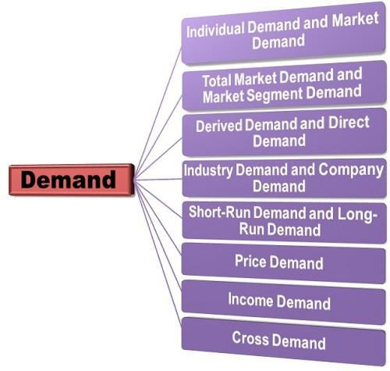

Type of Demand

Individual Demand and Market Demand: The individual demand refers to the demand for goods and services by the single consumer, whereas the market demand is the demand for a product by all the consumers who buy that product. Thus, the market demand is the aggregate of the individual demand.

Total Market Demand and Market Segment Demand: The total market demand refers to the aggregate demand for a product by all the consumers in the market who purchase a specific kind of a product. Further, this aggregate demand can be sub-divided into the segments on the basis of geographical areas, price sensitivity, customer size, age, sex, etc. are called as the market segment demand.

Derived Demand and Direct Demand: When the demand for a product/outcome is associated with the demand for another product/outcome is called as the derived demand or induced demand. Such as the demand for cotton yarn is derived from the demand for cotton cloth. Whereas, when the demand for the products/outcomes is independent of the demand for another product/outcome is called as the direct demand or autonomous demand. Such as, in the above example the demand for a cotton cloth is autonomous.

Industry Demand and Company Demand: The industry demand refers to the total aggregate demand for the products of a particular industry, such as demand for cement in the construction industry. While the company demand is a demand for the product which is particular to the company and is a part of that industry. Such as demand for tyres manufactured by the Goodyear. Thus, the company demand can be expressed as the percentage of the industry demand.

Short-Run Demand and Long-Run Demand: The short term demand is more elastic which means that the changes in price or income are reflected immediately on the quantity demanded. Whereas, the long run demand is inelastic, which shows that demand for commodity exists as a result of adjustments following changes in pricing, promotional strategies, consumption patterns, etc.

Price Demand: The demand is often studied in parlance to price, and is therefore called as a price demand. The price demand means the amount of commodity a person is willing to purchase at a given price. While studying the demand, we often assume that the other factors such as income of the consumer, their tastes, and preferences, the prices of other related goods remain unchanged. There is a negative relationship between the price and demand Viz. As the price increases the demand decreases and as the price decreases the demand increases.

Income Demand: The income demand refers to the willingness of an individual to buy a certain quantity at a given income level. Here the price of the product, customer’s tastes and preferences and the price of the related goods are expected to remain unchanged. There is a positive relationship between the income and demand. As the income increases the demand for the commodity also increases and vice-versa.

Cross Demand: It is one of the important types of demand wherein the demand for a commodity depends not on its own price, but on the price of other related products is called as the cross demand. Such as with the increase in the price of coffee the consumption of tea increases, since tea and coffee are substitutes to each other. Also, when the price of cars increases the demand for petrol decreases, as the car and petrol are complimentary to each other.

These are some of the important types of demand that the firms must cater to before deciding on the price and other factors related to their products.

Demand Planning

Demand planning is the process of forecasting the demand for a product or service so it can be produced and delivered more efficiently and to the satisfaction of customers. It is a main step in SCM. The purpose of demand planning is to prepare a statistical forecast. A planning team is usually assembled from the sales, operational and technical departments.

The team starts by reviewing the available information, such as historical data on sales, market research and surveys, and then agrees on a forecasting model it believes will be most effective at predicting demand. The team can then add new data as it comes in, such as actual sales of a product or competing products, and revise the model and resulting forecasts if necessary.

Demand planning is an integral part of the supply chain and perhaps the most crucial function of any enterprise. In this post, we look into the demand planning process for the manufacturing and service industries.

Demand planning refers to the future requirements for the products and services of the organisation. The process includes the identification, planning and management of the accurate and forecast business demands. This strategic function in the organisation’s supply chain is essential to coordinate and ensure the production alignment to meet demand, and plays a key role in influencing production flows and incoming sales. In the manufacturing industry, the demand planning function is responsible for managing the product demand and determining the raw materials and other goods required, which influences the procurement process. Demand planning is usually managed through a suitable management system such as MRP (master resource planning).

The success of a supply chain is often linked to its efficiency, which can be traced back to the ability of managers to conduct accurate forecasting when it comes revenue and inventory. Those two facets of a business are tied to a crucial process in the world of supply chain: demand planning.

Demand planning uses analytics that examines historical sales data, customer orders, shipments, current sales, and market indicators to better predict demand patterns based on market changes, enabling firms to make smart decisions about inventory and production levels.

Good demand planning is highly accurate, based on data and enhances profitability. But the process can be tedious, time-consuming and easy to mess up. One area of a supply chain, such as procurement, may improve its ability to forecast future demand, but logistics and manufacturing may lag behind, leading to higher levels of inventory and escalating costs.

Without proper demand planning, supply chains wind up dealing with production delays, inventory surpluses and strained relationships across the various disciplines that make up an organization. Avoiding such problems would call for professionals that possess two important skill sets:

Methods of demand planning

Much of the demand planning process consists of gathering and analyzing data that can be used to predict demand. Often, this involves collecting point-of-sale (POS) terminal data and analyzing it with the analytics tools in demand planning software. Some companies store POS data along with other demand signals, such as retail and wholesale inventory levels and data from loyalty programs, in a type of data warehouse called a demand signal repository.

Track the right metrics and use the right data – Metrics need to reduce error and paint a clearer picture, while data needs to simply identify areas where improvement is needed and drive accountability.

Define process models – Lacking a defined process for a demand planning cycle leads to chaos. Confusing process with information that is simply a set of widely known facts around an organization is all too common, making it difficult to hold anyone accountable and thus hurting overall performance. For most top supply chain companies, the demand planning process goes something like: preparation of data, initial forecasting, incorporation of market intelligence, meet with sales and finance teams to reconcile bottom-up forecasts with top-down finances and sales forecasts, refine a final forecast and finally, performance monitoring.

Careful implementation – Successful demand planners usually design a pilot version of the plan using historical data as a basis. They also make regular adjustments and have a team of people dedicated solely to the devising the plan, implementing it, reducing error and bias, and designing processes for execution.

A demand planner is entitled to do the followings; Create Annual Business Plan (ABP),

Align day to day, monthly and annual activities of ABP, Ensure all departmental data flow activities,

Ensure smooth operational coordination among production, sales and distribution & finance with Planning Statement,

Prepare Monthly, Annually Consumption Variance,

Prepare Business Plan including Master Budget, analysis and comparisons, Align National Stock Position with Sales, Production & Supply Chain,

Monitoring the progress on appropriate Inventory Management,

Prepare yearly/monthly/weekly Material Requirement Plan (MRP) based on Sales Forecast & Production forecasts,

Align Year to date & Month to date consumption variance with required RM / PM, Prepare Balance of Material (BOM) with Item Master Database,

Prepare Comparative Statement for commercial purchases and do trend analysis on annual progress, Create Material Consumption report year-to-date depot wise,

Prepare Value Fill Rates & Order Fill Rates,

Methods of Demand Forecasting

Definition: Demand Forecasting is a systematic and scientific estimation of future demand for a product. Simply, estimating the sales proceeds or demand for a product in the future is called as demand forecasting. There are several methods of demand forecasting applied in terms of; the purpose of forecasting, data required, data availability and the time frame within which the demand is to be forecasted. Each method varies from one another and hence the forecaster must select that method which best suits the requirement.

The methods of forecasting can be classified into two broad categories:

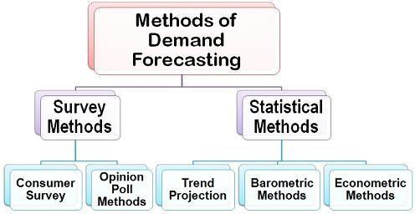

Survey Methods: Under the survey method, the consumers are contacted directly and are asked about their intentions for a product and their future purchase plans. This method is often used when the forecasting of a demand is to be done for a short period of time. The survey method includes:

Consumer Survey Method Opinion Poll Methods

Statistical Methods: The statistical methods are often used when the forecasting of demand is to be done for a longer period. The statistical methods utilize the time-series (historical) and cross-sectional data to

estimate the long-term demand for a product. The statistical methods are used more often and are considered superior than the other techniques of demand forecasting due to the following reasons:

There is a minimum element of subjectivity in the statistical methods.

The estimation method is scientific and depends on the relationship between the dependent and independent variables.

The estimates are more reliable

Also, the cost involved in the estimation of demand is the minimum. The statistical methods include:

Trend Projection Methods Barometric Methods Econometric Methods

Operations Management in Supply Chain

Operations management is chiefly concerned with planning, organizing and supervising in the context of production, manufacturing or the provision of services. It is delivery focused, ensuring that an organization successfully turns inputs to outputs in an efficient manner.. Inputs may be materials, equipments and technology.

The two disciplines of supply chain management and operations management are closely linked and dependent upon each other. In most organizations, supply chain management is part of operations management. But one contrast between supply chain and operation management is that operations management occurs internally. Operations managers work with various departments toward common goals – such as making sure the company’s products are manufactured according to specifications, packaged properly, sold to the right retailers and marketed successfully. Whether they’re working for a restaurant chain, a healthcare system or an automobile manufacturer, operations managers share many duties, including:

Forecasting sales Improving productivity Increasing responsiveness

Meeting customers’ demands Maintaining quality standards Contributing to the bottom line

Operations management can be strategic, tactical and operational. For example, an operations manager may be responsible for determining where a manufacturing plant is located, or the structure of a communications network. Designing the physical plant and selecting equipment may come under their direct supervision, along with managing inventory and monitoring quality control. Operations

management careers can be found in a wide variety of industries and businesses. Landing a job typically requires a strong understanding of business essentials, as well as the fundamentals of operations management – all of which are covered in an MS in Supply Chain Management degree program. Earning this respected credential can give you an advantage over the competition when pursuing operations management positions.

Operations and Supply Chain

The major difference between supply chain management and operations management is that supply chain is mainly concerned with what happens outside the company – obtaining materials and delivering products – while operations management is concerned with what happens inside the company.

Operations and Supply Chain

In smaller organizations, there can be overlap between operations and supply chain management. One person or department can manage or play a role in both supply chain and operations. In part this is because Supply Chain Management has become more complex over time and the demand for highly trained professionals has emerged. Previously, the roles in SCM were handled by Operation’s professionals. Both positions require leadership, goal setting, organization, finance, and decision making. Managers in both areas oversee people, parts, and supplies. They both require the ability to communicate across departments internally and externally, to lead people and teams, and to manage human capital.

What is Operations Management?

Depending on the size of the organization, operations managers manage day-to-day operations for an entire business or they may manage a specific part of the production process. Operations has a more internal company focus relative to supply chain. Operations managers make key decisions on design, production, planning, workflow, and staffing. Typical responsibilities include:

Directing and coordinating production, pricing, sales, or distribution of products managing finance activities including sales and other data evaluating performance data to make appropriate decisions regarding productivity, cost control, and improvements managing staff, work schedules, and assigning specific duties directing and coordinating budget activities determining products to be sold based on forecasts of customer demand.

What Is Supply Chain Management?

Generally, supply chain managers work more externally than operations managers. In today’s global market, supply chain managers are expected to have an understanding of working with suppliers, logistics, and customers all over the world. They make key decisions on suppliers, coordinate purchasing, warehousing, and forecasting. Supply chain management is focused externally. Its focus is on:

Planning products that consumers will want to buy sourcing raw materials, components or parts Transporting and warehousing products Delivering the goods to the point of purchase Supply Chain manager duties may include:

Forecasting demand for materials or products creating supply plans to ensure availability of raw materials evaluating suppliers and determining the effectiveness of multiple supplier strategies evaluating risks to supply chains and suppliers as well as troubleshooting issues in the chain analyzing inventories to determine how to increase inventory turns, reduce waste or optimize customer service managing activities

related to purchasing, inventory control, and warehousing coordination of supply chain with other functional areas, such as sales, marketing, finance, production or quality assurance.

Manage supply chain staff

Supply chain students focus on global markets, global supply chains, quality control, inventory control, transportation and logistics, decision modeling, forecasting, and designing value into the supply chain.In today’s environment, there is an unfortunate tendency to focus on the tools being used rather than understanding the problems faced. For example, consider a company with inventories growing out of control. Several consultants immediately had concluded the problem of too much inventory could be solved by adopting lean principles. In this instance, the solution was wrong. If the consultants understood the problem, they would have seen that the excess inventory was generated by bad forecasting rather than bad production practices. Reducing setups and run sizes could not make the forecasts better. Here, the tool drove the problem, rather than the problem driving the tool.

Principle of Manufacturing Management

It is a time to use new manufacturing strategies in the supply chan M. To achieve success and competitive advantage, all manufacturing companies in a supply chain must reduce cost, minimize process failures, globalize their operations, and improve quality.

Principle of organization

—All aspects of production must be organized into a coherent whole. Anybody can throw components together and get shipments out the door, but that does not ensure profits. If profits are to be predictable and consistent, then all activities leading to profits must be predictable and consistent with one another. It has long been recognized that manufacturing is related to systems in that it is an interconnected set of relationships. Changing one element of the system can lead to unpredictable results. Manufacturing has suffered from numerous instances of managers failing to recognize this interdependency. For example, one firm refurbished jet engines and competed on speed and flexibility. No matter what engine the customer provided, the company could turn it around faster than the competition. They offered this capability at a premium price. Internally, this strategy imposed a cost in the form of low capacity utilization and high spare parts inventory. Ultimately, because of its high prices, the firm was acquired by a large conglomerate. The manager assigned to take over this new acquisition saw a way of further improving profitability by increasing inventory turns. As inventory fell, lead times increased and sales suffered. The new leader didn’t recognize that excess inventory, which he saw as an evil, was the foundation upon which the company’s success was built. Moreover, he forgot that operations managers are the people responsible for ensuring all parts of the system work together.

Principle of fundamentals

—Strict adherence to the fundamentals is the foundation upon which all effective production is based. Maintaining accurate inventory records, bills of material (BOMs), general system disciplines, and the like will take operations managers80 percent of the way to success. The other 20 percent comes from adapting solutions, such as TOC, lean, and TQM, to a firm’s particular needs. Manufacturers rely on the fundamentals to survive. The only time professionals consider the fundamentals is when something goes wrong. Top managers are seldom interested in measuring fundamentals and their impact on performance; fundamentals just aren’t exciting. Managers want to see themselves as innovators, who push the boundaries of technology and practice. Managers assign fundamental measurement to a subordinate, who does not have the authority to enforce the disciplines necessary.

Principle of accountability

—People will not put effort into that for which they are not held accountable. Rewards and consequences, on the other hand, will result in great resolve.

Principle of variance

—Variances are inherent in every process. Lean literature gives the impression that variance is bad. This is too simplistic a view. The value of variance depends on the goals of the system. When the goal is to reduce cost and increase system predictability, then variance must be measured, monitored, and ultimately reduced. When the goal of the system is to increase options or enhance variety, then variance should be encouraged. But variance is more than dimensional deviation. It also refers to procedural variations and variations in thought processes. While dimensional deviation is never acceptable, process variation often leads to improved processes. Variation in thought processes is the source of creativity. If the goal is to foster radical innovation, then variance in thought processes is critical to success. Such variance increases the chances of finding a truly innovative new product. Yet, it is important to recognize that the two approaches to variance cannot be combined.

Principle of causality

—Problems that managers face often are symptoms. Consider urgent shipments, late quotes, expediting, and the like. Unless the underlying causes of these symptoms are resolved, managers will find themselves continuously fighting residual symptoms. To get rid of the symptom, the root causes must be resolved. Symptoms, such as late shipments, high scrap rates, and inaccurate inventories, demand attention because they are visible and urgent. Like a thermometer, they indicate the presence of a problem. However, attacking symptoms is ultimately self-defeating because they will either pop up somewhere else or recur later. Many times, treating one symptom—high inventories, for example—creates another symptom—low customer service. The real task is to determine the right level of inventory and what drives the requirement for the excess. Then, eliminate it.

Principle of managed passion

—Nothing drives a company forward like employees with a passion for their jobs. Nothing drags a company down like employees just putting in time. We all have worked with a person who has a passion for his or her job. These people are a joy, and they seem to get more done.

Principle of humility

—As good as an operations manager is, he or she will never know everything. Managers should not hesitate to admit ignorance, when appropriate, or get help from wherever it may come. A manufacturing manager is not hired because he knows it all. It is not necessary to be a winner on Jeopardy to succeed in manufacturing. Rather, managers are hired to get things done; they are hired to set objectives, implement appropriate measures, allocate resources, and resolve variances when they occur. Pride is not an asset for an operations manager. When a manager encounters something unfamiliar, his company should not pay the costs of having the manager learn through trial and error. An effective manager should know his limitations. Good managers do not view their limitations as a personal failing. The manager’s focus should be on the goal, not on convincing everyone that he knows everything. Ultimately, ignorance is hard to hide. Managers should call for help, learn, and move on.

Principle of success—Define what constitutes success. Markets change; therefore, the definition of success must be revised often. This will require a rethinking of some or all of the aforementioned

principles. Success can be defined in many ways. However, the one way that ultimately makes sense is in terms of customer needs. Managers must identify the critical customer. Every operations management system deals with a chain of customers. Each is different; each makes unique demands on the manufacturing system. They are not equally important. Critical customers must be formally and explicitly identified. Managers must strive to exceed these customers’ expectations.

Principle of change —Every manufacturing solution is temporary. Where some solutions fail, others will excel. Consequently, every operations manager must manage for stability in the short term and change in the long term. Good managers must know how to learn, unlearn old systems, and relearn. Such skills are critical to survive in a world where the principle of change reigns supreme. Production management deals with decision-making related to production processes so that the resulting goods or service is produced according to specification, in the amount and by the according to specification, in the amount and by the according to specification, schedule demanded and at minimum cost. Production management also deals with decision making regarding the quality, quantity, cost, etc., of production. It applies management principles to production.

Meaning of Forecasting:

All organizations operate in the external environment which is dynamic and uncertain. As this environment contains factors which affect business operations, plans should be made keeping into account the impact of these factors on business. The behaviour of these factors keeps changing as they operate in the dynamic environment and, therefore, it has to be protected through forecasts. Plans should forecast events for efficient working of the organization. Organizations should analyze the environment through various techniques of forecasting, identify their strengths and weaknesses and formulate the plans. These forecasts are based on past. Present behaviour of these factors and the probability of their occurrence in future is, to an extent, an extension of how they have been occurring in the past and present, though however, unprecedented changes can always take place. Forecasting is closely associated with planning premises. Premising means formulating plans under a set of assumptions or forecasts which may affect the plans. Forecasting is a useful tool for planning. For instance, in sales planning, it helps to estimate and forecast market share of a firm. Firms may find it difficult to project sales of their product. Identifying future sales problems is not easy for companies, small or big.

In some cases, it is very difficult to get information about future market sales. Sales forecasting, in such a case, is not just an estimation of sales; it is also matching sales opportunities – actual and potential – with sales planning and procedures. Forecasting is an important aid in effective and efficient planning. It helps management in reducing its dependence on chance. Forecasting is helpful in better planning based on assumptions about the future course of events.

In the world of uncertainty, future can never be predicted perfectly. Yet, the marketer or the administrator must plan and take decisions using his judgment and estimate about future developments. Sales forecast is an estimate of how much a company can sell with its given resources, sales people and marketing programme.

A forecast requires assessment of two sets of factors:

The outside forces which influence business operations, such as the weather, government activity and competitive behaviour. These forces are uncontrollable;

The internal marketing methods or practices of the firm that are likely to affect its operations, such as product quality, price, advertising, distribution and service.

If forecast is a pre-requisite of planning, it is a planning premise. For example, planning based on future economic conditions of the country is a planning premise. If forecast is made after the plans are put into action, it is not a planning premise. For example, a new machine is purchased and put to use. Forecasts about revenues from this machine is not a planning premise but a mere forecast of the future expectations.

2. Approaches to Forecasting:

These are two approaches to forecasting.

Top-down Approach: In this approach, forecast is done at the corporate level or the strategic level. It starts with a forecast of general economic conditions. It forecasts gross national product, consumer and wholesale price index, interest rates, unemployment level, government expenditures, etc. and estimates the market potential of the product for the entire industry. Then, it determines its current market share and forecasts success of its product in the market. This forecast is used for operational planning and budgeting the future programmes.

Bottom-up Approach:

In this approach, middle and lower-level employees project the business operations in the coming years. For instance, they do customer survey to know what customers want to buy. Such forecasts are made by different sales people which are finally summed up to give the sales forecast. Usually a questionnaire is mailed or completed through telephonic interview with the prospective customers to make such forecasts. These forecasts are usually reliable for small period of one year.

Benefits of Forecasting:

Forecasting has the following benefits:

Future oriented: It enables managers to visualize and discount future to the present. It, thus, improves the quality of planning. Planning is done for future under certain known conditions and forecasting helps in knowing these conditions. It provides knowledge of planning premises with which managers can analyse their strengths and weaknesses and take action to meet the requirements of the future market.For example, if the TV manufacturers feel that LCD or Plasma televisions will replace the traditional televisions, they should take action to either change their product mix or start manufacturing LCD/Plasma screens. Forecasting, thus, helps in utilizing resources in the best and most profitable business areas.In the fast changing technological world, businesses may find it difficult to survive if they do not forecast customers’ needs and competitors’ moves.

Identification of critical areas: Forecasting helps in identifying areas that need managerial attention. It saves the company from incurring losses because of bad planning or ill defined objectives. By identifying critical areas of management and forecasting the requirement of different resources like money, men, material etc., managers can formulate better objectives and policies for the organisation. Forecasting, thus, increases organizational and managerial efficiency in terms of framing and implementing organizational plans and policies.

Reduces risk: Though forecasting cannot eliminate risk, it reduces it substantially by estimating the direction in which environmental factors are moving. It helps the organization survive in the uncertain environment by providing clues about what is going to happen in future. If managers know in advance about changes in consumer preferences, they will bring required modifications in their product design in

order to meet the changed expectations of the consumers. Thus, forecasting cannot stop the future changes from happening but it can prepare the organizations to face them when they occur or avoid them, if they can.

Coordination: Forecasting involves participation of organizational members of all departments at all levels. It helps in coordinating departmental plans of the organization at all levels. People in all departments at all levels are actively involved in coordinating business operations with likely future changes predicted as a result of forecasting. Thus, forecasting helps in movement of all the plans in the same direction.

Effective management: By identifying the critical areas of functioning, managers can formulate sound objectives and policies for their organizations. This increases organizational efficiency, effectiveness in achieving the plans, better management and effective goal attainment.

Development of executives: Forecasting develops the mental, conceptual and analytical abilities of executives to do things in planned, systematic and scientific manner. This helps to develop management executives.

4. Measures to Increase the Effectiveness of Forecasting:

Forecasting provides information to facilitate decision-making and planning. In the complex and turbulent environment, forecasts may go wrong and so would the plans based on these forecasts. This may prove hazardous for the company but making plans not based on forecasts is more hazardous. Forecasting is therefore, necessary. Since future may not behave as predicted and deviations may occur, forecasting skills should improve to reduce the range of errors. This amounts to making forecasting effective.

The following measures can help in increasing the effectiveness of forecasting:

Forecasting methods should be simple. Complex methods can confuse data rather than provide meaningful information.

Compare forecasts with the situation of “no change”. Changes may not always occur and “no change”

situation may prove to be accurate many times.

Long range forecasts should not depend upon a single forecasting method. Several forecasting methods should be adopted and average of their results should be used to make predictions.

Forecasts should not be made for very long periods. Length of forecasts should be shortened to improve their accuracy. Accuracy of forecasts decreases as the time period of prediction increases.

Managerial skill should be improved to make reliable forecasts for planning decisions. Whatever forecasts are made, they should have complete support of the top management to make their implementation effective.

Forecasts should be based on facts and figures and not personal biases of the forecaster.

Process of Forecasting:

The following steps usually result in effective forecasting:

Determine the objective for which forecast is required:

Managers should know the reasons why forecasts are required. If there are rapid changes in the environment, it is necessary to forecast the environmental factors. Past records of the companies provide useful framework to know how effective forecasts have been in the past in making business operations successful.

Unless managers are clear of the reasons why forecasts are required to be made, the right choice of technique and also the right forecasts will not be made. Wrong forecasts lead to wrong business decisions, faulty planning and losses for business organisations.

Select the appropriate forecast method:

Depending upon the objective for which forecast is required, managers select the appropriate forecasting technique. These techniques may be quantitative or qualitative in nature. Based on past and present response of companies to environmental variables, these techniques represent future trend or behaviour of business activities. This future behaviour is supposed to be the likely outcome of forecasting method adopted.

Compare the actual results:

Though managers put in the best of efforts to forecast the future operations, the forecasts may still go wrong or the environmental changes may take place other than those predicted. In either case, the results or outcomes of forecasts will be different from those projected. This may require in making new forecasts or changes in plans because of changes in environmental factors. The actual results are, thus, compared with the forecasted results and deviations are detected as soon as possible so that necessary changes can be made in the forecasts or the plans.

Review and revise the forecasts:

If the actual results happen to be as projected, these forecasts become the basis for future forecasting. If, however, actual results are different from those projected, the forecasts are reviewed and revised to ensure better outcomes in the next forecasting period.

6. Techniques of Forecasting:

There are a number of techniques through which forecasts can be made. No technique can universally apply in similar business situations. These techniques, singly or in combination, are used depending upon the business situations when they have to be used.

The techniques of forecasting generally fall into two categories:

Quantitative Forecasting:

It applies mathematical models to past and present information to predict future outcomes. These techniques are used to have access to hard or quantifiable data. Some of the quantitative techniques are time series analysis, regression models and econometric models.

Qualitative Forecasting:

It applies when data are not available or very little data are available. Managers use judgement, intuition, knowledge and skill to make effective forecasts. Some of the qualitative techniques are jury of executive opinion method, sales force composite method and users’ expectation method.

These techniques are used for:

External environmental forecasting and

Internal environmental forecasting External Environmental Forecasting:

No firm, large or small, over a period of time, remains in a static condition. It experiences upward or downward swing. Robert C. Turner, an economist, states, “Business forecasting is unavoidable. Every business decision involves a forecast, implicit or explicit, because every business decision pertains to the future. Although business decision makers should neither accept any forecast as infallible nor rely exclusively on it, they would be well advised to give forecasts a significant weight in their own planning.”

Forecasts related to external environment are:

Economic forecasting,

Technological forecasting,

Forecasting regarding Government policies, and

Sales forecasting.

Choice of Forecasting Methods:

In practice, no single technique of forecast can apply to make predictions. A combination of different techniques is followed by the forecasters, where positive attributes of all the techniques are unified into a single forecast.

In a joint opinion method to make forecasts, all those concerned with the problem area jointly make judgments and forecasts are made through consensus of opinion. The best forecasting technique is a blend of statistical and industry/group/ industry judgment.

Accurate:

The forecast method should be accurate in terms of predicting results. No method can, however, be 100 per cent accurate. A range of deviations is, therefore, accepted by the forecasters. A range of 5 to 10 per cent is usually accepted by forecasters depending upon the nature of product, market, industry and the forecast.

Flexible:

Forecasting method should be flexible. It should change according to changing environmental conditions. Deviations in actual implementation become the basis of adopting another method of forecasting to make predictions.

Efficient: Every forecasting method has benefits and costs. Forecasts should adopt a method whose benefits are more than the costs to achieve optimum results.

Timeliness:

Forecasts should provide timely information of future behaviour of consumers, sales and industry trends. If forecasts exceed the time for actual sales in the market, they will become inefficient forecasts as costs would exceed the expected revenues. Though they should not relate to very near future, they should cover a period long enough to make rational forecasts.

Availability of information and personnel:

Good forecasts depend upon reliable, timely, accurate and comprehensive information about future. Lack of information will lead to wrong estimates and wrong forecasts. Besides availability of information, people who use this information should also be qualified to process the formation to market rational forecasts. Quality information will not generate quality forecasts if people do not have knowledge to process that information. People, therefore, have to be trained to make best use of information to make accurate forecasts.

IT in SCM

Technology can help to simplify your supply chain management, which will enable your business to operate more efficiently, give you more visibility and control over your inventory, and help to reduce your operational costs.

Introduction to IT used in Supply Chain Recent development in technologies enables the organization to avail information easily in their premises. These technologies are helpful to coordinates the activities to manage the supply chain. In the field of supply chain management, there has always been an abundance of data. Shipping bills alone make a lot of information. Gathering the data is important; evaluating the information, setting benchmarks and measuring performance and progress is critical, the purity of raw material is important. The small issues can have a measure impact. From the data available many reports are generated, which can pinpoint simple solutions that can generate cost saving and or service improvements.

Importance of IT Management In Supply Chain Gathering and evaluating information For report generation and decision making Competitive advantage Integrating and coordinating processes of supply chain Cost of information sharing Quick response

Benefits of Information Technology In Supply Chain Provide information availability and visibility Enable a single point of contact for data Allow decisions based on total supply chain Information Enable collaboration with Partners

Type of IT Use in SCM Drivers of Using IT in SCM Transaction processing Supply chain planning and collaboration Order tracking and delivery coordination

•Reduction of Cost.

•Volume of Transactions.

•Speeding up Information transfer

. •Elimination of Human Errors.

•Unpredictable and logistically demanding Environment.

•Project Orientation of the Business.

•In Transit Delivery Consolidation. Areas in which IT Use For Optimizing Supply Chain

Advanced planning and scheduling

Advanced planning and scheduling (APS) is a type of system that tracks costs based on the activities that are responsible for driving costs in the production of manufactured goods. An APS allocates raw materials and production capacity optimally to balance demand and plant capacity. It is an integrated system that can support shifting decisions in supply chain management. It analyses the implications of alternative decisions, highlights problems & consequences, and schedules for transfer to execution tools. It recommends a best overall solution that considers both material and resource availability.

INTEGRATED LOGISTICS-Logistics helps to interlink an enterprise with its customers and suppliers, there is inventory and information flow in this.
- PARTICIPANTS OF SUPPLY CHAIN MANAGEMENT- Suppliers, wholesalers, distributors, retailers, customers

COLD CHAIN STORAGE-Series of facilities for maintaining ideal temperature storage condition for perishables from point of origin to point of consumption. It consists of pre cooling facilities, refrigerated carriers, packaging etc

REVERSE LOGISTICS- Process of moving a product from the point of consumption to the point of origin like replacement of defective goods, repairing used products, replacing expired products etc.

ELECTRONIC DATA INTERCHANGE-Fastest, easiest and most productive way to conduct business with the transportation, warehousing and logistics industry. EDI is the exchange of information within or outside using electronic measure.

Procurement

Purchase (procurement) is as important function as production and marketing in contributing to profit and other objectives of an organisation. It deserves all the skills and knowledge of modern professional management. The importance of procurement function in agro-business is even more due to the following reasons:

Cost of raw material constitutes a very high percentage of the total cost of processed products• It involves operations under highly fluctuating markets•

It affects the economy of large number of producers (farmers) often inviting government intervention• The importance of agro-processing is increasing in view of the expected large growth of demand for processed products for internal consumption and exports, entry of a number of large national and multinational corporations in an organised manner. Retailing of processed agro-based products, fresh fruits and vegetables and other agricultural commodities has further created demand for professional

procurement managers. On socio-economic front, agri-business has a high potential for generation of non-farm employment. Hence, procurement of agricultural raw materials is expected to provide more challenging opportunities in years to come.

Nature of Agricultural Commodities

Perishable

Some of the agricultural commodities, such as milk, green leafy vegetables, and some fruits are highly perishable. These have to be procured as soon as produced, marketed/processed immediately so that quality is not lost and wastage is minimised before these reach the consumer.

Season Specific

Some of the agricultural raw materials are produced during specific season. For example, wheat is produced in winter (Rabi season), harvested in March-April and arrives in mandis, April onwards. Paddy is cultivated in rainy season (Kharif) and generally harvested in November (though in some regions of the country it is cultivated all the year round). Hence, procurement period for these crops is different. Similarly, there are fruits and vegetables that are available only in certain seasons. Thus, the seasonality of production determines the timing of procurement.

Region and Agro-climatic Specific

There are certain crops which grow only in certain locations having the needed agro-climatic conditions, e.g., apples in Kashmir and Himachal Pradesh, grapes in and around Nasik and Hyderabad, while onions cultivated all over India, are primarily available in and around Nasik. Tea is grown in North Bengal and Ooty Hills. Coffee and spices in South India’s coastal belt.

Essential Commodities

There are certain commodities which are considered as essential commodities as this form a major part of the food and consumption. These commodities are essential for survival and health of the people. These are cereals, pulses, oilseeds, oil, milk, sugar, salt, etc. Central and State governments keep a constant watch on production, movement, availability and prices of such commodities. It keeps large buffer stock of cereals and controls the prices of many essential commodities. A procurement manager has to be aware of government policy and regulations, while dealing with such commodities.

Price Variations

These said reasons, agricultural commodities are subjected to high price variations. The price variations greatly affect the purchasing decision in terms of quantity purchased for production of finished products, fixation of price for the consumable products, difficulty in competing with alternate products, etc., thus, you as a procurement manager needs to be aware of the following:

The characteristics/nature of commodities• The place of production•

The location of mandis where a particular raw material can be purchased•

Government policy and regulations related to marketing of agricultural commodities especially, essential commodities Price variations

Procurement Management Environment

Indian agriculture is an economic activity with mainly a small unit of management as are fishery and livestock rising. The small size causes two problems. On one hand, providing knowledge of modern agricultural practices (extension services), credit, inputs, irrigation, power and other services (including infrastructure) to each farmer and other primary producers becomes increasingly difficult and costly. On the other hand, small units produce small quantities; two units may produce the same commodity, but of somewhat different qualities. From this small produce ,he keeps some for his consumption and some for seed for next season. This marketable surplus is even smaller. This small surplus somehow gets pooled and then reaches the market.

Procurement managers of companies involved in buying commodities for marketing/processing/organised retailing and exports often list the problems that they face in getting the material of right quality, in the right quantity, at the right time and at the right price, caused by small and varied offerings of individual producers. Agricultural export business has been particularly affected by this, since exporters have to function in markets which are competitive in terms of quality, quantity, time and price.

Types of Purchasing

There are two types of purchasing, which are discussed in the paragraphs below:

Purchasing for Resale

In this type, buyer purchases the material for resale. This is done by traders, merchants, speculators and trading firms. For example, small traders/merchants buy wheat, paddy, oilseed, etc., from the farmers in villages and/or mandis (regulated markets) and resale these to bigger merchants/commission agents, retail shops, processing companies, etc. Speculators and trading firms buy such commodities and take physical delivery, stock these for some time and sell these when the prices are high, and make profit. For resale, the buyer knows in advance the market price and what his customer wants and sells the commodity at a price which includes his cost of buying (i.e., price he paid for the commodity plus his cost of travel, weighing, packaging, transport, octroi, and losses in trading the material), and profit.
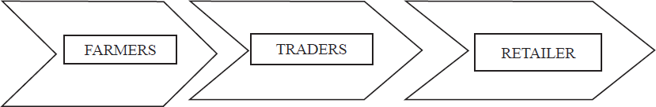

The buyers purchase from the farmer at a price which permits resale at a profit. Further, he is quite aware of the price he is likely to get in the mandis as well as the costs likely to be incurred on weighing, packaging, handling and transport. It is because of this knowledge of market price and various costs, he makes a profit. E.g., a vegetable hawker buys fruits and vegetables from the mandi early morning, load these on his/her four wheel cart, or carries it on his/her head, goes round the housing colonies or parks his cart at roadsides, and sell these to consumers. E.g., even large companies buy fruits and vegetables from farmers and mandis and after cleaning & grading sell these in retail chains, and supermarket outlets. For example, we have Reliance Fresh, Subhiksha, Tata’s Star Bazaar supermarket, Big Bazaar’s Food Bazaar, ITC’s e-choupal system for purchasing and reselling of farm produce. This kind of system of purchasing activities can be encouraged among the members of SHGS/FIGs/ CIGs to involve in group marketing.

Procurement Objective

The classical definition of procurement objective is to buy the following materials and services: Of the right quality

Of the right quantity At the right price

From the right source At the right time

Futures Trading and Agricultural Marketing

The futures market has emerged as one of the pivotal determinant of agricultural commodity production system and serving as a platform for discovering market prices in the recent past. Here, farmers selling a future contract and committed to deliver their produce at future date (may be after harvest of the produce, e.g., wheat, corn, groundnut, soya, etc.,) not to any buyer, directly, but to the clearing house of futures exchange. In this type of trading, the future prices are viewed as bench mark for farmers as well as to traders. They support the farmer’s choice of raising crops and decision-making of marketing produce as regards to the following :

Which crop to grow?•

When to market?

When to switch from one crop to another? Cope with agro climatic conditions.

Input availability management.

Above all, it facilitates the farmers, to decide on the most appropriate time to sell their produce and enable to get better price realization.

Under some circumstances, the futures will advantageous to the stake holders of the system. They are described as follows.

There are agricultural commodities, whose production is seasonal, location/region specific, but consumption is

throughout the year and even seen nationwide. In such cases, traders and stockiest invariably carry risk of price changes in such commodities. These kinds of issues greatly supported futures trading, by helping to even out prices of seasonal commodities through the year.

This trading system also helps in deciding the level of farm diversification. Being market driven, futures trading

help growers in their diversification decision. Commodities that have a good market value are traded on the futures market and farmers with fair knowledge on this perspective can decide on diversifying their farm as per the market demand. The price of a certain crop fluctuates; it is a win-win situation for a farmer as he can hedge his risk in futures

platform.The organized and unorganized retailers at the delivery end would use this platform for the procurement purposes and can think of effective logistic services.

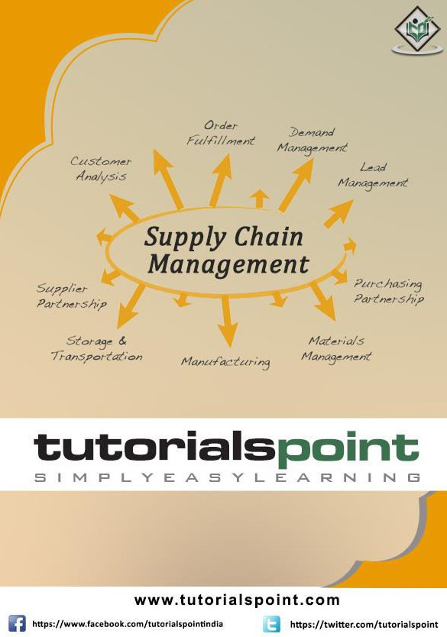

About the Tutorial
Supply Chain management can be defined as the management of flow of products and services, which begins from the origin of products and ends with the product’s consumption at the end-user.
This is a brief introductory tutorial that explains the methodologies applied in the rapidly growing area of Supply Chain Management in an organization.

Audience
This tutorial will be useful for students from management streams who aspire to learn the basics of Supply Chain Management. Professionals, regardless of which sector or industry they belong to, can use this tutorial to learn how to apply the methods of Supply Chain Management in their respective project environments.

Prerequisites
The readers of this tutorial are expected to have a general idea of what supply chain management means and what place and importance it holds in an organization.

Disclaimer & Copyright
© Copyright 2016 by Tutorials Point (I) Pvt. Ltd.
All the content and graphics published in this e-book are the property of Tutorials Point
      - Pvt. Ltd. The user of this e-book is prohibited to reuse, retain, copy, distribute or republish any contents or a part of contents of this e-book in any manner without written consent of the publisher.
We strive to update the contents of our website and tutorials as timely and as precisely as possible, however, the contents may contain inaccuracies or errors. Tutorials Point (I) Pvt. Ltd. provides no guarantee regarding the accuracy, timeliness or completeness of our website or its contents including this tutorial. If you discover any errors on our website or in this tutorial, please notify us at contact@tutorialspoint.com.

Table of Contents

About the Tutorial i
Audience i
Prerequisites i
Disclaimer & Copyright i
Table of Contents ii
- SCM – INTRODUCTION 1
Supply Chain Management – Advantages 2
Supply Chain Management – Goals 2
- SCM – PROCESS 4
Plan 4
Develop (Source) 4
Make 4
Deliver 5
Return 5
- SCM – PROCESS FLOW 6
Types 6
Material Flow 6
Information Flow 7
Money Flow 7
- SCM – FLOW COMPONENTS 8
Transportation 8
Warehousing 9
Sourcing and Procurement 10
Returns Management 10
Post-Sales Service 11
- SCM – DECISION PHASES 12
Supply Chain Strategy 12
Supply Chain Planning 13
Supply Chain Operations 13
- SCM – PERFORMANCE MEASURES 14
Quantitative Measures 14
Non-Financial Measures 14
Financial Measures 16
- SCM – STRATEGIC SOURCING 17
Understanding the Spend Category 18
Supplier Market Assessment 18
Supplier Survey 19
Building the Strategy 20
RFx Request 20
Selection 20
Communication with New Suppliers 20
- SCM – MAKE VS BUY 22
Business Strategy 23
Risks 24
Economic Factors 25
- SCM: NETWORKS 27
Network Models 28
- SCM – INVENTORY MANAGEMENT 30
Role of Inventory 31
Optimization Models 31
Mixed Integer Linear Programming 31
Stochastic Modeling 32
Uncertainty Modeling 32
Bi-level Optimization 32
- SCM – PRICING & REVENUE MANAGEMENT 33
RM for Multiple Customer Segments 33
RM for Perishable Assets 34
RM for Seasonal Demands 34
RM for Bulk and Spot Demands 35
- SCM – INTEGRATION 36
Push System 36
Pull System 37
Differences in Push and Pull System 37
Push & Pull System 38
Demand-Driven Strategies 39
- SCM – ROLE OF IT 41
Electronic Commerce 41
Electronic Data Interchange 42
Barcode Scanning 43
Data Warehouse 43
Enterprise Resource Planning (ERP) Tools 43
- SCM – AGILE AND REVERSE SUPPLY CHAINS 45
Agile Supply Chain 45
Reverse Supply Chain 46

Supply Chain Management can be defined as the management of flow of products and services, which begins from the origin of products and ends at the product’s consumption. It also comprises movement and storage of raw materials that are involved in work in progress, inventory and fully furnished goods.
Supply Chain Management

1. SCM – Introduction
The main objective of supply chain management is to monitor and relate production, distribution, and shipment of products and services. This can be done by companies with a very good and tight hold over internal inventories, production, distribution, internal productions and sales.
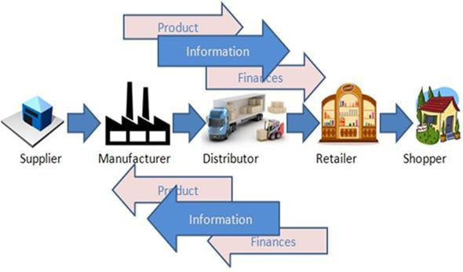
In the above figure, we can see the flow of goods, services and information from the producer to the consumer. The picture depicts the movement of a product from the producer to the manufacturer, who forwards it to the distributor for shipment. The distributor in turn ships it to the wholesaler or retailer, who further distributes the products to various shops from where the customers can easily get the product.
Supply chain management basically merges the supply and demand management. It uses different strategies and approaches to view the entire chain and work efficiently at each and every step involved in the chain. Every unit that participates in the process must aim to minimize the costs and help the companies to improve their long term performance, while also creating value for its stakeholders and customers. This process can also minimize the rates by eradicating the unnecessary expenses, movements and handling.
Here we need to note that supply chain management and supply chain event management are two different topics to consider. The Supply Chain Event Management considers the factors that may interrupt the flow of an effective supply chain; possible scenarios are considered and accordingly, solutions are devised for them.

Supply Chain Management – Advantages
In this era of globalization where companies compete to provide the best quality products to the customers and satisfy all their demands, supply chain management plays a very important role. All the companies are highly dependent on effective supply chain process.
Let’s take a look at the major advantages of supply chain. The key benefits of supply chain management are as follows:
  - Develops better customer relationship and service.

  - Creates better delivery mechanisms for products and services in demand with minimum delay.

  - Improvises productivity and business functions.

  - Minimizes warehouse and transportation costs.

  - Minimizes direct and indirect costs.

  - Assists in achieving shipping of right products to the right place at the right time.

  - Enhances inventory management, supporting the successful execution of just-in- time stock models.

  - Assists companies in adapting to the challenges of globalization, economic upheaval, expanding consumer expectations, and related differences.

  - Assists companies in minimizing waste, driving out costs, and achieving efficiencies throughout the supply chain process.
These were some of the major advantages of supply chain management. After taking a quick glance at the concept and advantages on supply chain management, let us take a look at the main goals of this management.

Supply Chain Management – Goals
Every firm strives to match supply with demand in a timely fashion with the most efficient use of resources. Here are some of the important goals of supply chain management:

  - Supply chain partners work collaboratively at different levels to maximize resource productivity, construct standardized processes, remove duplicate efforts and minimize inventory levels.

  - Minimization of supply chain expenses is very essential, especially when there are economic uncertainties in companies regarding their wish to conserve capital.

  - Cost efficient and cheap products are necessary, but supply chain managers need to concentrate on value creation for their customers.

  - Exceeding the customers’ expectations on a regular basis is the best way to satisfy them.

  - Increased expectations of clients for higher product variety, customized goods, off-season availability of inventory and rapid fulfillment at a cost comparable to in-store offerings should be matched.

  - To meet consumer expectations, merchants need to leverage inventory as a shared resource and utilize the distributed order management technology to complete orders from the optimal node in the supply chain.

Lastly, supply chain management aims at contributing to the financial success of an enterprise. In addition to all the points highlighted above, it aims at leading enterprises using the supply chain to improve differentiation, increase sales, and penetrate new markets. The objective is to drive competitive benefit and shareholder value.

Supply chain management is a process used by companies to ensure that their supply chain is efficient and cost-effective. A supply chain is the collection of steps that a company takes to transform raw materials into a final product. The five basic components of supply chain management are discussed below:
Supply Chain Management

2. SCM – Process

Plan
The initial stage of the supply chain process is the planning stage. We need to develop a plan or strategy in order to address how the products and services will satisfy the demands and necessities of the customers. In this stage, the planning should mainly focus on designing a strategy that yields maximum profit.
For managing all the resources required for designing products and providing services, a strategy has to be designed by the companies. Supply chain management mainly focuses on planning and developing a set of metrics.

Develop (Source)
After planning, the next step involves developing or sourcing. In this stage, we mainly concentrate on building a strong relationship with suppliers of the raw materials required for production. This involves not only identifying dependable suppliers but also determining different planning methods for shipping, delivery, and payment of the product.
Companies need to select suppliers to deliver the items and services they require to develop their product. So in this stage, the supply chain managers need to construct a set of pricing, delivery and payment processes with suppliers and also create the metrics for controlling and improving the relationships.
Finally, the supply chain managers can combine all these processes for handling their goods and services inventory. This handling comprises receiving and examining shipments, transferring them to the manufacturing facilities and authorizing supplier payments.

Make
The third step in the supply chain management process is the manufacturing or making of products that were demanded by the customer. In this stage, the products are designed, produced, tested, packaged, and synchronized for delivery.
Here, the task of the supply chain manager is to schedule all the activities required for manufacturing, testing, packaging and preparation for delivery. This stage is considered as the most metric-intensive unit of the supply chain, where firms can gauge the quality levels, production output and worker productivity.

Supply Chain Management

Plan

Develop
Return
Supply Chain Management
Deliver

Deliver

Make
The fourth stage is the delivery stage. Here the products are delivered to the customer at the destined location by the supplier. This stage is basically the logistics phase, where customer orders are accepted and delivery of the goods is planned. The delivery stage is often referred as logistics, where firms collaborate for the receipt of orders from customers, establish a network of warehouses, pick carriers to deliver products to customers and set up an invoicing system to receive payments.

Return
The last and final stage of supply chain management is referred as the return. In the stage, defective or damaged goods are returned to the supplier by the customer. Here, the companies need to deal with customer queries and respond to their complaints etc.
This stage often tends to be a problematic section of the supply chain for many companies. The planners of supply chain need to discover a responsive and flexible network for accepting damaged, defective and extra products back from their customers and facilitating the return process for customers who have issues with delivered products.

Supply chain management can be defined as a systematic flow of materials, goods, and related information among suppliers, companies, retailers, and consumers.
Supply Chain Management

3. SCM – Process flow

Types
There are three different types of flow in supply chain management:
  - Material flow
  - Information/Data flow
  - Money flow
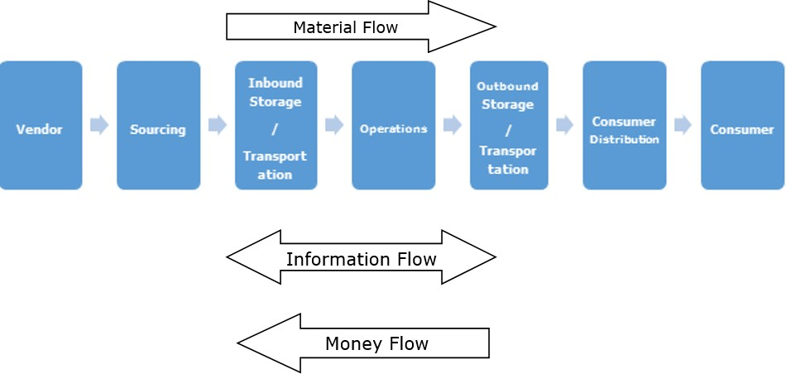

Let us consider each of these flows in detail and also see how effectively they are applicable to Indian companies.

Material Flow
Material flow includes a smooth flow of an item from the producer to the consumer. This is possible through various warehouses among distributors, dealers and retailers.
The main challenge we face is in ensuring that the material flows as inventory quickly without any stoppage through different points in the chain. The quicker it moves, the better it is for the enterprise, as it minimizes the cash cycle.
The item can also flow from the consumer to the producer for any kind of repairs, or exchange for an end of life material. Finally, completed goods flow from customers to their consumers through different agencies. A process known as 3PL is in place in this scenario. There is also an internal flow within the customer company.

Supply Chain Management

Information Flow
Information/data flow comprises the request for quotation, purchase order, monthly schedules, engineering change requests, quality complaints and reports on supplier performance from customer side to the supplier.
From the producer’s side to the consumer’s side, the information flow consists of the presentation of the company, offer, confirmation of purchase order, reports on action taken on deviation, dispatch details, report on inventory, invoices, etc.
For a successful supply chain, regular interaction is necessary between the producer and the consumer. In many instances, we can see that other partners like distributors, dealers, retailers, logistic service providers participate in the information network.
In addition to this, several departments at the producer and consumer side are also a part of the information loop. Here we need to note that the internal information flow with the customer for in-house manufacture is different.

Money Flow
On the basis of the invoice raised by the producer, the clients examine the order for correctness. If the claims are correct, money flows from the clients to the respective producer. Flow of money is also observed from the producer side to the clients in the form of debit notes.
In short, to achieve an efficient and effective supply chain, it is essential to manage all three flows properly with minimal efforts. It is a difficult task for a supply chain manager to identify which information is critical for decision-making. Therefore, he or she would prefer to have the visibility of all flows on the click of a button.

After understanding the basic flows involved in the supply chain management, we need to consider the different elements present in this flow. Thus, the different components of the flow of supply chain are described below.
Supply Chain Management

4. SCM – Flow Components

Transportation
Transportation or shipment is necessary for an uninterrupted and seamless supply. The factors that have an impact on shipment are economic uncertainty and instability, varying fuel prices, customers’ expectations, globalization, improvised technologies, changing transportation industry and labor laws.
The major elements that influence transportation should be considered, as it is completely dependent on these factors for order completion as well as for ensuring that all the flows work properly. The major factors are:

Long-term Decisions
Transportation managers should acknowledge the supply freight flow and accordingly design the network layout. Now, when we say long term decision, we mean that the transportation manager has to select what should be the primary mode of transportation.
The manager has to understand the product flows, volume, frequency, seasonality, physical features of products and special handlings necessities, if any. In addition to this, the manager has to make decisions as to the extent of outsourcing to be done for each

and every product. While considering all these factors, he should carefully consider the fact that the networks need not be constant.
For example, in order to transport stock to regional cross dock facilities for sorting, packaging and brokering small loads to individual customers, stock destinations can be assembled through contract transportation providers.

Lane Operation Decisions
These functional decisions stress on daily freight operations. Here, the transportation managers work on real time information on products’ requirements at different system nodes and must collaborate every move of the product that is both inbound and outbound shipping lanes so as to satisfy their services demands at the minimal possible cost.
Managers who make good decisions easily handle information and utilize the opportunities for their own profit and assure that the product is moved to them immediately, whenever it is demanded, that too in the right quantity. At the same time, they are saving cost on transportation also.

For example, a shipment has landed from a supplier who is based in New Jersey and in the same week, a product needs to be dispatched to New York as it becomes available for movement. If the manager is aware of this information in advance, he would prepare everything as per the demand and the products could be shipped out immediately.

Choice and Mode of Carrier
A very important decision to be made is to choose the mode of transportation. With the improvement in the means of transportation, modes of transport that were not available in the traditional transportation modes in the past can be now be a preferred choice.
For example, rail container service may offer a package that is cost-efficient and effective as compared to a motor transport. While making a decision, the manager has to consider the service criteria that need to be met, like the delivery time, date special handling requirements, while also taking into consideration the element of cost, which would be an important factor.

Dock Level Operations
This involves the last level of decision-making. This comprises planning, routing and scheduling. For example, if a carriage is being loaded with different customers’ orders, the function of the dock-level managers is to assure that the driver is informed of the most efficient route and that loads are placed in the order of the planned stops.

Warehousing
Warehousing plays a vital role in the supply chain process. In today’s industry, the demands and expectations of the customers are undergoing a tremendous change. We want everything at our door step – that too with efficient price. We can say that the management of warehousing functions demands a distinct merging of engineering, IT, human resources and supply chain skills.

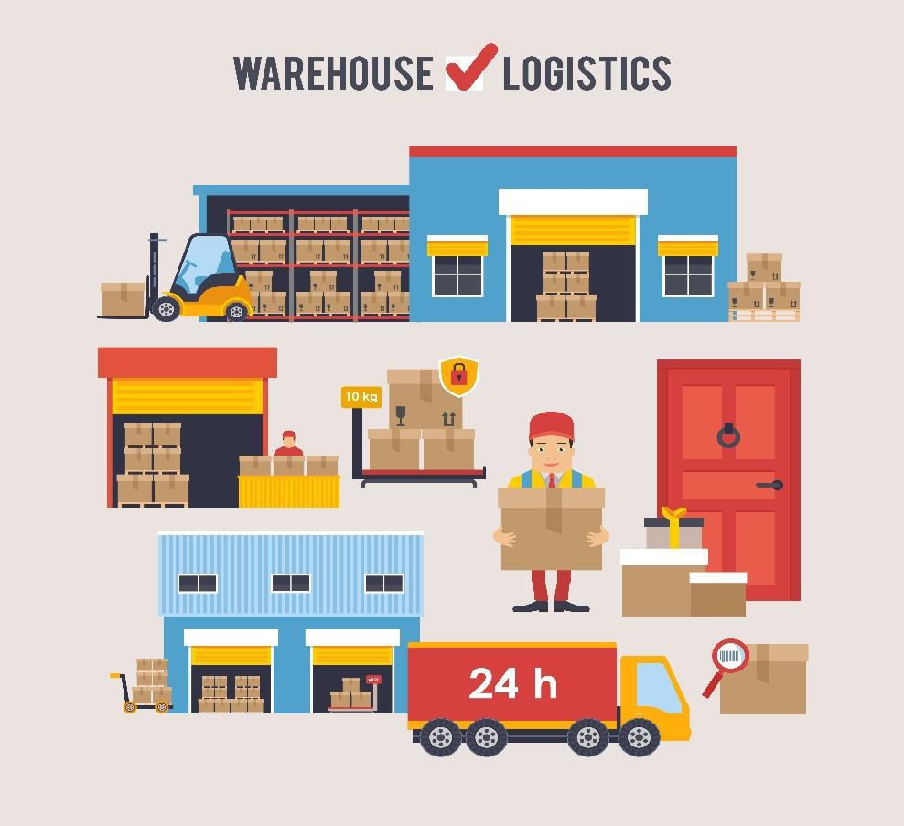

To neutralize the efficiency of inbound functions, it is ideal to accept materials in an immediately storable conveyance, like a pallet, case or box. For labeling the structure, tool selection and business process demand the types and quantities of orders that are processed. Further, the number of stock-keeping units (SKU’s) in the distribution centers is a crucial consideration.
The Warehouse Management Systems (WMS) leads the products to their storage location where they should be stored. The required functionality for the completion and optimization of receiving, storing and shipping functions is then supplied.

Sourcing and Procurement
Sourcing and procurement are a vital part of the supply chain management. The company decides if it wants to perform all the exercises internally or if it desires to get it done by any other independent firm. This is commonly referred as the make vs buy decision, which we will be discussing in brief in another chapter.

Returns Management
Returns management can be defined as the management that invites the merger of challenges and opportunities for inbound logistics. A cost-effective reverse logistics program links the available supply of returns with the product information and demand for repairable items or re-captured materials. We have three pillars that support returns management processes. These are as follows:
  - Speed: It is a must to have quick and easy returns management and automate decisions regarding whether to produce return material authorizations (RMAs) and if so, how to process them. Basically, the tools of speed return processing include automated workflows, labels & attachments and user profiles.

  - Visibility: For improving the visibility and predictability, information needs to be captured initially in the process, ideally prior to delivering the return to the receiving dock. Most effective and easily implementable approaches for obtaining visibility are web-based portals, carrier integration and bar-coded identifiers.

  - Control: In case of returns management, synchronizing material movements is a common issue that needs to be handled. The producers need to be very cautious and pay close attention to receipts and reconciliation and update the stakeholders of impending quality issues. In this case, reconciliation activates visibility and control all over the enterprise. The key control points in this process are regulatory compliance, reconciliation and final disposition and quality assurance.
Software solutions can assist in speeding up the returns management by supporting user profiles and workflows that state supply chain partners and processes, by labeling and documentation that tracks the material along with the web-based portals and by exception-based reporting to deliver information for timely reconciliation. These characteristics, when executed with the three pillars mentioned above, support a reliable and predictable returns process to count value across the company.
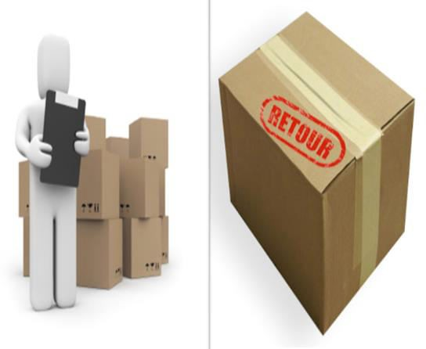

Post-Sales Service
Now that the ordered shipment is over, what is the next step? The post sales service in supply chain tends to be an increasingly essential factor as businesses offer solution instead of products.
The post sales services comprise selling spare parts, installing upgrades, performing inspection, maintenance and repairs, offering training & education and consulting.
Presently, with the growing demands of the clients, a high volume of after sales service proves to be a profitable business. Here, the services are basically heterogeneous and the value-added services are different from those provided prior to sales service.

Decision phases can be defined as the different stages involved in supply chain management for taking an action or decision related to some product or services. Successful supply chain management requires decisions on the flow of information, product, and funds that fall into three decision phases.
Supply Chain Management

5. SCM – Decision Phases
Here we will be discussing the three main decision phases involved in the entire process of supply chain. The three phases are described below:

Supply Chain Strategy
In this phase, decision is taken by the management mostly. The decision to be made considers the sections like long term prediction and involves price of goods that are very expensive if it goes wrong. It is very important to study the market conditions at this stage.
These decisions consider the prevailing and future conditions of the market. They comprise the structural layout of supply chain. After the layout is prepared, the tasks and duties of each is laid out.
All the strategic decisions are taken by the higher authority or the senior management. These decisions include deciding manufacturing the material, factory location, which should be easy for transporters to load material and to dispatch at their mentioned location, location of warehouses for storage of completed product or goods and many more.
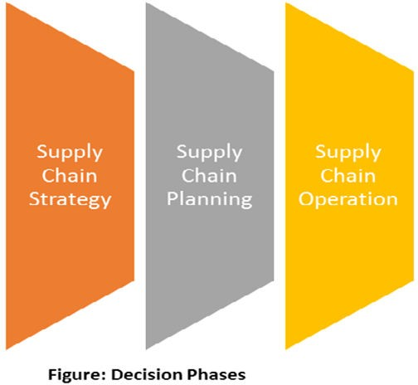

Supply Chain Management

Supply Chain Planning
Supply chain planning should be done according to the demand and supply view. In order to understand customers’ demands, a market research should be done. The second thing to consider is awareness and updated information about the competitors and strategies used by them to satisfy their customer demands and requirements. As we know, different markets have different demands and should be dealt with a different approach.
This phase includes it all, starting from predicting the market demand to which market will be provided the finished goods to which plant is planned in this stage. All the participants or employees involved with the company should make efforts to make the entire process as flexible as they can. A supply chain design phase is considered successful if it performs well in short-term planning.

Supply Chain Operations
The third and last decision phase consists of the various functional decisions that are to be made instantly within minutes, hours or days. The objective behind this decisional phase is minimizing uncertainty and performance optimization. Starting from handling the customer order to supplying the customer with that product, everything is included in this phase.
For example, imagine a customer demanding an item manufactured by your company. Initially, the marketing department is responsible for taking the order and forwarding it to production department and inventory department. The production department then responds to the customer demand by sending the demanded item to the warehouse through a proper medium and the distributor sends it to the customer within a time frame. All the departments engaged in this process need to work with an aim of improving the performance and minimizing uncertainty.

Supply chain performance measure can be defined as an approach to judge the performance of supply chain system. Supply chain performance measures can broadly be classified into two categories:
Supply Chain Management

6. SCM – Performance Measures
  - Qualitative measures: For example, customer satisfaction and product quality.

  - Quantitative measures: For example, order-to-delivery lead time, supply chain response time, flexibility, resource utilization, delivery performance.
Here, we will be considering the quantitative performance measures only. The performance of a supply chain can be improvised by using a multi-dimensional strategy, which addresses how the company needs to provide services to diverse customer demands.

Quantitative Measures
Mostly the measures taken for measuring the performance may be somewhat similar to each other, but the objective behind each segment is very different from the other.
Quantitative measures is the assessments used to measure the performance, and compare or track the performance or products. We can further divide the quantitative measures of supply chain performance into two types. They are:

  - Non-financial measures
  - Financial measures

Non-Financial Measures
The metrics of non-financial measures comprise cycle time, customer service level, inventory levels, resource utilization ability to perform, flexibility, and quality. In this section, we will discuss the first four dimensions of the metrics:

Cycle Time
Cycle time is often called the lead time. It can be simply defined as the end-to-end delay in a business process. For supply chains, cycle time can be defined as the business processes of interest, supply chain process and the order-to-delivery process. In the cycle time, we should learn about two types of lead times. They are as follows:

    - Supply chain lead time
    - Order-to-delivery lead time

The order-to-delivery lead time can be defined as the time of delay in the middle of the placement of order by a customer and the delivery of products to the customer. In case the item is in stock, it would be similar to the distribution lead time and order management time. If the ordered item needs to be produced, it would be the summation

of supplier lead time, manufacturing lead time, distribution lead time and order management time.
The supply chain process lead time can be defined as the time taken by the supply chain to transform the raw materials into final products along with the time required to reach the products to the customer’s destination address.
Hence it comprises supplier lead time, manufacturing lead time, distribution lead time and the logistics lead time for transport of raw materials from suppliers to plants and for shipment of semi-finished/finished products in and out of intermediate storage points.
Lead time in supply chains is governed by the halts in the interface because of the interfaces between suppliers and manufacturing plants, between plants and warehouses, between distributors and retailers and many more.
Lead time compression is a crucial topic to discuss due to the time based competition and the collaboration of lead time with inventory levels, costs, and customer service levels.

Customer Service Level
The customer service level in a supply chain is marked as an operation of multiple unique performance indices. Here we have three measures to gauge performance. They are as follows:
  - Order fill rate: The order fill rate is the portion of customer demands that can be easily satisfied from the stock available. For this portion of customer demands, there is no need to consider the supplier lead time and the manufacturing lead time. The order fill rate could be with respect to a central warehouse or a field warehouse or stock at any level in the system.

  - Stockout rate: It is the reverse of order fill rate and marks the portion of orders lost because of a stockout.

  - Backorder level: This is yet another measure, which is the gauge of total number of orders waiting to be filled.

  - Probability of on-time delivery: It is the portion of customer orders that are completed on-time, i.e., within the agreed-upon due date.
In order to maximize the customer service level, it is important to maximize order fill rate, minimize stockout rate, and minimize backorder levels.

Inventory Levels
As the inventory-carrying costs increase the total costs significantly, it is essential to carry sufficient inventory to meet the customer demands. In a supply chain system, inventories can be further divided into four categories.
  - Raw materials
  - Work-in-process, i.e., unfinished and semi-finished sections
  - Finished goods inventory
  - Spare parts

Every inventory is held for a different reason. It’s a must to maintain optimal levels of each type of inventory. Hence gauging the actual inventory levels will supply a better scenario of system efficiency.

Resource Utilization
In a supply chain network, huge variety of resources is used. These different types of resources available for different applications are mentioned below.
  - Manufacturing resources: Include the machines, material handlers, tools, etc.

  - Storage resources: Comprise warehouses, automated storage and retrieval systems.

  - Logistics resources: Engage trucks, rail transport, air-cargo carriers, etc.

  - Human resources: Consist of labor, scientific and technical personnel

  - Financial resources: Include working capital, stocks, etc.
In the resource utilization paradigm, the main motto is to utilize all the assets or resources efficiently in order to maximize customer service levels, reduce lead times and optimize inventory levels.

Financial Measures
The measures taken for gauging different fixed and operational costs related to a supply chain are considered the financial measures. Finally, the key objective to be achieved is to maximize the revenue by maintaining low supply chain costs.
There is a hike in prices because of the inventories, transportation, facilities, operations, technology, materials, and labor. Generally, the financial performance of a supply chain is assessed by considering the following items:
  - Cost of raw materials.
  - Revenue from goods sold.
  - Activity-based costs like the material handling, manufacturing, assembling rates etc.
  - Inventory holding costs
  - Transportation costs
  - Cost of expired perishable goods
  - Penalties for incorrectly filled or late orders delivered to customers
  - Credits for incorrectly filled or late deliveries from suppliers
  - Cost of goods returned by customers
  - Credits for goods returned to suppliers
In short, we can say that the financial performance indices can be merged as one by using key modules such as activity based costing, inventory costing, transportation costing, and inter-company financial transactions.

Strategic sourcing can be defined as a collective and organized approach to supply chain management that defines the way information is gathered and used so that an organization can leverage its consolidated purchasing power to find the best possible values in the marketplace.
Supply Chain Management

7. SCM – Strategic Sourcing
We cannot build up the significance of operating in a collaborative manner. Several decades have witnessed a major transformation in the profession of supply chain, from the purchasing agent comprehension, where staying in repository was the criterion, to emerging into a supply chain management surrounding, where working with cross functional and cross location teams is important, to achieve success.
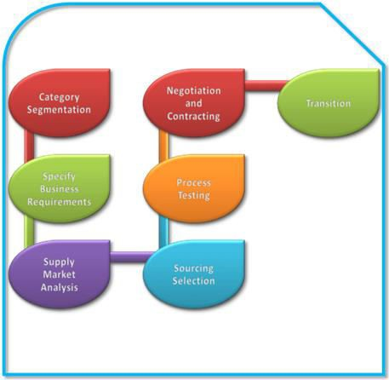

Strategic sourcing is organized because of the necessity of some methodology or process. It is collective because one of the most essential necessities for any successful strategic sourcing attempt is of receiving operational components, apart from the procurement, engaged in the decision-making and assessment process.
The process of strategic processing is a step by step approach. There are seven distinct steps engaged in the process of strategic processing. These steps are explained below in brief.

Understanding the Spend Category
The first three steps involved in the strategic sourcing are carried out by the sourcing team. In this first stage, the team needs to do a complete survey on the total expenditure. The team ensures that it acknowledges every aspect regarding the spend category itself.
The five major regions that are analyzed in the first stage are as follows:
  - Complete previous expenditure records and volumes.
  - Expenditures divided by items and sub items.
  - Expenditures by division, department or user.
  - Expenditures by the supplier.
  - Future demand projections or budgets.

For example, if the classification is grooved packaging at a customer goods company, the team has to acknowledge the description of the classification, application patterns and the reason behind specification of particular types and grades specified.
Stakeholders at all functioning units and physical locations are to be determined. The logistics, for instance, needs an updated report regarding the transportation specifications and marketing requirements to acknowledge some quality or environmentally applicable features.

Supplier Market Assessment
The second step includes frequent assessment of the supplier market for pursuing substitute suppliers to present incumbents. A thorough study of the supplier marketplace dynamics and current trends is done. The major element of the key products design is should-cost. Along with it, an analysis on the major suppliers’ sub-tier marketplace and examination for any risks or new opportunities are also important.

Now, it is not recommended to analyze the should-cost for every item. There are many instances where conservative strategic sourcing techniques tend to work better. But in the instances where the application of strategic sourcing is not applicable, the should- cost analysis supplies a valuable tool that drives minimizing of cost and regular progress efforts of the supplier.

Supplier Survey
The third step is developing a supplier analysis for both incumbent and potential substitute suppliers. This analysis assists in examining the skills and abilities of a supplier. In the meanwhile, data collected from incumbent suppliers is used for verifying spend information that suppliers have from their sales systems.

The survey team considers the above-mentioned areas for gathering information. The areas are as follows:
  - Feasibility
  - Capability
  - Maturity
  - Capacity

The analysis is done to examine the potential and skills of the market to satisfy the customer demands. This analysis helps in the examination done at the initial stage to find out if the proposed project is feasible and can be delivered by the identified supply base.
This analysis also supplies an initial caution of the customer demands to the market and enables suppliers to think about how they would react to and fulfill the demand. Here the

motto is to motivate the appropriate suppliers with the right structural layout to respond to the demands.

Building the Strategy
The fourth step comprises constructing the sourcing strategy. The merger of the first three steps supports the necessary elements for the sourcing strategy. For every region or category, the strategy depends on answering the questions given below.
  - How willing is the marketplace to oppose the supplier?
  - How supportive are the clients of a firm for testing incumbent supplier relationships?
  - What are the substitutes to the competitive assessment?

Generally, these substitutes are opted when a purchasing firm has little leverage over its supply base. They will depend on the belief that the suppliers will share the profits of a new strategy. Thus, we say that the sourcing strategy is an accumulation of all the drivers thus far mentioned.

RFx Request
Mostly, the competitive approach is applied in general cases. In this approach, a request for proposal or bid needs to be prepared (e.g., RFP, RFQ, eRFQ, ITT) for most spend classifications or groups.
This defines and clarifies all the needs for all prequalified suppliers. The request should comprise product or service specifications, delivery and service requirements, assessment criteria, pricing structure and financial terms and conditions.
In the fifth stage, an interaction plan needs to be executed to allure maximum supplier interest. It must be ensured that each and every supplier is aware that they are competing on a level playing field. After sending the RFP to all suppliers, it is to be confirmed that they are given enough time to respond. In order to motivate greater response, follow-up messages should also be sent.

Selection
This step is all about selecting and negotiating with suppliers. The sourcing team is advised to apply its assessment constraints to the responses generated by the suppliers.
If information across the limitation of RFP response is required, it can be simply asked for. If done correctly, the settlement process is conducted first with a larger set of suppliers and then shortlisted to a few finalists. If the sourcing team utilizes an electronic negotiation tool, large number of suppliers can sustain in the process for longer duration, giving more wide suppliers a better opportunity at winning the enterprise.

Communication with New Suppliers
After informing the winning supplier(s), they should be invited to take part in executing recommendations. The execution plans vary according to the scale of switches the supplier makes.

For obligatory purposes, a communication plan will be set up, including any modification in specifications and improvements in delivery, service or pricing models. These tend to be communicated to users as well.
As we know, the company gains immensely from this entire process of creating a communication plan, making some modifications according to the customer demand and further forwarding this to the customer. It’s essential that this process should be acknowledged by both the company and the supplier.
For new suppliers, we need to construct a communication plan that copes with the alteration from old to new at every point in the process engaged by the spend category. The sections that have an impact of this change are the department, finance and customer service.
In addition, the risk antennae will be particularly sensitive during this period. It is essential to gauge closely the new supplier’s performance during the first weeks of performance.
Another essential task is to grasp the intellectual capital of the sourcing team, which has been developed within the seven-step process, so that it can be used the next time that category is sourced.

Production units are identified mostly with their decision to make or buy. In other words, do they wish to produce the desired product on their own or do they want to purchase it from the foreign market.
Supply Chain Management

8. SCM – Make vs Buy
This decision is critical because the third-party suppliers especially in countries like Eastern Europe, China, and other low-cost parts of the world hold out the promise of essential beneficiaries, which the developed nations fail to offer.

However, the developed countries can easily overcome the expenses cost in the imported material through activities like human resources, information technology, maintenance and customer relations.
If properly utilized and taken care of, these activities may yield profit rather than leading the nation to suffer more loss. All the expense of outsourcing can be regained through these activities and thus they should not be neglected when the options are considered.

The Make Vs Buy decision of a nation depends on three pillars. These pillars are:
  - Business strategy
  - Risks
  - Economic factors

Business Strategy
The first pillar in the Make Vs Buy decision is the business strategy adopted by a nation. Business strategy strategically engages the importance of the company whose product or service is being considered for outsourcing, in addition to the process, technologies or skills needed to design the product or deliver that particular service.
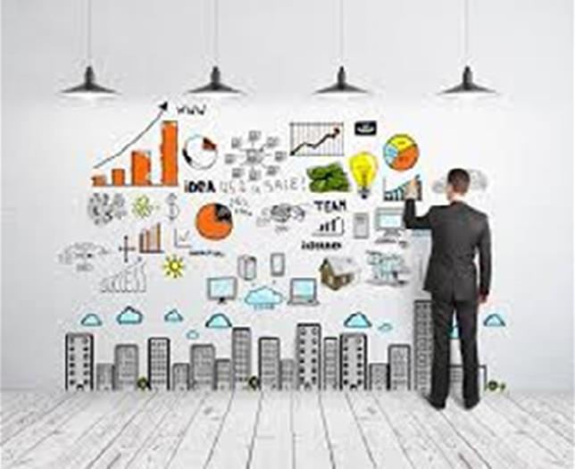
These factors should be carefully considered, not just on the basis of current competitive environment but also by anticipating the changing competitive environment in future.
So, as a rule, it’s advisable to select the in-house skills and abilities when a product or a function plays a very important role in improving the company’s performance or is considered a core operation.
Perhaps, if we consider a time-sensitive product or a product, which is prone to consequent design changes, third-party producing would likely be a mistake. In simple worlds, companies must opt for outsourcing in the following scenarios:

  - Remove the processes, which are intensive on the balance sheet, e.g., capital or labor.

  - Minimize the costs.

  - Achieve flexibility for adjusting output in comeback to changing demand.

  - Phase out management of paperwork, documents or training.

  - Monitor fewer workers.

  - Have access to new process or network tools and technologies.

  - Leverage external expertise.

In fact, if a product relies on proprietary technology or intellectual property or if a product or an operation is critical for the company’s performance, it is recommended to select in-house skills & abilities rather than outsourcing.
Obviously, outsourcing is worth considering under some situations. If a product or function has essentially become a commodity or is derived from factors other than unique or differentiating capabilities and as such, moving production or management to a third party does not give rise to significant risk to the company’s strategy, outsourcing would be the perfect solution.

Risks
The second pillar under the Make Vs Buy strategy is risks involved with any decision. The major risk factors involved in making a product in the home country or purchasing it from foreign countries are quality, reliability, and predictability of outsourced solutions or services. Along with these, there are risks inherent in the process of labeling and selecting the right supplier and structuring a workable ongoing relationship.
When we have numerous suppliers, a single failure in the supply chain may not be deadly. Even when the suppliers are making parts of an item instead of that completely furnished item, there will be errors in manufacturing. These errors should be identified before the products are assembled so that the faulty item cannot be delivered to the consumer directly.
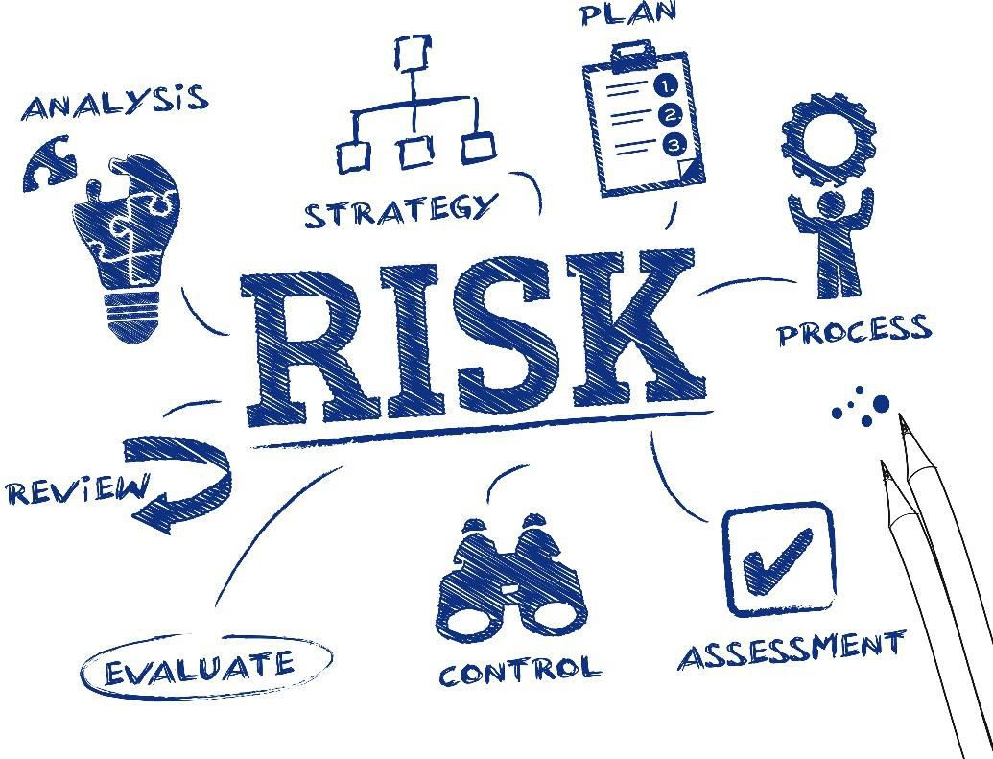

We know outsourcing opens up a broad array of new risks. We need to be attentive of any potential pitfalls with producers and examine outsourcing partners on the basis of their importance to the company.
Operations in outsourcing that lead to failure of service could be overwhelming, for example, an IT network, a payroll processing system or element manufacturing, as compared to risks or problems like a glitch in a training program or a long-term product development plan, which is much lesser.
It is very important to acknowledge the risks that are related to the location of an external supplier. Apart from judging the source country’s political stability, companies require to examine the safety and lead times of shipment schedule. Along with this, they have to label and examine potential secondary carriers or routes or search for other producers as a backup in a different area that supplies incremental volume during peaks in demand or disruptions of the primary source of supply.
When we merge the outsourced manufacturing of products or outsourced processes that demand distinct skills or assets, making it difficult or expensive to re-source, the supply chain management becomes a highly complex function. In fact, these risks through which a producer may exploit a customer’s highly reliable relationship by increasing prices or charging better terms (referred as hold up risks) can be easily handled with some external solutions.
This is a very important decision to make. One has to go through all the available options and select the best one out of them before making any commitments to the supplier because outsourcing agreements can be difficult to amend or break.

Economic Factors
The third pillar in the Make Vs Buy strategy is the economic factors residing in the country that needs to decide if to buy a product or make it on its own. The various economic factors comprise the effect of outsourcing on capital expenditures, return on invested capital and return on assets, along with the probable savings gained by outsourcing.
To study the importance of pricing mechanisms, let’s consider those companies that base their decision on if they need to outsource solely on approximate calculations of the in- house as compared to the external costs related to the outsourced function, for example, the cost of each item produced or the price of running an HR department or an IT network instead on the total costs. The net prices that need to be taken care of comprise the layouts for handling the outsource supplier, exclusively as the outsourced process changes. These changes prove to be very essential.
For example, customizing some software on a third-party information technology network can compute a large surcharge to the outsourcing deal. Tackling the customization in-house, i.e., within the home country, where the IT department can work closely, their work can be easily monitored and more productively with end-users to satisfy their demands can be obtained, tend to be less costly.
Along with this, the home country needs to choose the outsourcing partners very cautiously. In case the outsourcing partners are not selected properly, the companies often attempt to protect themselves from failures or delays by replicating in-house some of the effort that was originally farmed out. This leads to multiple prices for the same project and potential costs are mostly neglected when the outsourcing deal is made.

The costs that are often neglected in outsourcing manufacturing operations are as follows:

  - Transportation and handling charges.
  - Expanded, extended inventories.
  - Administrative bills like the supplier management and quality control rates.
  - Casted complexity and its effect on lean flows.
  - Minimal return on invested capital.
  - Production dependability and quality control.

Taking all these costs into consideration, depending on a one-time quote to measure the competitiveness of an external producer is mostly not enough. Enterprises can be saved from this mistake by factoring into the outsourcing equation the economic effects of comparative wage prices, labor productivity, tools and staff utilization, the biasness of both the labor base and functional processes, the potential for process and product innovation and relative purchasing power.
Finally, we can say that for a successful outsourcing relationship, the basic factors include the sharing of savings from productivity progress, so that both sides have an inducement to merge.
After establishing a sober formal relationship, it is very essential to search for the right balance between fully transparent supplier functions and micromanagement or the perception of it. After the outsourcing decisions are made and suppliers have been chosen, it is crucial to be on the same front on a fair and balanced pricing mechanism, productivity progress and cost minimization expectations and the necessary scale of responsiveness to design, service or delivery changes.

The network design in supply chain determines its physical arrangement, design, structural layout and infrastructure of the supply chain. Here the major decisions to be made are on the number, locations and size of manufacturing plants and warehouses and the assignment of retail outlets to warehouses, etc. This stage witnesses some other major sourcing decisions as well. The basic time duration for planning horizon is few years.
Supply Chain Management
9.
SCM: Networks
Many major decisions involving the long-term location, capacity, technology and supplier selection have to be made by considering the probable uncertainties present in the market development accompanied by changing economic and legal conditions.
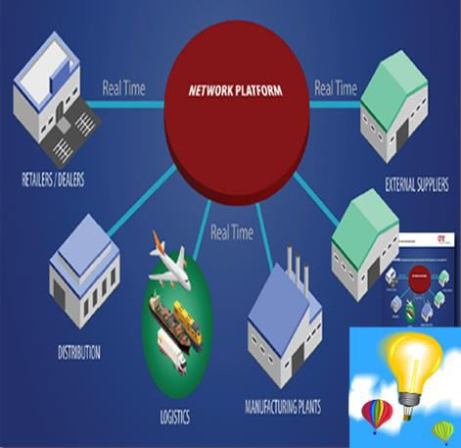

The network design in supply chain concentrates mainly on the development of multi- stage stochastic optimization methods required for decision support under demand, freight rate and exchange rate uncertainty. Here, we will discuss the various strategies to study the uncertainty and scenario modeling.
  - Warehouse location: When companies expand their branches into various new locations, they need new storage places as well. Here the company faces a warehouse location problem. Within the set of probable choices in locations, the one that has minimal fixed costs and operational costs by fulfilling the required demand is chosen.

  - Traffic network design: With the growing population, the traffic in cities is increasing. Because of the higher transportation demand, the traffic networks have also to be widened. Since the budget allotted is usually limited, the major issue is to determine which projects should be constructed to develop the flow inside a traffic network.

  - Reshoring: This phenomenon has emerged recently because of the rising cost and other circumstances. It is the exercise of bringing outsourced products and services back to the source point from which they were originally shipped. It outlines the process of moving some or all producing back to its original source.

Network Models
Supply chain networks present different types of models that help us understand the various optimization methods used for studying the uncertainty and scenario modeling. There are six distinct supply chain network models, as given below.

  - Producer storage with direct shipping
  - Producer storage with direct shipping and in-transit merge (cross docking)
  - Distributor storage with package carrier delivery
  - Distributor storage with last mile delivery
  - Producer or distributor storage with costumer pickup
  - Retail storage with customer pickup

The supply chain network basically deals with three major entities: Producer, Distributor and Merchant. Two different options are available, i.e., customer pickup or door delivery. For example, if the door delivery option is opted for, there is transport between producer and distributor, distributor and merchant and producer and merchant.
The distribution system decision is made on the basis of the choice of the customers. This in turn results in the demand for the product or products and cost of the distribution arrangement.
New companies may come to a halt through the application of a single type of distribution network. Mostly, companies go for merging of different types for distinct products, different customers and different usage situations, coming back to the different optimization models mentioned above. Now we will discuss each model in brief.

Producer storage with direct shipping
In this model, goods are moved directly from the manufacturer’s location as the starting point to the end customer’s location as the destination point bypassing the retailer. The retailer is the person who takes the order and initiates the delivery request. This option

is also called drop-shipping, with product delivered directly from the manufacturer’s location to the customer’s destination.

Producer storage with direct shipping and in-transit merge
It is somewhat congruent to pure drop-shipping or moving, but the difference is that pieces of the order come from different locations and they are merged into one so that the customer gets a single delivery.

Distributor storage with package carrier delivery
This comes into action when the inventory is not owned by the manufacturers at the plants; instead it is owned by the merchants/retailers in intermediate warehouses and package carriers are used for shipment of goods from the intermediate location to the final customer.

Distributor storage with last mile delivery
This type results when the merchant/retailer delivers the goods ordered by the customer
to the customer’s home instead of using a package carrier.

Producer/distributor storage with customer pickup
In this type, the inventory is stored at the warehouse owned by the manufacturer or producer but the customers place their orders online or through phone and then come to pick up points allotted for collecting their orders.

Retail storage with customer pickup
This is mostly applied on situations when inventory is locally stored at retail stores; customers walk into the retail shop or order something online or on the phone and pick it up at the retail store.

As seen under the major objectives of supply chain, one of the basic objectives of SCM is to make sure that all the activities and functions within as well as across the company are managed efficiently.
Supply Chain Management

10. SCM – Inventory Management
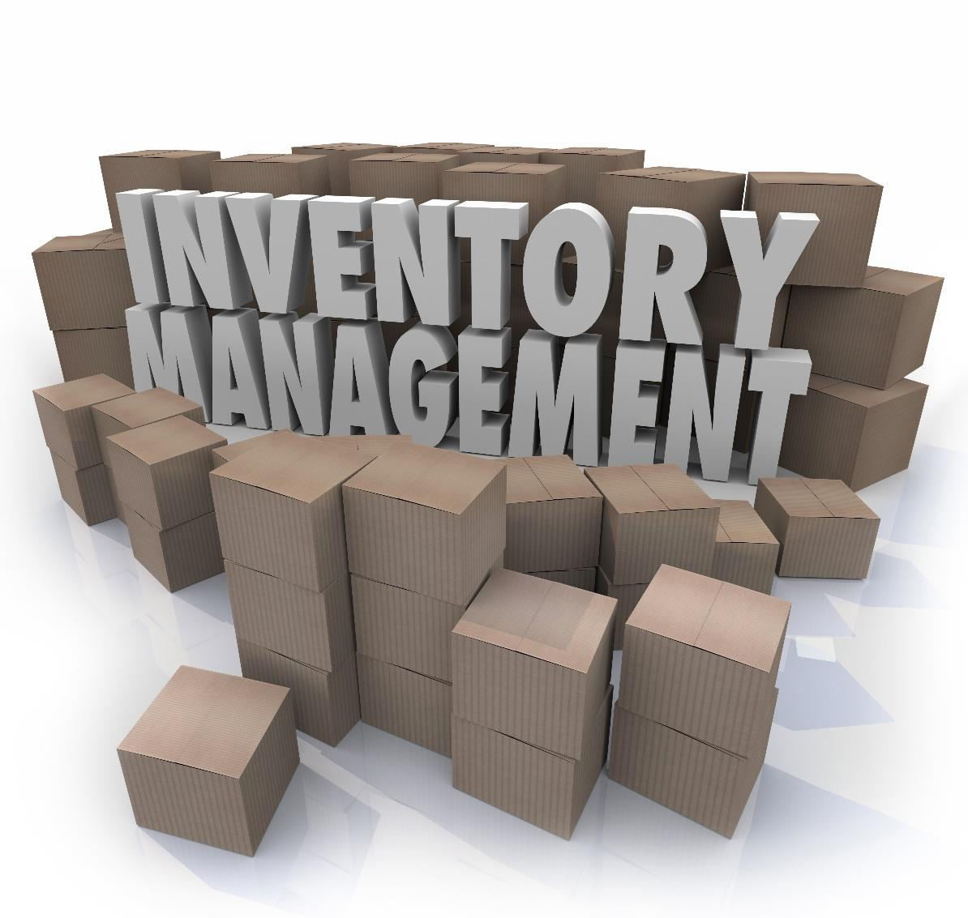
There are instances where efficiency in supply chain can be ensured by efficiencies in inventory, to be more precise, by maintaining efficiency in inventory reductions. Though inventory is considered a liability to efficient supply chain management, supply chain managers acknowledge the need of inventory. However, the unwritten rule is to keep inventory at a bare minimum.
Many strategies are developed with the objective of streamlining inventories beyond the supply chain and holding the inventory investment as low as possible. The supply chain managers tend to maintain the inventories as low as possible because of inventory investment. The cost or investment related with owning inventories can be high. These costs comprise the cash outlay that is necessary for purchasing the inventory, the costs of acquiring the inventories (the cost of having invested in inventories rather than investing in something else) and the costs related with managing the inventory.

Role of Inventory
Before understanding the role of inventory in supply chain, we need to understand the cordial relationship between the manufacturer and the client. Handling clients, coping up with their demands and creating relationships with manufacturer is a critical section of managing supply chains.
There are many instances where we see the concept of collaborative relationship being marked as the essence of supply chain management. However, a deeper analysis of supply chain relationships, especially those including product flows, exposes that at the heart of these relationships is inventory movement and storage.
More than half of it relies on the purchase, transfer or management of inventory. As we know, inventory plays a very important role in supply chains, being a salient feature.
The most fundamental functions that inventory has in supply chains are as follows:
  - To supply and support the balance of demand and supply.
  - To effectively cope with the forward and reverse flows in the supply chain.

Companies need to manage the upstream supplier exchanges and downstream customer demands. In this situation, the company enters a state where it has to maintain a balance between fulfilling the demands of customers, which is mostly very difficult to predict with precision or accuracy, and maintaining adequate supply of materials and goods. This balance can be obtained through inventory.

Optimization Models
Optimization models of supply chain are those models that codify the practical or real life issues into mathematical model. The main objective to construct this mathematical model is to maximize or minimize an objective function. In addition to this, some constraints are added to these issues for defining the feasible region. We try to generate an efficient algorithm that will examine all possible solutions and return the best solution in the end. Various supply chain optimization models are as follows:

Mixed Integer Linear Programming
The Mixed integer linear programming (MILP) is a mathematical modeling approach used to get the best outcome of a system with some restrictions. This model is broadly used in many optimization areas such as production planning, transportation, network design, etc.
MILP comprises a linear objective function along with some limitation constraints constructed by continuous and integer variables. The main objective of this model is to get an optimal solution of the objective function. This may be the maximum or minimum value but it should be achieved without violating any of the constraints imposed.
We can say that MILP is a special case of linear programming that uses binary variables. When compared with normal linear programming models, they are slightly tough to solve. Basically the MILP models are solved by commercial and noncommercial solvers, for example: Fico Xpress or SCIP.

Stochastic Modeling
Stochastic modeling is a mathematical approach of representing data or predicting outcomes in situations where there is randomness or unpredictability to some extent.
For example, in a production unit, the manufacturing process generally has some unknown parameters like quality of the input materials, reliability of the machines and competence within the employees. These parameters have an impact on the outcome of the manufacturing process but it is impossible to measure them with absolute values.
In these types of cases, where we need to find absolute value for unknown parameters, which cannot be measured exactly, we use Stochastic modeling approach. This modeling strategy helps in predicting the result of this process with some defined error rate by considering the unpredictability of these factors.

Uncertainty Modeling
While using a realistic modeling approach, the system has to take uncertainties into account. The uncertainty is evaluated to a level where the uncertain characteristics of the system are modeled with probabilistic nature.
We use uncertainty modeling for characterizing the uncertain parameters with probability distributions. It takes dependencies into account easily as input just like Markov chain or may use the queuing theory for modeling the systems where waiting has an essential role. These are common ways of modeling uncertainty.

Bi-level Optimization
A bi-level issue arises in real life situations whenever a decentralized or hierarchical decision needs to be made. In these types of situations, multiple parties make decisions one after the other, which influences their respective profit.
Till now, the only solution to solve bi-level problems is through heuristic methods for realistic sizes. However, attempts are being made for improving these optimal methods to compute an optimal solution for real problems as well.

Pricing is a factor that gears up profits in supply chain through an appropriate match of supply and demand. Revenue management can be defined as the application of pricing to increase the profit produced from a limited supply of supply chain assets.
Supply Chain Management

11. SCM – Pricing & Revenue Management

Ideas from revenue management recommend that a company should first use pricing to maintain balance between the supply and demand and should think of further investing or eliminating assets only after the balance is maintained.

The assets in supply chain are present in two forms, namely capacity and Inventory.

Capacity assets in the supply chain are present for manufacturing, shipment, and storage while inventory assets are present within the supply chain and are carried to develop and improvise product availability.
Thus, we can further define revenue management as the application of differential pricing on the basis of customer segment, time of use and product or capacity availability to increment supply chain surplus.
Revenue management plays a major role in supply chain and has a share of credit in the profitability of supply chain when one or more of the following conditions exist:

  - The product value differs in different market segments
  - The product is highly perishable or product tends to be defective.
  - Demand has seasonal and other peaks.
  - The product is sold both in bulk and the spot market.

The strategy of revenue management has been successfully applied in many streams that we often tend to use but it is never noticed. For example, the finest real life application of revenue management can be seen in the airline, railway, hotel and resort, cruise ship, healthcare, printing and publishing.

RM for Multiple Customer Segments
In the concept of revenue management, we need to take care of two fundamental issues. The first one is how to distinguish between two segments and design their pricing to make one segment pay more than the other. Secondly, how to control the demand so that the lower price segment does not use the complete asset that is available.
To gain completely from revenue management, the manufacturer needs to minimize the volume of capacity devoted to lower price segment even if enough demand is available from the lower price segment to utilize the complete volume. Here, the general trade-off is in between placing an order from a lower price or waiting for a high price to arrive later on.
These types of situations invite risks like spoilage and spill. Spoilage appears when volumes of goods are wasted due to demand from high rate that does not materialize. Similarly, spill appears if higher rate segments need to be rejected due to the commitment of volume goods given to the lower price segment.

To reduce the cost of spoilage and spill, the manufacturer can apply the formula given below to segments. Let us assume that the anticipated demand for the higher price segment is generally distributed with mean of DH and standard deviation of σH:

CH = F⁻¹(1-pL/pH,DH,σH) = NORMINV(1-pL/pH,DH,σH)

Where,
CH = reserve capacity for higher price segment pL = the price for lower segment
pH = the price for higher segment

An important point to note here is the application of differential pricing that increments the level of asset availability for the high price segment. A different approach that is applicable for differential pricing is to build multiple versions of product that focus on different segments. We can understand this concept with the help of a real life application of managing revenue for multiple customer segments, that is, the airlines.

RM for Perishable Assets
Any asset that loses its value in due course of time is considered as a perishable item, for example, all fruits, vegetables and pharmaceuticals. We can also include computers, cell phones, fashion apparels, etc.; whatever loses its value after the launch of new model is considered as perishable.
We use two approaches for perishable assets in the revenue management. These approaches are:
- Fluctuate cost over time to maximize expected revenue.
- Overbook sales of the assets to cope or deal with cancellations.

The first approach is highly recommended for goods like fashion apparels that have a precise date across which they lose a lot of their value; for example, apparel designed for particular season doesn’t have much value in the end of the season. The manufacturer should try using effective pricing strategy and predict the effect of rate on customer demand to increase total profit. Here the general trade-off is to demand high price initially and allow the remaining products to be sold later at lower price. The alternate method may be charging lower price initially, selling more products early in the season and then leaving fewer products to be sold at a discount.
The second approach is very fruitful here. There are occurrences where the clients are able to cancel placed orders and the value of asset lowers significantly after the deadline.

RM for Seasonal Demands
One of the major applications of revenue management can be seen in the seasonal demand. Here we see a demand shift from the peak to the off-peak duration; hence a better balance can be maintained between supply and demand. It also generates higher overall profit.
The commonly used effective and efficient revenue management approach to cope with seasonal demand is to demand higher price during peak time duration and a lower price during off-peak time duration. This approach leads to transferring demand from peak to off-peak period.

Companies offer discounts and other value-added services to motivate and allure customers to move their demand to off-peak period. The best suited example is Amazon.com. Amazon has a peak period in December, as it brings short-term volume that is expensive and reduces the profit margin. It tempts customers through various discounts and free shipping for orders that are placed in the month of November.
This approach of reducing and increasing the price according to the demand of customers in the peak season generates a higher profit for various companies just like it does for Amazon.com.

RM for Bulk and Spot Demands
When we talk about managing revenue for bulk and spot demand, the basic trade-off is somewhat congruent to that of revenue management for multiple customer segments.
The company has to make a decision regarding the quantity of asset to be booked for spot market, which is higher price. The booked quantity will depend upon the differences in order between the spot market and the bulk sale, along with the distribution of demand from the spot market.
There is a similar situation for the client who tends to make the buying decision for production, warehousing and transportation assets. Here the basic tradeoff is between signing on long-term bulk agreement with a fixed, lower price that can be wasted if not used and buying in the spot market with higher price that can never be wasted. The basic decision to be made here is the size of the bulk contract.
A formula that can be applied to achieve optimal amount of the asset to be purchased in bulk is given below. If demand is normal with mean µ and standard deviation σ, the optimal amount Q* to be purchased in bulk is

Q* = F⁻¹ (p*, μ, σ) = NORMINV (p*, μ, σ)

Where,
p* = probability demand for the asset doesn’t exceed Q*
Q* = the optimal amount of the asset to be purchased in bulk
The amount of bulk purchase increases if either the spot market price increases or the bulk price decreases.
We can now conclude that revenue management is nothing but application of differential pricing on the basis of customer segments, time of use, and product or capacity availability to increase supply chain profit. It comprises marketing, finance, and operation functions to maximize the net profit earned.

Supply chain integration can be defined as a close calibration and collaboration within a supply chain, mostly with the application of shared management information systems. A supply chain is made from all parties that participate in the completion of a purchase, like the resources, raw materials, manufacturing of the product, shipping of completed products and facilitating services.
Supply Chain Management

12. SCM – Integration
There are different levels of supply chain integration. We will understand this with the help of an example of a computer manufacturing company. The initial step in integration shall include choosing precise merchants to supply certain inputs and ensuring compliance for them for supplying certain amount of inputs within the year at a set cost.
This assures that the company has the appropriate materials required to produce the expected output of computers during the year. In the meanwhile, this computer company may sign a bond with a large supplier of circuit boards; the bond expects it to deliver a precise quantity at precise times within a year and fix a price that will be effective during the bond year.
If we move to a higher level, the next step would be to integrate the companies more closely. The circuit board supplier may construct a plant close to the assembly plant and may also share production software. Hence, the circuit board company would be able to see how many boards are required in the upcoming month and can construct them in time, as the company requires them in order to meet its sales demand.
Further higher level is referred as vertical integration. This level starts when the supply chain of a company is actually owned by the company itself. Here, a computer company may buy the circuit board company just to ensure a devoted supply of elements.

Push System
In a push-based supply chain, the goods are pushed with the help of a medium, from the source point, e.g., the production site, to the retailer, e.g., the destination site. The production level is set in accordance with the previous ordering patterns by the manufacturer.
A push-based supply chain is time consuming when it has to respond to fluctuations in demand, which can result in overstocking or bottlenecks and delays, unacceptable service levels and product obsolescence.
This system is based on the deliberation of customer’s demand. It tries to push as many products into the market as possible. As a result, the production is time consuming because the producer and the retailer struggle to react to the changes in the market. Forecast or prediction plays an important role in the push system.
Optimum level of products can be produced through long term prediction. This deliberative nature of the push system leads to high production cost, high inventory cost as well as high shipment cost due to the company’s desire to halt products at every stage.
Thus, in the push view of supply chain integration, the manager of a firm may sometimes fail to satisfy or cope with the fluctuating demand pattern. This system leads to high inventory and high size of batches.

Here, the companies focus more on minimizing the cost of supply chain and neglect the responsiveness. This system models challenges along with demand management and transportation management.

Pull System
The pull-based supply chain is based on demand-driven techniques; the procurement, production and distribution are demand-driven rather than predicting. This system doesn’t always follow the make-to-order production. For example, Toyota Motors Manufacturing produces products yet do not religiously produce to order. They follow the supermarket model.
According to this model, limited inventory is kept and piled up as it is consumed. Talking about Toyota, Kanban cards are used to hint at the requirement of piling up inventory.
In this system, the demand is real and the company responds to the customer demands. It assists the company in producing the exact amount of products demanded by the clients.
The major drawback in this system is that in case the demand exceeds than the amount of products manufactured, then the company fails to meet the customer demand, which in turn leads to loss of opportunity cost.
Basically in the pull system, the total time allotted for manufacturing of products is not sufficient. The production unit and distribution unit of the company rely on the demand. From this point of view, we can say that the company has a reactive supply chain.
Thus, it has less inventories as well as variability. It minimizes the lead time in the complete process. The biggest drawback in pull based supply chain integration is that it can’t minimize the price by ranking up the production and operations.

Differences in Push and Pull System
The major differences between push and pull view in supply chain are as follows:
  - In the push system, the implementation begins in anticipation of customer order whereas in the pull system, the implementation starts as a result of customer’s order
  - In the push system, there is an uncertainty in demand whereas in pull system, the demand remains certain
  - The push system is a speculative process whereas the pull system is a reactive process.
  - The level of complexity is high in the push system whereas it is low in the pull system.
  - The push based system concentrates on resources allocation whereas the pull system stresses on responsiveness.
  - The push system has a long lead time whereas the pull system has a short lead time.
  - The push system assists in supply chain planning whereas the pull system facilitates in order completion.
To conclude, the push based supply chain integrations works with an objective of minimizing the cost whereas the pull based supply chain integration works with an objective to maximize the services it provides.

Push & Pull System
Mostly we find a supply chain as merger of both push and pull systems, where the medium between the stages of the push-based and the pull-based systems is referred as the push–pull boundary.
The terms push and pull were framed in logistics and supply chain management, but these terms are broadly used in the field of marketing as well as in the hotel distribution business.

To present an example, Wal-Mart implements the push vs. pull strategy. A push and pull system in business represents the shipment of a product or information between two subjects. Generally, the consumers use pull system in the markets for the goods or information they demand for their requirements whereas the merchants or suppliers use the push system towards the consumers.
In supply chains, all the levels or stages function actively for the push and the pull system. The production in push system depends on the demand predicted and production in pull system depends on absolute or consumed demand.
The medium between these two levels is referred as the push–pull boundary or decoupling point. Generally, this strategy is recommended for products where uncertainty in demand is high. Further, economies of scale play a crucial role in minimizing production and/or delivery costs.
For example, the furniture industries use the push and pull strategy. Here the production unit uses the pull-based strategy because it is impossible to make production decisions on the basis on long term prediction. Meanwhile, the distribution unit needs to enjoy the benefits of economy of scale so that the shipment cost can be reduced; thus it uses a push-based strategy.

Demand-Driven Strategies
The demand-driven strategies were first developed to understand the impact of inactivity and collection, as information fertilizes the supply chain from the source of demand to the suppliers.
Within a mentioned supply lead time, normally the manufacturers manufacture sufficient goods to satisfy the needs of their clients predicted. But this is only somewhat accurate at the granular level at which inventory decisions are made.
Anyways, when the actual demand varies from the demand predicted, the first thing to be done is to adjust the supply levels needed in accordance with each step of the supply chain. But because of time delay between changing demands and its detection at several at points along the supply chain, its impact is amplified, resulting in inventory shortages or excesses.
The inventory levels of the companies are disturbed because of the overcompensation done by the companies either by slowing down or speeding up production. These fluctuations prove to be a costly and inefficient affair for all participants.
Basically, the demand-driven strategies or the demand-driven supply chain is completely based on the demand as well as the supply part of marketing. So it can be uniquely organized in terms of the demand side and supply side initiatives.
The demand-side initiatives concentrate on efficient methods to acquire the demand signal closer to the source, observe the demand to sense the latest and most accurate demand signal and shape the demand by implementing and following promotional and pricing strategies to gear up demand in accordance with business objectives.

On the other hand, the supply side initiatives mostly need to do with reducing reliance on the prediction by developing into an agile supply chain accompanied by faster response when absolute demand is known.
All the strategies discussed above are addressed under the demand-driven strategy, but we a company following all of them is rare. In fact, we can conclude that companies concentrate on different markets on the basis of features of the market and industry.

Companies that opt to participate in supply chain management initiatives accept a specific role to enact. They have a mutual feeling that they, along with all other supply chain participants, will be better off because of this collaborative effort. The fundamental issue here is power. The last two decades have seen the shifting of power from manufacturers to retailers.
Supply Chain Management

13. SCM – Role of IT
When we talk about information access for the supply chain, retailers have an essential designation. They emerge to the position of prominence with the help of technologies. The advancement of inter organizational information system for the supply chain has three distinct benefits. These are:
  - Cost reduction: The advancement of technology has further led to ready availability of all the products with different offers and discounts. This leads to reduction of costs of products.

  - Productivity: The growth of information technology has improved productivity because of inventions of new tools and software. That makes productivity much easier and less time consuming.

  - Improvement and product/market strategies: Recent years have seen a huge growth in not only the technologies but the market itself. New strategies are made to allure customers and new ideas are being experimented for improving the product.
It would be appropriate to say that information technology is a vital organ of supply chain management. With the advancement of technologies, new products are being introduced within fraction of seconds increasing their demand in the market. Let us study the role of information technology in supply chain management briefly.
The software as well as the hardware part needs to be considered in the advancement and maintenance of supply chain information systems. The hardware part comprises computer's input/output devices like the screen, printer, mouse and storage media. The software part comprises the entire system and application program used for processing transactions management control, decision-making and strategic planning.
Here we will be discussing the role of some critical hardware and software devices in SCM. These are briefed below:

Electronic Commerce
Electronic commerce involves the broad range of tools and techniques used to conduct business in a paperless environment. Hence it comprises electronic data interchange, e- mail, electronic fund transfers, electronic publishing, image processing, electronic bulletin boards, shared databases and magnetic/optical data capture.

Electronic commerce helps enterprises to automate the process of transferring records, documents, data and information electronically between suppliers and customers, thus making the communication process a lot easier, cheaper and less time consuming.

Electronic Data Interchange
Electronic Data Interchange (EDI) involves the swapping of business documents in a standard format from computer-to-computer. It presents the capability as well as the practice of exchanging information between two companies electronically rather than the traditional form of mail, courier, & fax.

The major advantages of EDI are as follows:

  - Instant processing of information
  - Improvised customer service
  - Limited paper work
  - High productivity
  - Advanced tracing and expediting
  - Cost efficiency
  - Competitive benefit
  - Advanced billing

The application of EDI supply chain partners can overcome the deformity and falsehood in supply and demand information by remodeling technologies to support real time sharing of actual demand and supply information.

Barcode Scanning
We can see the application of barcode scanners in the checkout counters of super market. This code states the name of product along with its manufacturer. Some other practical applications of barcode scanners are tracking the moving items like elements in PC assembly operations and automobiles in assembly plants.

Data Warehouse
Data warehouse can be defined as a store comprising all the databases. It is a centralized database that is prolonged independently from the production system database of a company.
Many companies maintain multiple databases. Instead of some particular business processes, it is established around informational subjects. The data present in data warehouses is time dependent and easily accessible. Historical data may also be accumulated in data warehouse.

Enterprise Resource Planning (ERP) Tools
The ERP system has now become the base of many IT infrastructures. Some of the ERP tools are Baan, SAP, PeopleSoft. ERP system has now become the processing tool of many companies. They grab the data and minimize the manual activities and tasks related to processing financial, inventory and customer order information.
ERP system holds a high level of integration that is achieved through the proper application of a single data model, improving mutual understanding of what the shared data represents and constructing a set of rules for accessing data.
With the advancement of technology, we can say that world is shrinking day by day. Similarly, customers' expectations are increasing. Also companies are being more prone

to uncertain environment. In this running market, a company can only sustain if it accepts the fact that their conventional supply chain integration needs to be expanded beyond their peripheries.
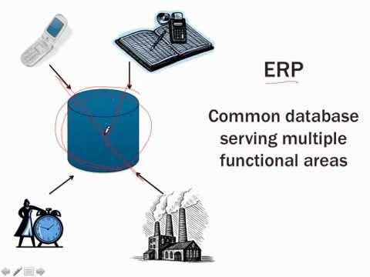

The strategic and technological interventions in supply chain have a huge effect in predicting the buy and sell features of a company. A company should try to use the potential of the internet to the maximum level through clear vision, strong planning and technical insight. This is essential for better supply chain management and also for improved competitiveness.
We can see how Internet technology, World Wide Web, electronic commerce etc. has changed the way in which a company does business. These companies must acknowledge the power of technology to work together with their business partners.
We can in fact say that IT has launched a new breed of SCM application. The Internet and other networking links learn from the performance in the past and observe the historical trends in order to identify how much product should be made along with the best and cost effective methods for warehousing it or shipping it to retailer.

In this chapter, we will throw some light on two specialized supply chains —
Supply Chain Management

14. SCM – Agile and Reverse Supply Chains
  - Agile Supply Chain
  - Reverse Supply Chain

Agile Supply Chain
An agile supply chain can be defined as a chain of supply that has the potential to respond to changing requirements in a way that accelerates the delivery of ordered goods to customers.
In simple words, supply chain agility is a custom adopted by many companies for choosing a dealer. As we know, a supply chain with flexibility and the ability to quickly react to emergency requirements can help the business answer more efficiently to its customers. Apart from flexibility, speed and accuracy are also signature marks of this type of supply chain.
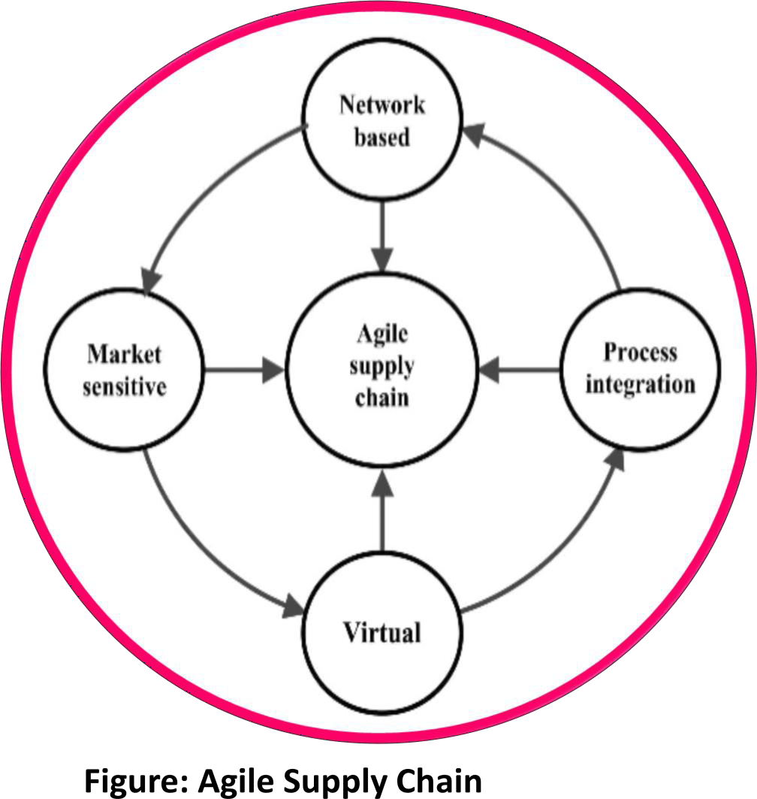

To acknowledge the advantages of an agile supply chain, we have to learn about the elements of any type of supply chain. These include elements like collection of orders and processing, supply of materials to create the goods used to complete orders, packaging and transport of finished goods, and the quality of customer service that is advertised throughout the process from the point of sale to the actual delivery and beyond.
Thus, for considering the functions of supply chain as agile, each one of these elements must be managed efficiently and coordinated in such a way that makes it possible to adapt to changing circumstances.
With the help of an agile supply chain, merchants can easily respond to the varying requirements of customer with relatively less time required. For example, if a client has already placed a sizable order but demands the product to be delivered few days prior to the projected delivery date, a merchant with a truly agile supply chain can easily accommodate that change in the client’s situation, at least in part. Working collaboratively, the merchant and the customer develop a strategy to permit the delivery of as much of the order as possible within the new time frame required.
There are times when merchants need to think creatively along with some flexibility in terms of scheduling production time, selecting shippers and basically looking closely at each step in the order completion process to search for ways to reduce the time required to successfully accomplish those tasks and abide with the customer’s request.

Reverse Supply Chain
Reverse supply chain states the evolution of products from customer to merchant. This is the reverse of the traditional supply chain evolution of products from merchant to customer.
Reverse logistics is the process of planning, executing, monitoring and controlling the efficient and effective inbound flow and storage of secondary goods and information related to the purpose of recovering value or proper disposal. Some examples of reverse supply chain are as follows:
  - Product returns and handling product displacement.

  - Remanufacturing and refurbishing exercises.

  - Management and sale of surplus, along with returned equipment and machines from the hardware leasing business.
Different types of reverse supply chain arise at different stages of the product cycle. Mostly reverse supply chain is designed to carry out the below given five key processes:
  - Product acquisition: Accumulating the used product from the user by the reseller or manufacturer because of some manufacturing defect or some other reason. It is basically considered as a company’s growth strategy.

  - Reverse logistics: Shipping of products from their final destination for auditing, sorting and disposition.

  - Inspection and disposition: Examining the condition of the product returned along with making the most profitable decision for reusing it in some other way.

  - Remanufacturing or refurnishing: Returning the product to its original source from where it was ordered in the very first place along with specifications. This is done basically when there is a manufacturing or furnishing defect in the goods.

  - Marketing: Establishing secondary markets for the goods that have been recovered by the merchant from the client who initially ordered it in the beginning but chose to return it.

In short, we can say that the enterprises that closely coordinate with their forward supply chains are the one that have been most successful with their reverse supply chains. These two chains create a closed-loop system. For example, the company designs a product layout according to the manufacturing decisions followed by recycling and reconditioning. Bosch is a beautiful example of reverse supply chain. It constructs sensors into the motors of its power tools, which signs if the motor is worth reconditioning.
Technology plays a great role here by reducing the inspection and disposition costs, sanctioning the company to make a profit on the remanufactured tools. In fact, along with reverse supply chains, forward thinking results in big dividends.

