Ammunition

It is one or more loaded cartridges consisting of a primed case propellant and projectile. It is an assembly which creates power or force in a firearm. It is anything which provides energy to the firearm.

Parts of ammunitions:
- Buck shots- Lead or steel pallets ranging in size from 0.2mm to 0.36mm in diameter normally loaded in shot guns.
- Cartridge- A unit of ammunition made of cartridge case, primer, powder and projectile.
- Gun Powder- Various powders used in ammunition as a propellant charge.
- Primer- An explosive substance that ignites when struck by firing pin to detonate the powder in cartridge. Ex- mercury fulminate, lead azide, etc.
- Propellant Charge- It is the house of energy that allows the push to projectile
- Wads- Its present on top of the cartridge and it provides cushioning between the shots and the propellant charge.
- Percussion cap- U-shaped aluminium cups which are house of primer mixers molded inside the base of cartridge.
- Projectile- In the form of bullets (single mass of lead) or shots (multiple masses of small iron balls). It is something that projects out to hit a target.
- Cartridge Case- A brass or cardboard made material in which the projectile, propellant charge and primers are packed to form ammunition.

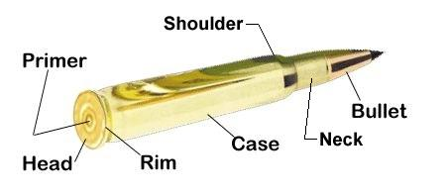

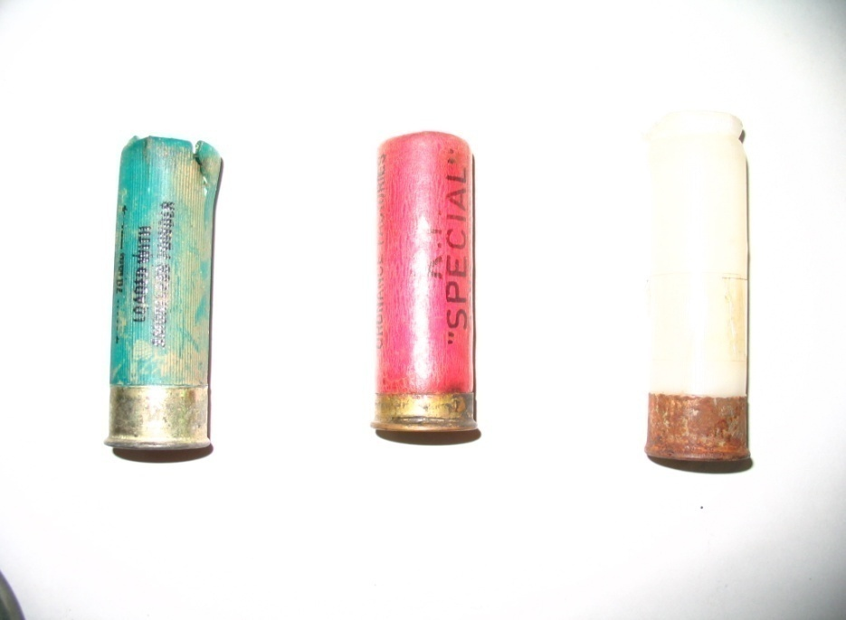
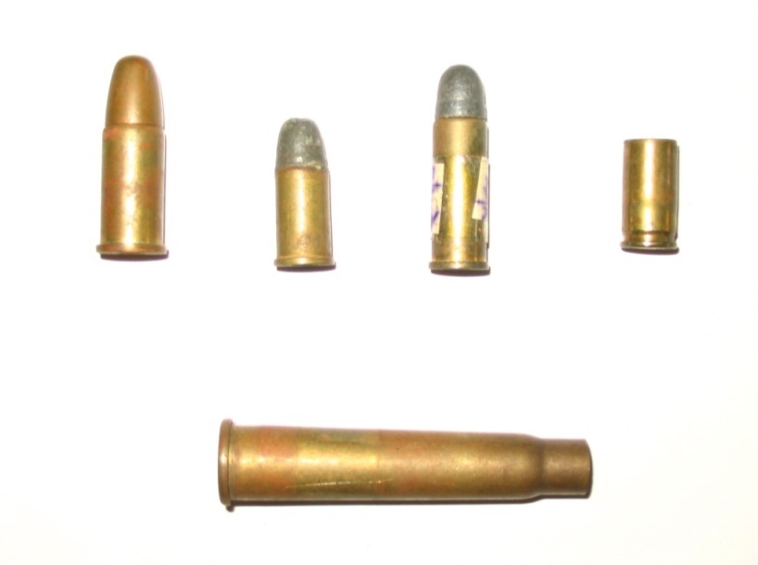
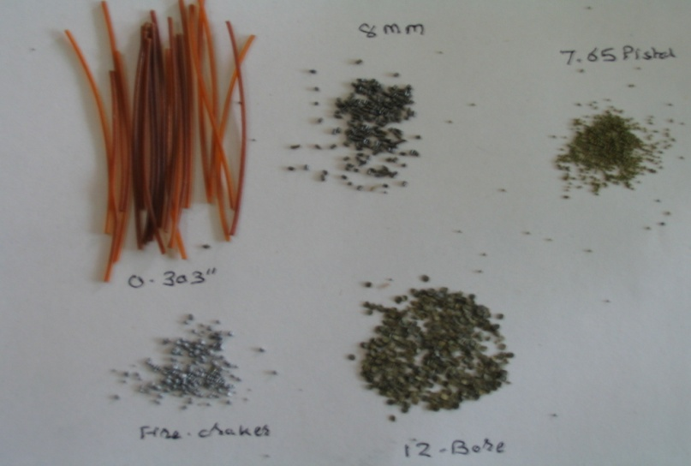
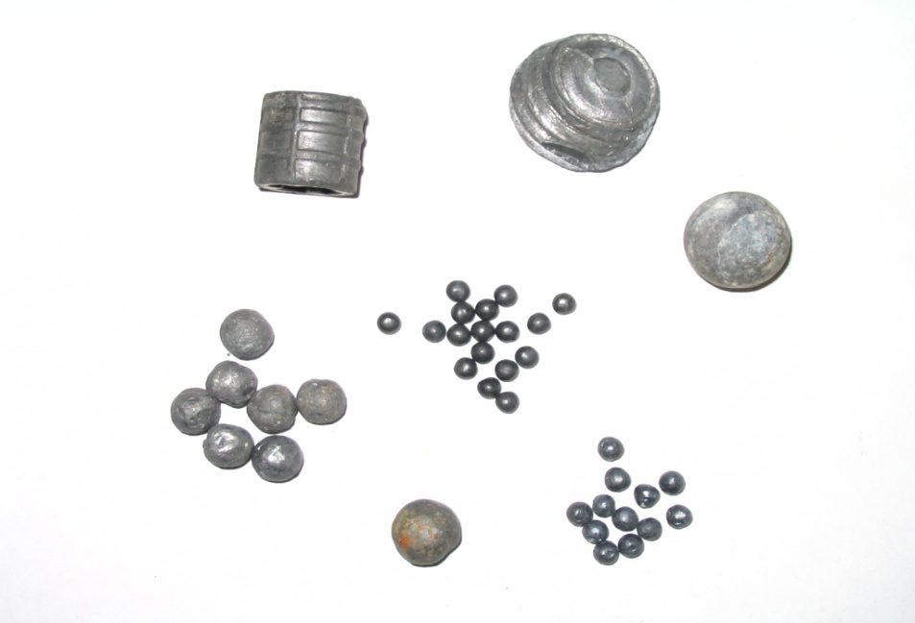
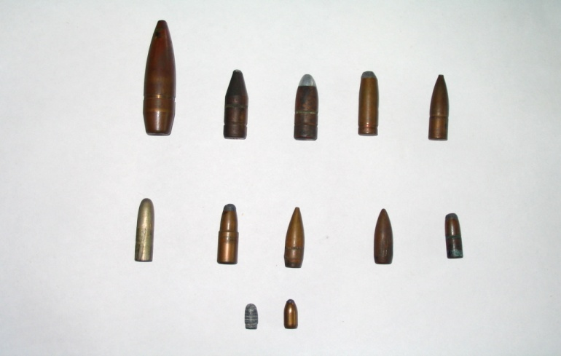
Information on the Cartridge Case Headstamp-
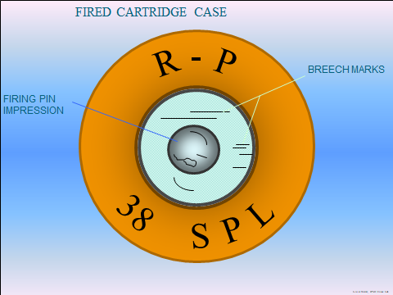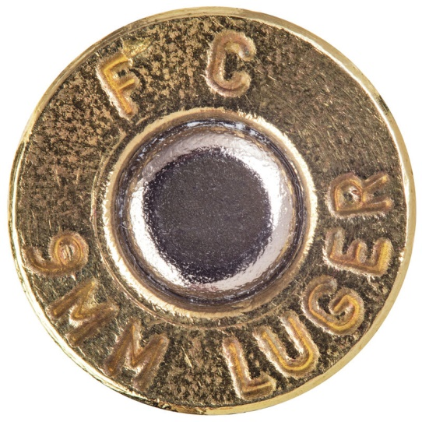

- Company Name- FC
- Year of manufacturing
- Calibre- 9MM

