Ammunitions of Rifle
It involves bullet which are the single mass of lead which can be jacketed or not which takes a flight out of a firearm. They have low density and durability. The case is made of brass.
These ammunitions have properties like-
- Stability due to gyrostatic movement
- Increases the range
- Overcomes gravitational pull
- Eases penetration
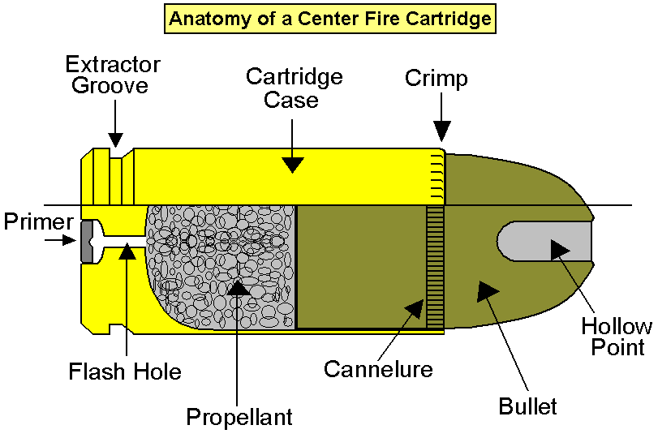

Ammunitions of Shotgun
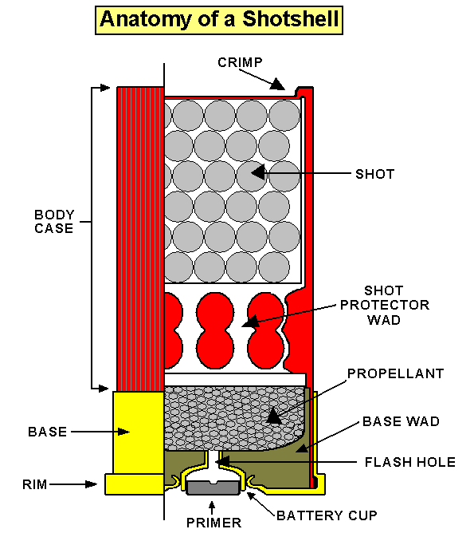
Instead of bullets, shots are used in shotguns. They are the multiple masses of small iron balls because lead in small masses will decrease the penetration. It consists of 2 wads, one on top and the other as cushion between the charge and the shots. These wads are used to maintain and reach high pressures. The cartridge cases are made of cardboards.

