External Ballistics: Trajectory Formation

Definition
- External ballistics or exterior ballistics is the part of ballistics that deals with the behavior of a projectile in flight after leaving the barrel of the firearm. The projectile may be bullet or shots.
- In other words it refers to the movement of the projectile after leaving the muzzle of the firearm, which includes the movement of the projectile and its flight up to the target.
- External Ballistics is the study of projectiles after they come out from barrel & is followed by the products of combustion like flame, smoke, unburnt & partially burnt powder grains & metallic particles, wads till they strikes the target.

Introduction-
- The path travelled by the projectile is called its trajectory. There are three stages of trajectory namely, straight horizontal line, parabola like flight and vertical drop.
- The two main factors which affect the performance of bullet on leaving the barrel are:
1. Air resistance.
2. Effect of gravitational pull.
As result of these forces, the bullet on leaving the barrel will describe a downward curved path or trajectory. The exact shape of the trajectory can be determined by knowing the gravitational pull, muzzle velocity, angle of elevation of barrel, cross-sectional density of bullet and shape of bullet.
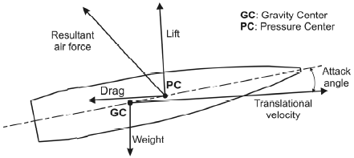

Trajectory Formation-
Trajectory is the curved path of projectile from muzzle to target.
When a projectile comes out of the muzzle it should go along the axis of the barrel of the firearm and travel equal distances in equal interval of time. If no, external forces are acting upon it to change the course of the projectile.
The air resistance is one of the main causes of vibrations. If the air resistance is ignored, one may get some qualitative idea about the trajectories. Such trajectories are called vacuum trajectories.

