Wound Ballistics- Entry and Exit Wounds

Injury is defined as any discontinuity or irregularities of the skin tissues. They found in two forms- Entry wounds and exit wounds.

Entry Wounds:
- The course of bullet entering the living target is entry wound.
- They are smaller in diameter, which are generally round shaped.
- Their margins are inverted due to elasticity of the skin.
- Presence of ecchymosis, abrasions, bruises and red colored ring with swelling in cases of ante mortem fire.
- Settling of GSR particles may be seen around and inside this wound.
- Singeing of hair may be observed in cases of flame contact with the skin.
- In cases of mushrooming, torn of skin and lacerations may be seen.
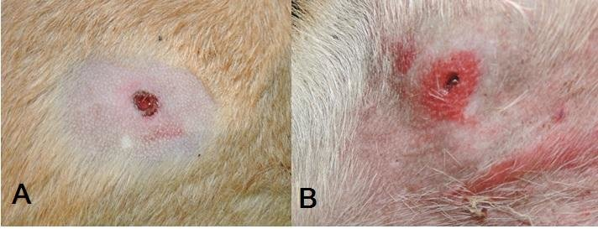

Exit Wounds:
- The bullet exiting or leaving the living target forms exit wound.
- They are larger in diameter due to loss of elasticity caused by cellular death.
- They are found mostly in cases of high velocity projectiles.
- Some amount of clothing, muscles, bony areas and blood protrude out of the exit wound.
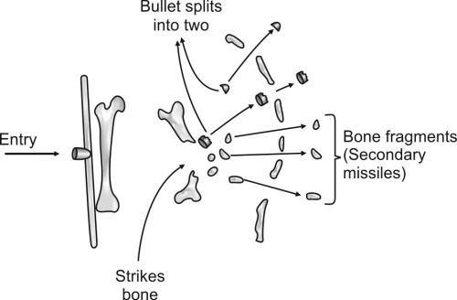

Entry and exit wounds for different firearms-

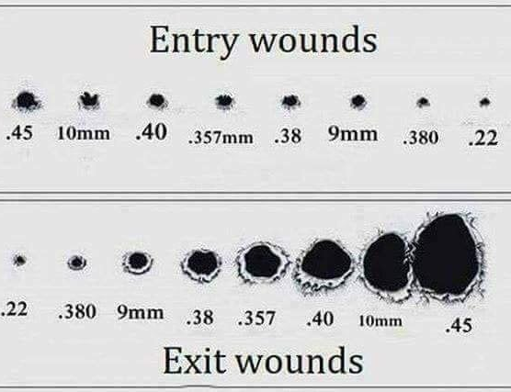

*Cadaveric Spasm may be observed in the suicidal cases.

