Firearms Analysis
Law of Individuality- Any two man-made objects cannot have identical features throughout.
When the cartridge is fired it comes in contact with various parts of firearms.

Forensic Evidences in case of ballistics include
- Firearm
- Firearm injuries
- Cartridge
- Gun Shot Residues
- Distance
- Trajectory
- Fingerprints

The firearm undergoes various processes such as cutting, hammering, polishing, rimming, filing, grinding, etc. during its manufacture. These processes leave microscopic irregularities randomly distributed in the form of nicks & notches, pits & striations, etc.

All these factors affect the distribution of stresses in the metal and hence the fracture pattern and thus, provides individuality to the barrel. This individuality gets enhanced due to normal wear and tear or by some accidental damage or by some new natural formations (eg: rust)

When a firearm is fired, characteristics are transferred to the bullets and cartridge cases.
- Class characteristics
- Individual characteristics

A fired cartridge case contains:
- Firing pin mark (over the percussion cap)
- Breech face marks (on the head of the CC)
- Chamber marks (on the wall of the CC)
- Extractor marks (on the rim surface & extractor groove)
- Ejector marks (on the periphery of head of CC)

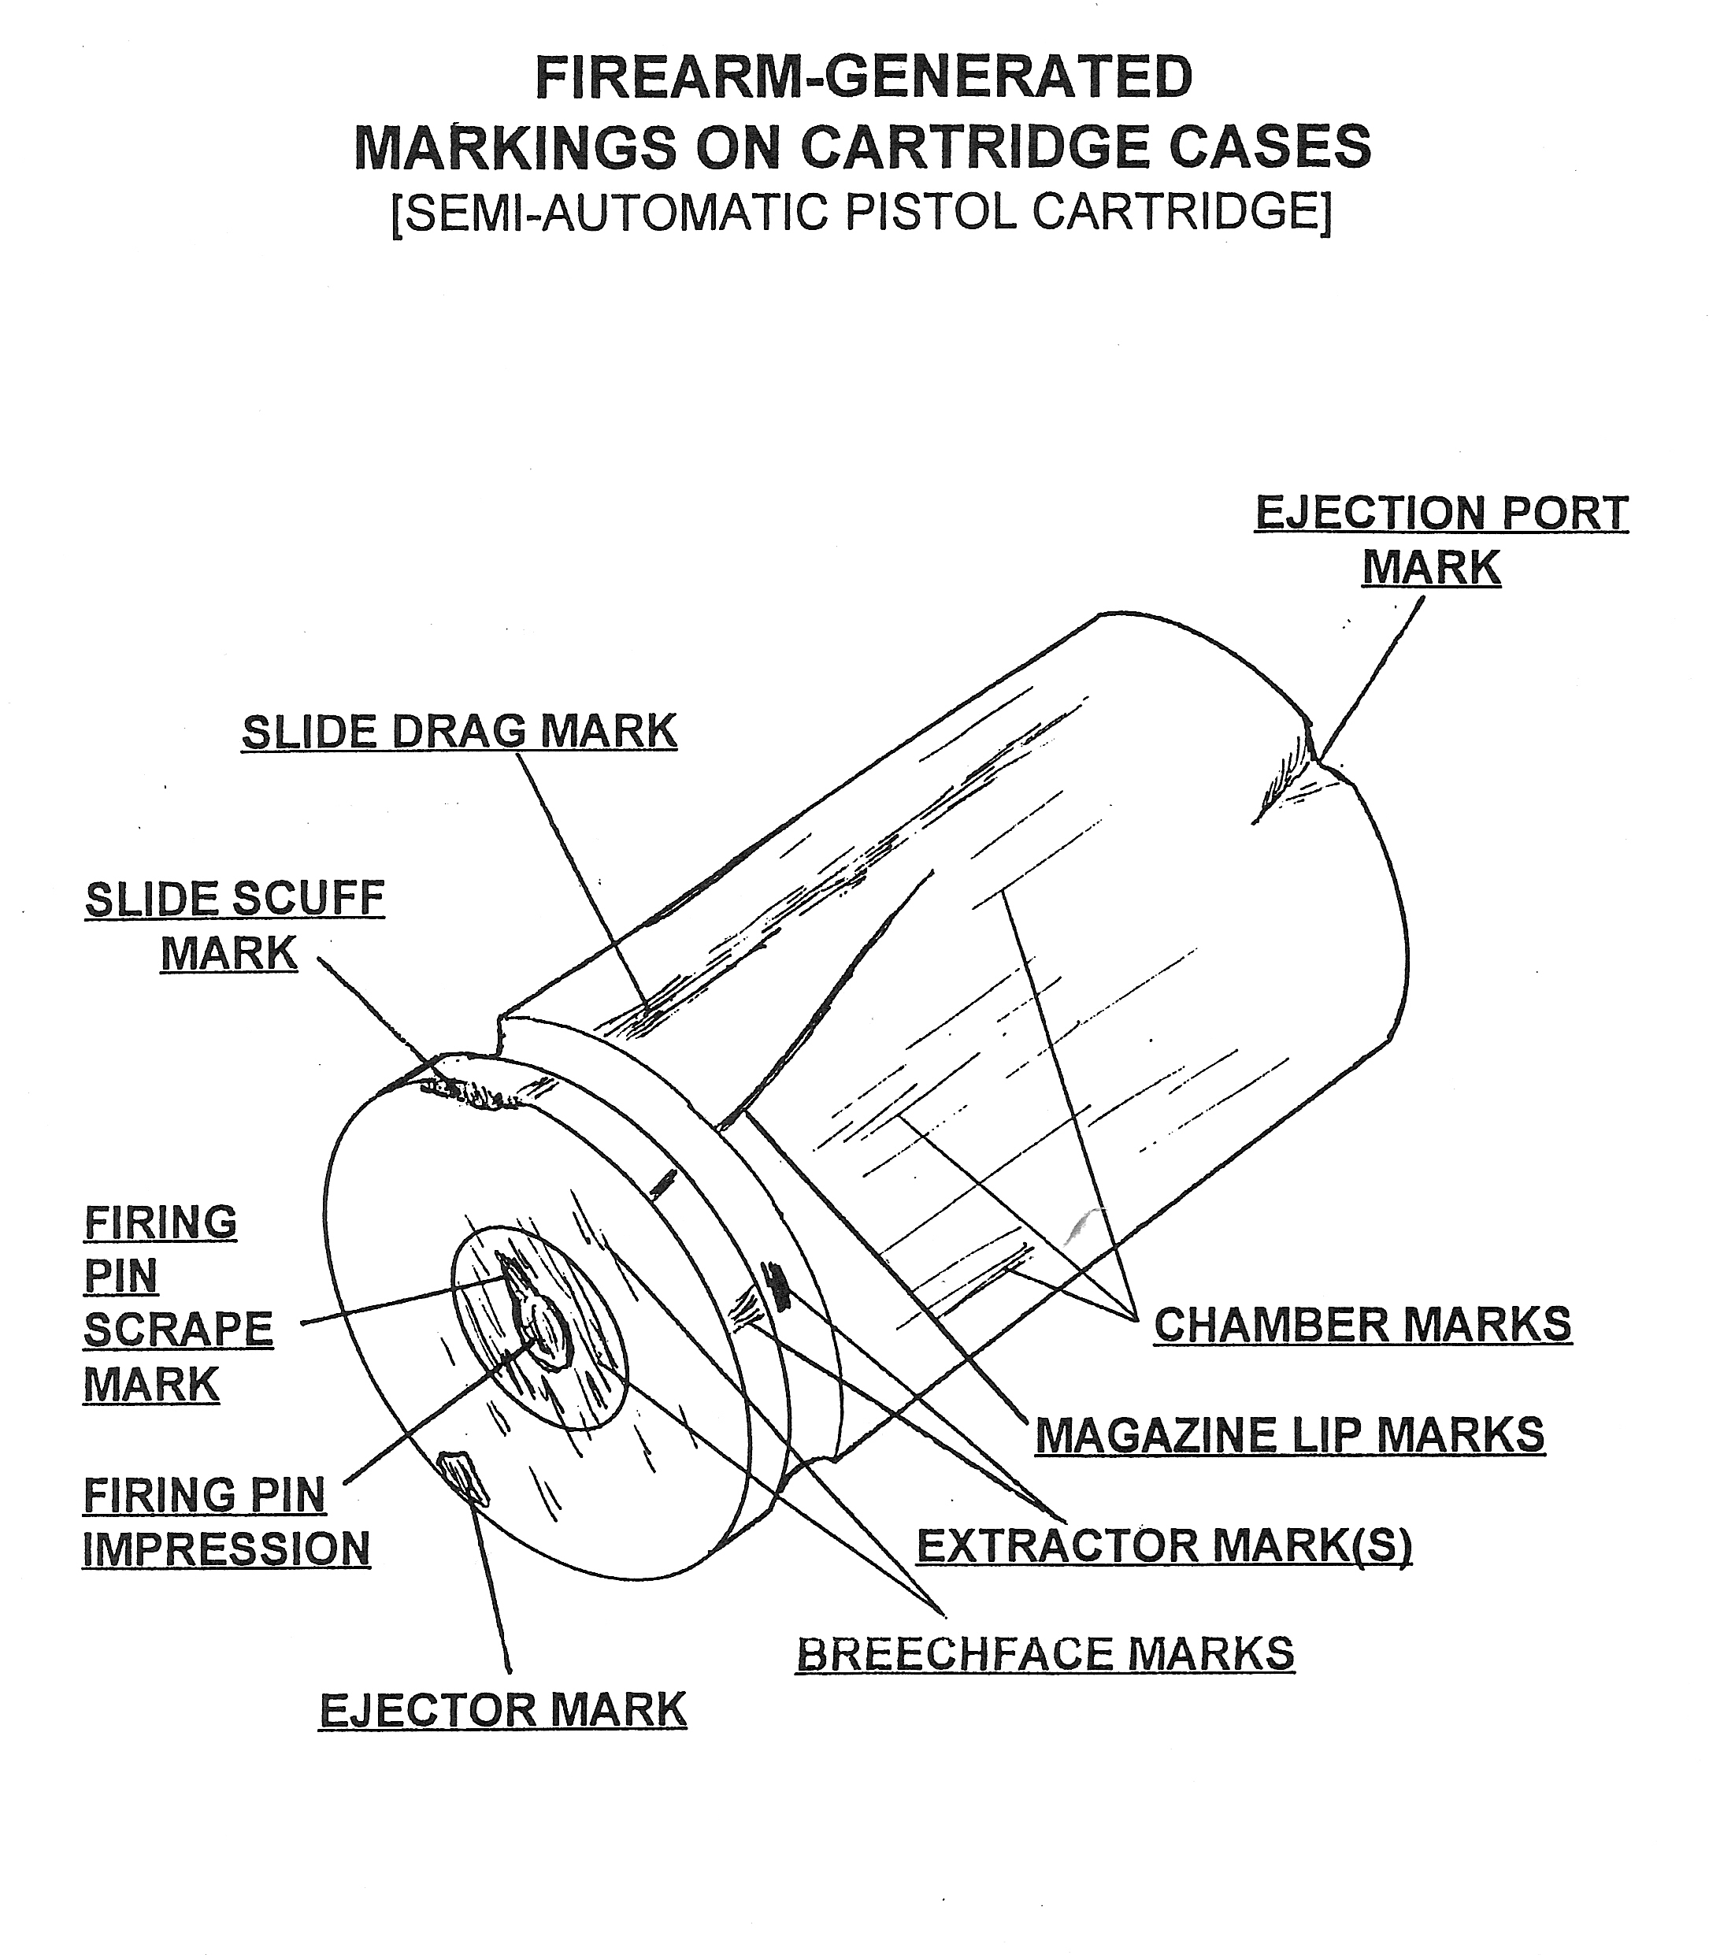
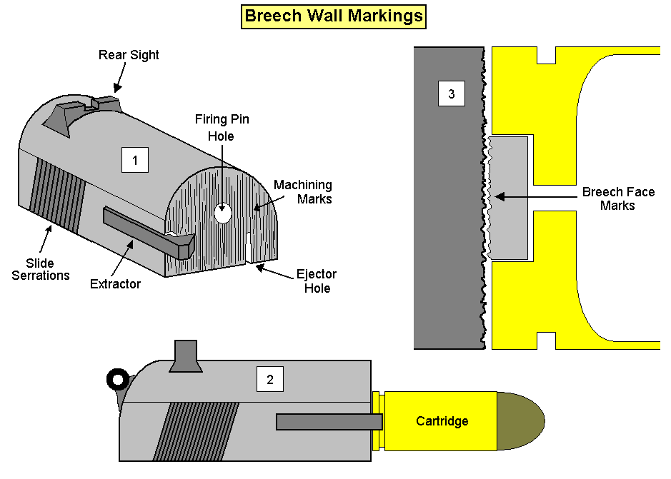

These analyses can be seen in different levels as:

Based on this, there are 3 conclusions-
- Positive (Yes)
- Negative (No)
- Inconclusive (Maybe)

Individuality in firearms:
- Firearm manufacturing processes involve continual but random tool wear and chip formation
- Firearm working surfaces changes randomly with use and abuse
- Items marked by the same surface tend to have areas of microscopic similarity
- Items marked by different surfaces rarely show any significant similarity

