Firearms and its Parts

Firearms- It is an assembly of barrel and action for which a projectile is discharged by means of rapidly burning propellant. These are the machines that are required for hurdling of projectile.

Parts of Firearms-
- Barrel- The metal tube through which projectile or cartridge is fired.
- Bore- It is inside of the barrel. On the basis of presence of rifling it can be smooth and rifled bore.
- Breech- The area around the firing pin which is against the head of cartridge during firing.
- Butt- A solid frame in hand guns
- Stock- A wooden frame in shot guns that absorbs recoil
- Extractor- The mechanism of firearm that withdraws a cartridge case from the chamber of firearm.
- Ejector- The mechanism of firearm that ejects or expels a cartridge case from the firearm.
- Trigger- Initiation of cycle of operation of firing, attached to firing pin.
- Trigger guard- U- shaped part to prevent accidental firing
- Safety lock- Locks or unlocks a firearm
- Hammer- Visual striking steel part that hits the base of the firing pin.
- Corking- Firearms ready to fire, positioning the hammer.
- Rear Sight- Sight on the breech end.
- Front Sight- Sight on the muzzle end.
- Magazine- House of live ammunitions, movable and attachable.
- Grip
- Firing pin- The typical firing pin is a thin, simple rod with a hardened, rounded tip that strikes and crushes the primer.
- Muzzle- First mouth or opening through which the projectile leaves the firearms.

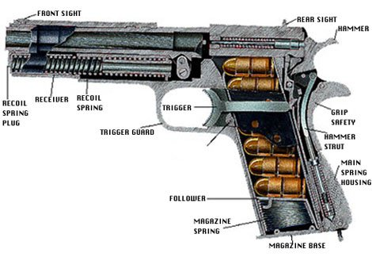
Fig. Parts of Pistol
