Caliber, Bore, Rifling, Choking

Caliber: It is the distance between two lands in a firearm or base of the bullet/ projectile.

Bore: It is the interior of the firearm (shotguns).
Bore formula: d³ = 4.567
N (Bore no.)

Rifling: A single steel rod is drilled to form a barrel. Further rifling is created using different methods-
- Broach Cutter
- Button rifling
- Hook / Simple Cutter
- Single disc Cutter
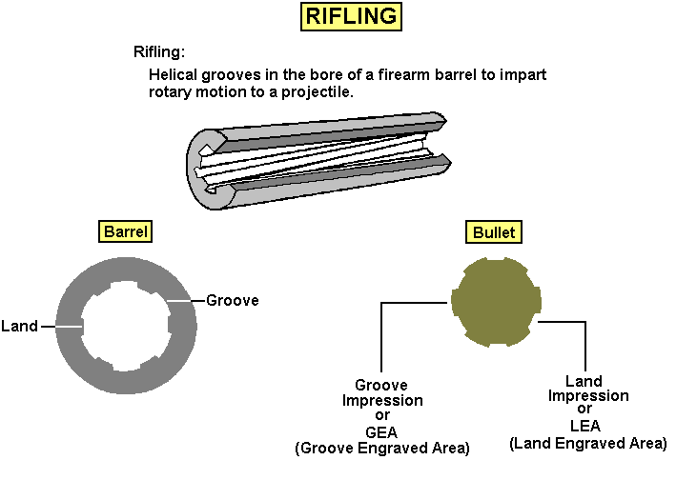

Choking: It is the constriction at the muzzle end of the barrel to decrease dispersion so that more pallets reach 40 yards to cause more fatal injuries.
It is done by different techniques-
- Based on their shape-
  - Cylinder
  - Jug
  - Poly (Fringes)
  - Reverse choke

- Based on the Constriction-
  - Full: d_{b}-d_{m}= 1cm
  - Half: d_{b}-d_{m}= 0.5cm
  - Quarter: d_{b}-d_{m}= 0.25cm
  - Zero: d_{b}-d_{m}= 0cm

