Chapter-1
Introduction to Human Resource Management
1.1 Britain Industrial revolution (1700-1785):
A revolution in agriculture in the 1700s created conditions that favored the Industrial Revolution. Farmers began growing new crops and using new technology such as the seed drill and the iron plow. Increased food production improved people's diet and health, which in turn contributed to rapid population growth. Better farming methods meant that fewer people were needed to farm. As a result, unemployed farmers formed a large new labor force.

1.1.1 Why Britain took the lead:
- At the time period, agriculture in Britain was more commercialized than in any other place. British agriculture had been transformed by new techniques, new crops, and new patterns of property holding. This commercialized agriculture was more productive and thus produced more food for the growing population.
- There was a growing supply of available capital in Britain. London had become one of the most significant centers for international trade as well as headquarters for the transfer of raw material, capital, and manufactured products throughout the world.
- Unlike the rest of Europe, Britain did not have a system of internal tolls and tariffs, so goods could be moved freely to wherever the best market was.
- Great Britain enjoyed many advantages that helped it take the lead in the Industrial Revolution. It had plentiful iron and coal resources and a good transportation system.
- It was a leading commercial power so merchants had the capital to invest in new enterprises. It had colonies that supplied raw materials and bought finished goods. The British government encouraged improvements in transportation and used its navy~ to protect British trade.
- Finally, the British accepted the idea that people could move ahead in society by hard work and talent.

1.2 Organization of Production:
The Organization for Production Technology is dedicated to supporting the process automation and operations needs of the technical and management professions in process manufacturing. The interchange and development of information and knowledge in order to help its members succeed and to exert a positive influence on industry. Automation processing is a common manufacturing method in the chemical, pharmaceutical, pulp and paper, and food and beverage industries. Membership is intended for manufacturers and suppliers associated with these and other similar industries. Activities or items of a commercial nature are limited to assure that services and events retain an educational perspective.
1.2.1 Domestic system:-
A manufacturing system whereby workers make products in their own homes with materials supplied by entrepreneurs. The workers involved could work at their own speed while at home or near their own home. Children working in the system were better treated in this system than they were to be in the factory system. As the women of a family usually worked at home, someone was always there to look after the children. Conditions of work were better as windows could be open, people worked at their own speed and rested when they needed to. Meals could be taken when needed. as people worked for themselves they could take a pride in what they did. Tension in the work place was minimal as the family worked as a unit. the best home produced goods were of a very good quality - though this probably was not true at a general level.
MAJOR WEAKNESSES:
The production was very slow and the finished product was simply not enough to, in the case of textiles, cloth the fast growing population of the United Kingdom. A better and faster system of production was needed. The complete process of production was usually done in several cottages and time was lost as materials were taken from cottage to cottage as one stage progressed to the next. the power of water was being developed and small cottages could not possibly take advantage of this source of power. the image of nice quaint country cottages giving workers a quality lifestyle (if not well paid) simply is not a correct one. With a growing population that needed feeding, clothing etc. a new way was needed to meet the demands that a growing population would make on Britain. This would lead to the new factories, large and deep coal mines, huge ship building ports and the growth of our industrial cities with all the problems they were to bring.

1.2.2 PUTTING-OUT SYSTEM:-

The putting-out system is a means of subcontracting work. Historically it was also known as the workshop system and the domestic system. In putting-out, work is contracted by a central agent to subcontractors who complete the work in off-site facilities, either in their own homes or in workshops with multiple craftsmen. The domestic system was suited to pre-urban times because workers did not have to travel from home to work which was quite impracticable due to the state of roads and footpaths and members of the household spent many hours in farm or household tasks. Early factory owners sometimes had to build dormitories to house workers, especially girls and women. Putting-out workers had some flexibility to balance farm and household chores with the putting-out work, this being especially important in winter. At that point, it underwent name and geographical changes. However, bar some technological advancements, the putting-out system has not changed in essential practice. Contemporary examples can be found in China, India and South America, and are not limited to the textiles industry.

1.2.3 THE FACTORY SYSTEM:-
The factory system was a method of manufacturing first adopted in England at the beginning of the Industrial Revolution in the 1750s and later spread abroad. This system replaced the putting-out system. The main characteristic of the factory system was the use of machinery, usually powered by water or steam.
Workers were paid either daily wages or for piece work, either in the form of money or some combination of money, housing, meals or goods from a company store. Piece work went out of favor with the advent of the production line, which was designed on standard times for each operation in the sequence, and workers had to keep up with the work flow.
The cost and complexity of machinery, especially that powered water or steam, was more than cottage industry workers could afford or had the skills to maintain. The exception was the sewing machine, which allowed putting out of sewing to continue for decades after the rise of factories. Home spinning and weaving were displaced after in the years following the introduction of factory production, especially where transportation facilitated distribution.
Because the efficiency of steam engines decreased with decreasing size and because cost per horsepower went up as size went down, the smallest steam engines were about 2 horsepower. This was a larger size than needed by most workshops and consequently most workshops relied on manual power until electrification in the 1910s and 1920s.
1.3 WELFARE MOVEMENT:-
Early human resource management techniques included social welfare approaches aimed at helping immigrants adjust to their jobs and to life in the United States. These programs assisted immigrants in learning English and obtaining housing and medical care. In addition, these techniques promoted supervisory training in order to increase productivity.
There were two particularly important contributing factors to the origination of modem HRM during that period. The first was the industrial welfare movement, which represented a shift in the way that managers viewed employees—from nonhuman resources to human beings. That movement resulted in the creation of medical care and educational facilities.
The second factor was Frederick W. Taylor's (1856-1915) Scientific Management, a landmark book that outlined management methods for attaining greater productivity from low-level production workers.
The first corporate employment department designed to address employee concerns was created by the B.F. Goodrich Company in 1900. In 1902 National Cash Register formed a similar department to handle worker grievances, wage administration, record keeping, and many other functions that would later be relegated to HRM departments. HRM as a professional discipline was especially bolstered by the passage of the Wagner Act in 1935 (also known as the National Labor Relations Act), which remained the basic U.S. labor law through the 1990s. It augmented the power of labor unions and increased the role and importance of personnel managers.
During the 1930s and 1940s the general focus of HRM changed from a focus on worker efficiency and skills to employee satisfaction. That shift became especially pronounced after World War II, when a shortage of skilled labor forced companies to pay more attention to workers' needs. Employers, influenced by the famous Hawthorne productivity studies and similar research, began to emphasize personal development and improved working conditions as a means of motivating employees.
In the 1960s and 1970s the federal government furthered the HRM movement with a battery of regulations created to enforce fair treatment of workers, such as the Equal Pay Act of 1963, the Civil Rights Act of 1964, the Employee Retirement Income Security Act of 1974 (ERISA), and the Occupational Safety and Health Act of 1970. Because of these acts, companies began placing greater emphasis on HRM in order to avoid lawsuits for violating this legislation. These regulations created an entirely new legal role for HRM professionals. Furthermore, during the 1970s, HRM gained status as a recognized profession with the advent of human resource programs in colleges.
By the end of the 1970s, virtually all medium-sized and large companies and institutions had some type of HRM program in place to handle recruitment, training, regulatory compliance, dismissal, and other related issues.
1.4 THE BEGINNING OF SCIENTIFIC MANAGEMENT:-

It was a theory of management that analyzed and synthesized workflows. Its main objective was improving economic efficiency, especially labor productivity. It was one of the earliest attempts to apply science to the engineering of processes and to management. Its development began with Frederick Winslow Taylor in the 1880s and 1890s within the manufacturing industries. Its peak of influence came in the 1910s; by the 1920s, it was still influential but had begun an era of competition and syncretism with opposing or complementary ideas. Although scientific management as a distinct theory or school of thought was obsolete by the 1930s, most of its themes are still important parts of industrial and management today. These include analysis; synthesis; logic; rationality; empiricism; work ethic; efficiency and elimination of waste; standardization of best practices; disdain for tradition preserved merely for its own sake or merely to protect the social status of particular workers with particular skill sets; the transformation of craft production into mass production; and knowledge transfer between workers and from workers into tools, processes, and documentation.

1.4.1 FOUR PRINCIPLES OF SCIENTIFIC MANAGEMENT:-
Taylor's four principles are as follows:
- Replace working by "rule of thumb," or simple habit and common sense, and instead use the scientific method to study work and determine the most efficient way to perform specific tasks.
- Rather than simply assign workers to just any job, match workers to their jobs based on capability and motivation, and train them to work at maximum efficiency.
- Monitor worker performance, and provide instructions and supervision to ensure that they're using the most efficient ways of working.
- Allocate the work between managers and workers so that the managers spend their time planning and training, allowing the workers to perform their tasks efficiently.

1.5 Features of Personnel Management:

- Personnel management relates to managing people at work. It covers all levels of personnel’s and their needs, expectations and so on. In this sense, it is a comprehensive function and is basically concerned with managing people at work.
- Personnel management is concerned with employees, both as individuals as well as a group. The aim of personnel management is to get better results (for the Organisation) through their involvement, motivation and co-operation. It is a people-oriented process of bringing people and organisations together so that the goals of each are met property.
- Personnel management is concerned with helping the employees to learn and develop their potentialities to the highest level for their benefits as well as for the benefits of their Organisation.
- Personnel management is inherent in all organisations as all organisations (including industrial and commercial) need manpower for the conduct of their activities. They are concerned with recruitment, selection, utilization and development of manpower available. Personnel management is an integral aspect of total business management.
- Personnel management is a continuous activity/function in an Organisation as personnel problems continue to exist as long as employees are working in an Organisation. They need constant attention as they may disturb normal working of an Organisation, if neglected.
1.6 THE NATURE OF MANAGEMENT:
Human Resource Management is a process of bringing people and organizations together so that the goals of each are met. The various features of HRM include:
- It is pervasive in nature as it is present in all enterprises.
- Its focus is on results rather than on rules.
- It tries to help employees develop their potential fully.
- It encourages employees to give their best to the organization.
- It is all about people at work, both as individuals and groups.
- It tries to put people on assigned jobs in order to produce good results
- It helps an organization meet its goals in the future by providing for competent and well-motivated employees.
- It tries to build and maintain cordial relations between people working at various levels in the organization.
- It is a multidisciplinary activity, utilizing knowledge and inputs drawn from psychology, economics, etc.
1.7 Functions of HRM:-
It Includes:
- Human resource or manpower planning
- .Recruitment, selection and placement of personnel.
- Training and development of employees.
- Appraisal of performance of employees.
- Taking corrective steps such as transfer from one job to another.
- Remuneration of employees.
- Social security and welfare of employees.
- Setting general and specific management policy for organizational relationship.
- Collective bargaining, contract negotiation and grievance handling.
- Staffing the organization.
- Aiding in the self-development of employees at all levels.
- Developing and maintaining motivation for workers by providing incentives.
- Reviewing and auditing manpower management in the organization
- Potential Appraisal. Feedback Counseling.
- Role Analysis for job occupants.
- Job Rotation.
- Quality Circle, Organization development and Quality of Working Life.
1.8 The Hard and Soft version of HRM:-
John Storey (1995), in New Perspectives on Human resource management, made a distinction between two versions of HRM.
HARD HRM: It emphasises the need to manage people in ways that will obtain added value from them and thus achieve competitive advantage. Thus it concentrates on quantitative, measurable criteria, control and performance management. The hard approach emphasises:
- The interests of management
- Adopting a strategic approach that is closely integrated with business strategy
- Obtaining added value from people by the process of human resource deployment and performance management
- The need for a strong corporate culture expressed in mission and value statements and reinforced by communications, training and performance management process.
SOFT VERSION: The soft model of HRM is based upon human relations school and is identified by Storey as involving `treating employees as valued assets, a source of competitive advantage through their commitment, adaptability and high quality.
- The need to gain commitment of employees
- The interests of management and employees should coincide
- Integration and team work.

1.9 THE HRM MODELS:
1.9.1 THE MATCHING MODEL/ FOMBURN MODEL:
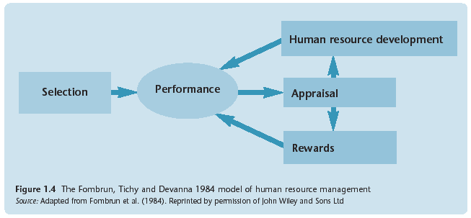

The early HRM model developed by Fombrun emphasizes the interrelatedness and the coherence of human resource management activities. The human resource management cycle in their model consists of four key constituent components selection, appraisal, development and rewards. These four human resource activities aim to increase organizational performance. The strength of the model, however, is that it expresses the coherence of internal HRM policies and practices to the organization’s external business strategy. The HRM cycle is also a simple model that serves as a pedagogical framework for explaining the nature and significance of key HRM practices and the interactions among the factors making up the complex fields of human resource management.
The concept of FIT has been criticised on a number of fronts:
- A number of writers have commented that business strategy dictates HR strategy. Business strategy is formulated in a rational way, by the top down approach.
- A perfect match between business strategy and Hr strategy might not be to the advantage of the organisation as a whole.
- It ignores the complex nature of human beings and the possibility that workers and their unions might influence strategic planning.
1.9.2 THE HARVARD MODEL:
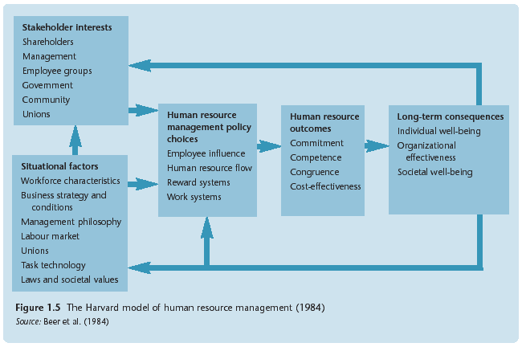

The analytical framework of the ‘Harvard model’ consists of six basic components.
1. Situational factors
2. Stakeholders interests
3. Human Resource Management policy choice
4. HRM outcome
5. Long-term consequences
6. A feedback loop through which the outputs flow.
The situational factors influence HRM policy and choices. Conversely, however, long-term outputs can influence the situational factors, stakeholder interests and HRM policies. The feedback loop reflects this two-way relationship. There is no doubting the attractiveness of the Harvard model. It clearly provides a useful analytical basis for the study of HRM. The model also contains elements that are analytical (that is, situational factors, stakeholders, strategic choice levels) and prescriptive (that is, notions of commitment, competence and so on).

Significance of Harvard Model:- It serves as a guide to practice. It assists to set the framework upon which the principles of HRM could be applied for better results.

1.9.3 GUEST’S MODEL:-
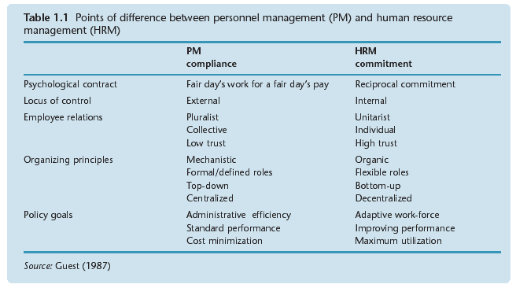David Guest's (1989, 1997) model of HRM has 6 dimensions of analysis:
- HRM strategy
- HRM practices
- HRM outcomes
- Behavior outcomes
- Performance outcomes
- Financial outcomes
The model is prescriptive in the sense that it is based on the assumption that HRM is distinctively different from traditional personnel management (rooted in strategic management, etc.).It is idealistic, implicitly embodying the belief that fundamental elements of the HRM approach (essentially those of the Harvard map) such as commitment have a direct relationship with valued business consequences.
However, Guest has acknowledged that the concept of commitment is 'messy' and that the relationship between commitment and high performance is (or, perhaps, was - given the age of this material) difficult to establish. It also employs a 'flow' approach, seeing strategy underpinning practice, leading to a variety of desired outcomes. Like its American predecessors, this UK model is unitarist (tying employee behaviour and commitment into the goals of strategic management) and lukewarm on the value of trade unions. The employee relationship is viewed as one between the individual and the organization.
    - Warwick Model:
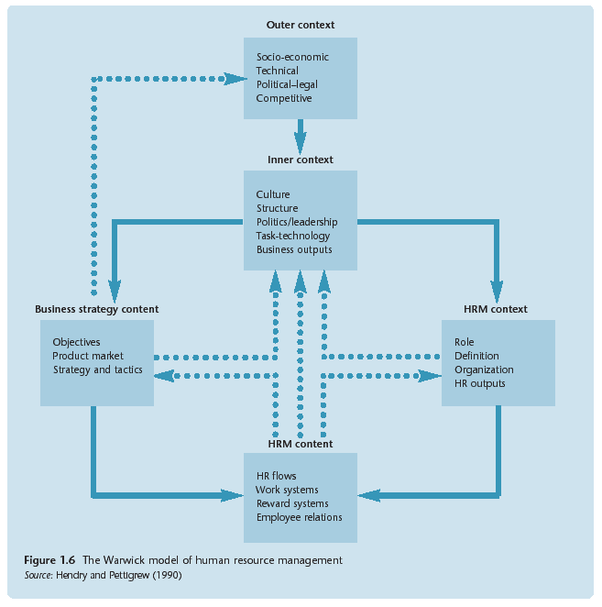
This model emanates from the Centre for Corporate Strategy and Change at the University of Warwick and with two particular researchers, Hendry and Pettigrew (1990). The Warwick model draws heavily from the Harvard framework to extend the analysis of HRM and has five elements:
1. Outer context
2. Inner Context
3. Business strategy content
4. HRM Context
5. HRM content

The model takes cognizance of HRM business strategy and HRM practices, the external and internal context in which these activities take place, and the process by which such change takes place, including interactions between changes in both context and content. The strength of the model is that it identifies and classifies important environmental influence on HRM. Hendry and Pettigrew’s research focused on mapping the context, identifying an inner (organizational) context and an external (wider environment) context and exploring how HRM adapted to changes in context.

1.9.5 Storey Model:
The ‘Storey Model’ is derived from the speculative accounts of what the HRM paradigm might consist of and from the literature on the ‘standard modems’. The model demonstrates the difference between what Storey termed the ‘personnel and industrials’ and the HRM paradigm. His model also has four parts:
1. Beliefs and assumptions
2. Strategic aspects
3. Line management
4. Key levers
The model is built on the following principles.
1. Increase the trust and commitment of employee
2. Corporate planning
3. Transformational leadership role of the head
4. Harmonization of conditions, performance must be related to pay.

