Managing Performance
Session objectives:
- The student will be able to understand the nature and objective of Performance Management.
- The student will be able to compare between Performance management system and performance appraisal system.
- The student will be able to identify, describe and compare the methods of performance appraisal.
- The student will be identify the critical issues associated with performance appraisal.
Performance Appraisal:

Performance Management:

Objectives of Performance Management:
- To determine appropriate rewards and compensation.
- To facilitate employee development.
- To enhance employee motivation.
- To facilitate legal compliance.
- To facilitate human resource planning process

Performance Appraisal VS Performance Management:
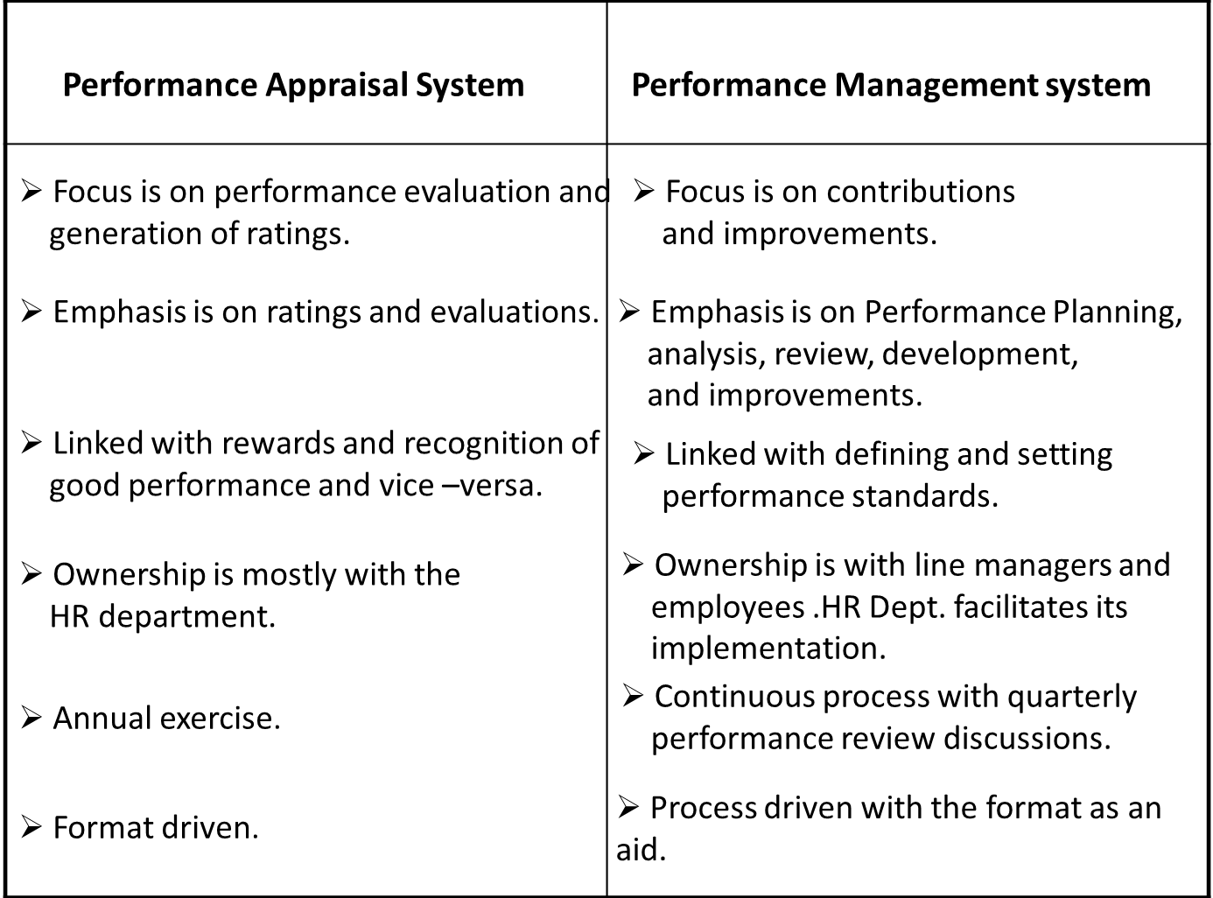

Performance Appraisal Methods:
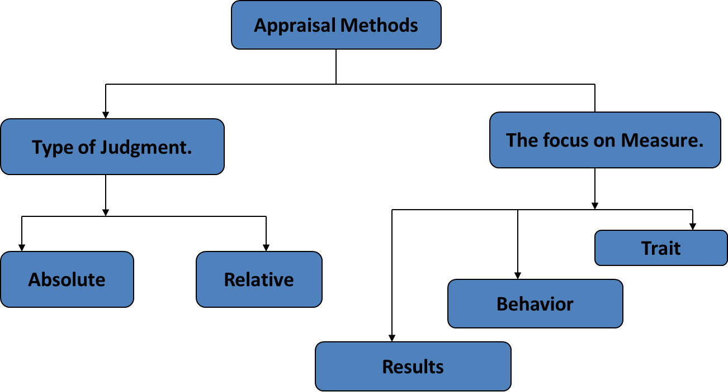

Trait systems:
Graphic rating scale:
• The Rating Scale is a form on which the manager simply checks off the employee’s level of performance.
• This is the oldest and most widely method used for performance appraisal.
• The scales may specify five points, so a factor such as job knowledge might be rated 1 (poorly informed about work duties) to 5 (has complete mastery of all phases of the job).

Advantages of the rating scales
• Graphic rating scales are less time consuming to develop.
• They also allow for quantitative comparison.

Disadvantages of the rating scales
• Different supervisors will use the same graphic scales in slightly different ways.
• One way to get around the ambiguity inherent in graphic rating scales is to use behavior based scales, in which specific work related behaviors are assessed.

Comparison systems:-
- Straight ranking method:

This is one of the oldest and simplest techniques of performance appraisal. In this method the appraisers rank the employees from the best to the poorest on the basis of their overall performances. It is quiet useful for a comparative evaluation. Bajaj, SPIC and BASF use this method.

- Paired comparison ranking method:

A better technique of comparison than the straight ranking method, this method compares each employee with all others in the group, one at a time. After all the comparisons on the basis of the overall comparisons, the employees are given the final rankings. Godrej soaps, KOPRAN, NOCIL and OTIS follow this method.

- Forced distribution method:

Forced ranking is a method of performance appraisal to rank employee but in order of forced distribution. For example, the distribution requested with 10 or 20 percent in the top category, 70 or 80 percent in the middle, and 10 percent in the bottom. The top-ranked employees are considered “high-potential” employees and are often targeted for a more rapid career and leadership development programs. In contrast, those ranked at the bottom are denied bonuses and pay increases. They may be given a probationary period to improve their performance. GE, Ford Motor, Conoco, Sun Microsystems, Cisco Systems, EDS, Enron and a host of other U.S. corporations have adopted similar policies of this method

Behavioral System:
Behavioral systems rate employees on the extent to which they display successful job performance behaviors.They are
- Critical Incident Technique
A critical incident can be described as one that makes a significant contribution—either positively or negatively—to an activity or phenomenon. Critical incidents can be gathered in various ways, but typically respondents are asked to tell a story about an experience they have had. CIT is a flexible method that usually relies on five major areas. The first is determining and reviewing the incident, then fact-finding, which involves collecting the details of the incident from the participants. When all of the facts are collected, the next step is to identify the issues. Afterwards a decision can be made on how to resolve the issues based on various possible solutions.
- Behavioral anchored rating scales (BARS):
Behaviorally anchored rating scales (BARS) are rating scales whose scale points are defined by statements of effective and ineffective behaviors. They are said to be behaviorally anchored in that the scales represent a continuum of descriptive statements of behaviors ranging from least to most effective. An evaluator must indicate which behavior on each scale best describes an employee's performance.
BARS differ from other rating scales in that scale points are specifically defined behaviors. Also, BARS are constructed by the evaluators who will use them. There are four steps in the BARS construction process:
1. Listing of all the important dimensions of performance for a job or jobs
2. Collection of critical incidents of effective and ineffective behavior.
3. Classification of effective and ineffective behaviors to appropriate performance dimensions
4. Assignment of numerical values to each behavior within each dimension (i.e., scaling of behavioral anchors)
Management by Objectives
Management by objectives (MBO) involves setting specific measurable goals with each employee and then periodically discussing his/her progress toward these goals. The term MBO almost always refers to a comprehensive organization-wide goal setting and appraisal program.
1. Set the organizations goals. Establish organization-wide plan for next year and set goals.
2. Set departmental goals. Here department heads and their superiors jointly set goals for their departments
3. Discuss and allocate department goals. Department heads discuss the department's goals with all subordinates in the department (often at a department-wide meeting) and ask them to develop their own individual goals; in other words, how can each employee contribute to the department's attaining its goals?
Appraisal Methods: A comparison
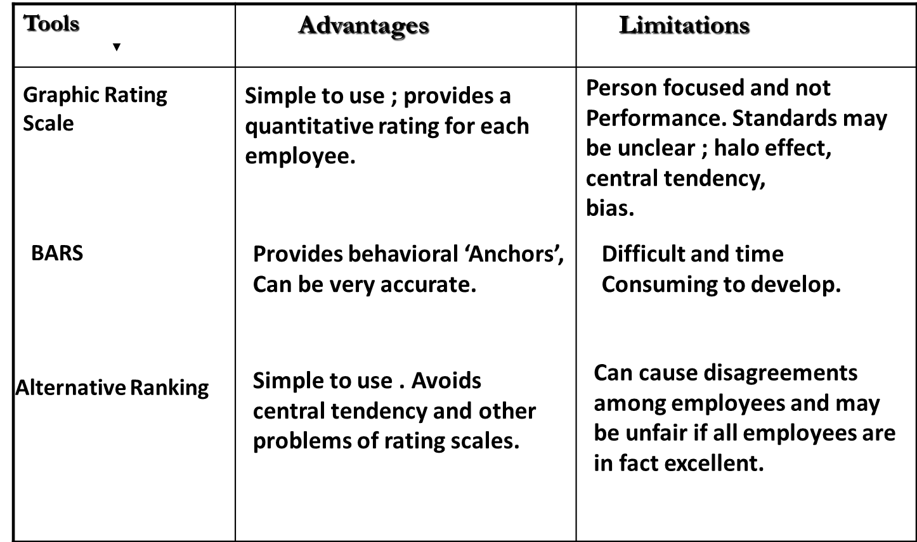

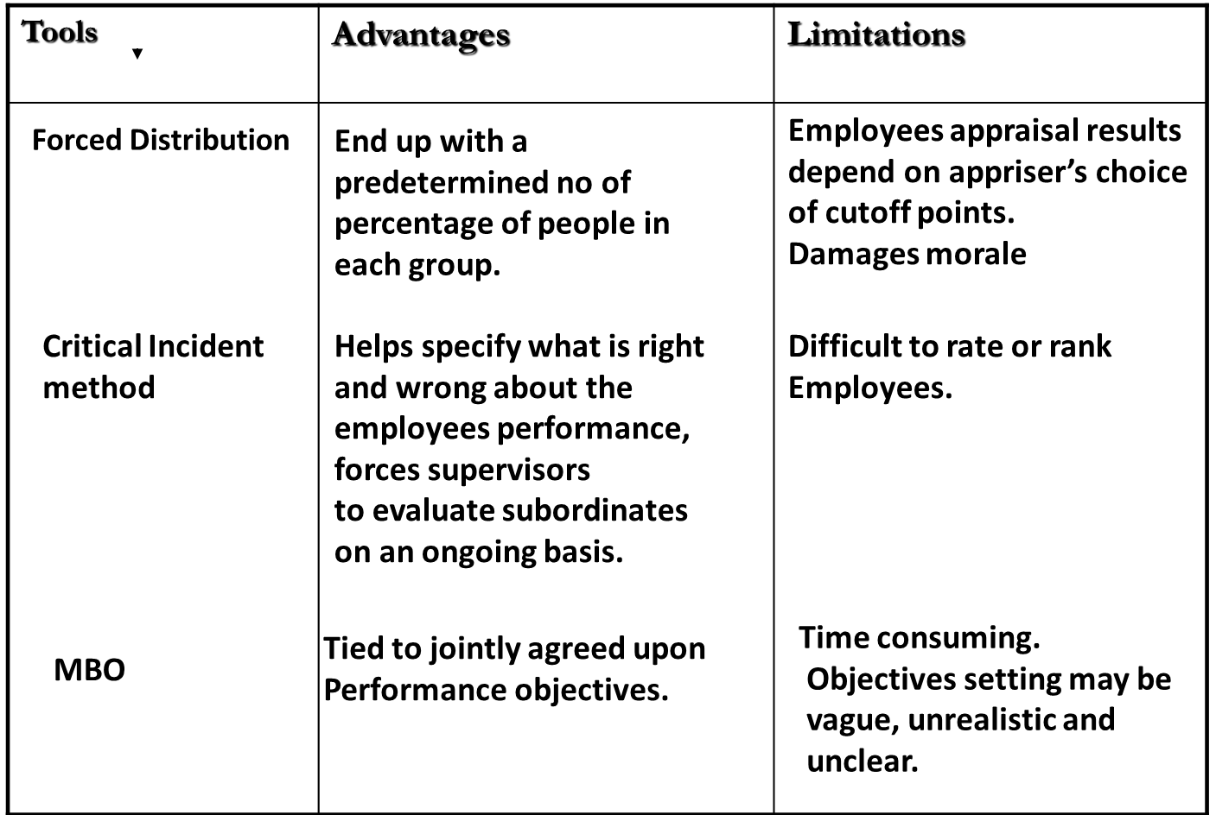

360-degree Feedback:
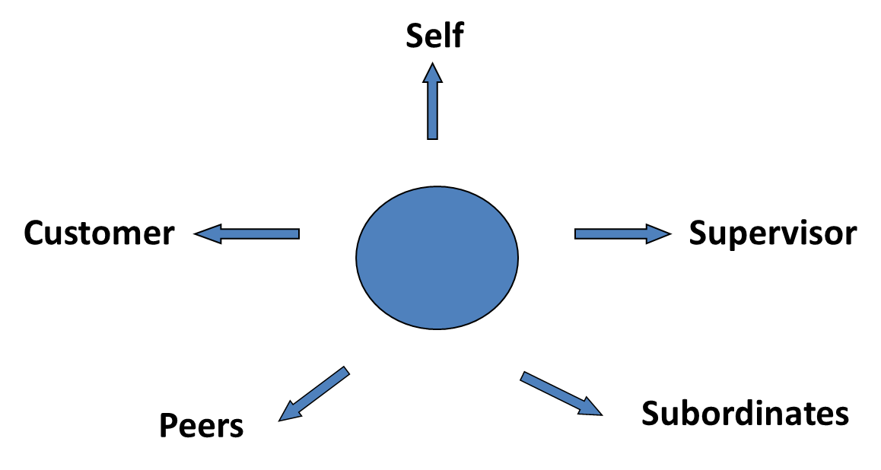
360-degree feedback, also known as multi-rater feedback, multi source feedback, or multi source assessment, is feedback that comes from members of an employee's immediate work circle. Most often, 360-degree feedback will include direct feedback from an employee's subordinates, peers, and supervisor(s), as well as a self-evaluation. It can also include, in some cases, feedback from external sources, such as customers and suppliers or other interested stakeholders. It may be contrasted with "upward feedback," where managers are given feedback only by their direct reports, or a "traditional performance appraisal," where the employees are most often reviewed only by their managers.
The results from a 360-degree evaluation are often used by the person receiving the feedback to plan and map specific paths in their development. Results are also used by some organizations in making administrative decisions related to pay and promotions. When this is the case, the 360 assessment is for evaluation purposes, and is sometimes called a "360-degree review.

Performance Appraisal : An Insightful Criticism
The quality expert ‘W. Edwards Deming’ advocated in elimination of performance appraisal system. He believed appraisal systems are based on false assumptions and too much subjectivity and thus can debilitate the quality of individual output.
Performance Management : Critical Issues
System design and operating problems.
    - Poor evaluation Criteria.
    - Cumbersome technique.
    - Focus on personality traits than performance.
    - Time consuming.
- Unclear standards.
- Rater error and bias .
    - Halo error. ( The tendency to rate similarly across dimensions.)
    - Restriction of range error. (Leniency, central tendency and severity)
    - Opportunity bias.
    - Knowledge of predictor bias.
Appraisal Interview:
An Interview in which the supervisor and subordinate review the appraisal and make plans to remedy deficiencies and reinforce strengths.
The popular methods are.
- The Tell and Sell method.
- The Tell and Listen method.
- The Problem solving approach.

